**Aggregation inhibition of Parkinson’s related alpha-synuclein through interactions with its homolog beta-synuclein.**

**by**

**Maria K. Janowska**

**A dissertation submitted to the**

**Graduate School of New Brunswick**

**Rutgers, the State University of New Jersey**

**In partial fulfillment of the requirements**

**For the degree of**

**Doctor of Philosophy**

**Graduate Program in Chemistry and Chemical Biology**

**And**

**Graduate Program in Computational Biology and Molecular Biophysics**

**Written under the direction of**

**Prof. Jean Baum**

**And approved by**

**______________________**

**______________________**

**______________________**

**______________________**

**New Brunswick, New Jersey**

**August, 2015**

# Abstract of the dissertation

**Aggregation inhibition of Parkinson’s related alpha-synuclein through interactions with its homolog beta-synuclein.**

**By Maria K. Janowska**

**Dissertation Director**

**Jean Baum Ph.D**

alpha and beta synucleins are small pre-synaptic neuronal proteins, are implicated in the regulation of the synaptic vesicles pool. However behavior of aS and bS is significantly different in light of the Parkinson's disease, while aS is believed to be a centerpiece and its aggregation is the main hallmark of the PD bS is believed to negative regulator of aS toxicity aggregation both in vivo and in vitro, but also has significantly non-aggregating nature. In my research I focused on 1.) Understanding non-aggregating properties of bS. 2.) Understanding basis for the inhibition of aS aggregation by bS.

I looked to answer these questions using integrated biophysical methods, primarily focusing on NMR with compliments from CD, DLS, ESI-MS, aggregation assays, cell toxicity assays, chromatography and TEM. Using paramagnetic relaxation enhancement (PRE) I was able to obtain the first ever contact maps for alpha synuclein transient dimers. A similar approach enabled me to discriminate between interactions of alpha synuclein homo-dimers and alpha/beta hetero-dimers which shed light on the interactivity profiles of alpha and beta synuclein. PRE titrations further revealed additional differences in the interactive propensities of these two proteins, that possibly give rise to the differences in aggregation rates. Thus, I was able to provide an initial answer to the first question: beta synuclein can inhibit alpha synuclein aggregation through specific weak interactions that can slow down formation of the aggregation prone complexes.

To answer the second question I investigated the molecular determinants of beta synuclein mutant P123H which can switch beta synuclein from being a non-toxic to a toxic species. I found that the mutation in the C-terminus induces a conformational change in the P123H ensemble that leads to a collapse of the C-terminus. It is especially interesting that this one mutation can exacerbate the effect of alpha synuclein aggregation, suggesting again that the extension of the synuclein C-terminus plays an important regulatory role in aggregation and inhibition. Coupled together these facts suggest that beta-synuclein’s conformational characteristics make it particularly well-suited to inhibit alpha synuclein aggregation, which in turn provides a good candidate platform for developing inhibitors of alpha synuclein aggregation.

# Acknowledgements

I am very grateful to many people without whom I would not be who I am today and who help me get to the point of life I am at right now. The Ph.D. and events that brought me here are amazing mixture of coincidences and small every day miracles and wonderful people who God put on my path that make me a person who I am now.

First of all I would like to thank my parents for theirs love and theirs support., for letting me to learn on my own mistakes and for teaching me responsibility and honesty, for believing in me and also sometimes doubting, that I could fight hard to get what I wanted. I would like to thank my siblings: Krystian, Magda, Andrzej, Michal, Krzysiek and Faustyna: you are the best teachers of life one could imagine. I still recall the adventures we had together, and the way everything was new and fun. I would like also thank all my family: grandparents, uncles, aunts, cousins for being there for me and for giving me support I needed.

I would like to deeply thank my acquired family: my second Mother and Father, for accepting me without reservation, for the time you took to create a friendship with me and for always being there for me if I needed something, for the support you gave me when I arrived to the foreign country. I am touched to the core that I was so blessed to have you here.

Next round of gratitude goes to my girlfriends: Basia Kwiecien i Dominika Slowak. Girls, because of you I know what friendship is about. We can be apart for long, long time, and we are never stopping being kindred spirits.

I would like to thank my teachers from the middle school and high school who helped me to understand the basis and much more! Special thanks to Mrs. Szymanska, Mrs. Kaminska, Mr. Mazurkiewicz, Mrs. Czarnecka great science and math teachers but that was not only what you thought me.

I also thank Biophysics program in the Biotechnology department in Jaggiellonian University, Krakow: all the professors

Table of Contents

Abstract of the dissertation ii

Acknowledgements iv

Abbreviations used viii

Chapter 1. Introduction 1

1.1. Background: Role of alpha synuclein conformations in disease 1

1.1.1. Paper citation information 1

1.1.2. General considerations about αS. 2

1.1.3. Overview of non-acetylated αsyn ensemble: monomers and dimers 4

1.1.4. Heterogeneity of the αsyn oligomeric structures and their pathogenicity. 8

1.1.5. αsyn is N-terminally acetylated in vivo. 12

1.1.6. αsyn is proposed to be a helical tetramer in its native state. 15

1.1.7. Conclusions 21

1.2. Background: Alpha synuclein and beta synuclein characterization. Inhibitory role of beta synuclein 23

1.2.1. Synuclein family 23

1.2.2. beta synuclein as alpha synuclein regulator 23

1.2.3. Functions of synucleins as analyzed by mice knock-outs (KO). 25

1.2.4. Toxicity of bS 26

1.2.5. Characterization of bSyn 27

1.2.6. beta synuclein as inhibitor of alpha synuclein aggregation 30

1.2.7. Inhibition of aS aggregation by many factors. 31

1.2.8. Seeding and cross-seeding in neurodegenerative diseases 32

Chapter 2. Methods 34

2.1. Expression, purification and biophysical methods. 34

2.1.1. Mutagenesis, expression and purification 34

2.1.2. NMR experiments 34

2.1.3. Thioflavin T (ThT). 38

2.1.4. Electrospray ionization mass spectroscopy (ESI-MS). 38

2.1.5. Dynamic light scattering (DLS). 38

2.1.6. Negative straining TEM. 38

2.2. PRE experiments 39

2.2.1. Materials 41

2.2.2. Methods 43

2.2.3. Notes 45

2.3. Biological methods 48

2.3.1. Cell culture maintenance 48

2.3.2. Cell toxicity assay – LDH assay. 50

2.3.3. Immuno-staining and cell imaging 51

Chapter 3. Toxic bS mutant characterization: P123H and V70M. 56

# Abbreviations used

PD - Parkinson’s disease;

αsyn - α-synuclein;

Ac-αsyn - Acetylated α-synuclein;

IDP- intrinsically disordered protein;

BOG, beta-octyl glucopyranoside;

GST, glutathione S-transferase;

CD, circular dichroism;

CN-PAGE, clear native PAGE;

NAC, non-amyloid component region;

PTM, post-translational modifications;

RBC, red blood cells;

Nat, N-acetyltransferase;

NatB, N-acetyltransferase B;

SE-AUC, sedimentation equilibrium-analytical ultracentrifugation;

ELISA, enzyme-linked immunosorbent assay;

ThT, Thioflavin T;

SEC, Size exclusion chromatography;

SLS, static light scattering;

NMR, nuclear magnetic resonance;

ESI-MS Electrospray ionization mass spectrometry

Tg- transgenic

# Chapter 1. Introduction

My PhD research has focused on uncovering the basis for the inhibition of alpha synuclein aggregation by its homolog beta synuclein. Alpha synuclein is an abundant neuronal protein whose aggregation constitutes the hallmark of Parkinson’s disease. Despite high sequence similarity between alpha and beta synuclein, only alpha synuclein aggregates readily, while beta synuclein is fibrillation resistant and able to inhibit aggregation of alpha synuclein both *in vivo* and *in vitro*. Both proteins belong to the class of intrinsically disordered proteins. Thus, previous efforts to uncover their aggregation tendencies had proved challenging. In my research I aimed to answer two main questions:

1. How is beta synuclein able to inhibit alpha synuclein aggregation?
2. What are the molecular determinants of beta synuclein that contribute to its non-fibrillogenic nature?

As the problem is highly complex I will focus on different aspects of the problem in the introduction. The background is divided into two main parts, first part focuses on the importance of aS and its involvement in Parkinson’s disease, and second part will be characterization of the bS and its influence on aS aggregation.

## Background: Role of alpha synuclein conformations in disease

### Paper citation information

Chapter 1.1 was published as review paper in special issue: Many faces of the proteins and published in FEBS letter. I was second author on the paper, and I partially wrote and edited the paper. Paper citation:

### General considerations about αS.

Alpha synuclein (αsyn) fibrils are found in the Lewy Bodies of patients with Parkinson’s disease (PD). It is believed that the transition from the native state to the highly ordered fibrils can be one of the causes of PD. Recently, the view of the native state of αsyn as a monomeric ensemble was challenged by a report suggesting that αsyn exists in its native state as a helical tetramer. This review reports on our current understanding of αsyn within the context of these recent developments and describes the work performed by a number of groups to address the monomer/tetramer debate. A number of in depth studies have subsequently shown that both non-acetylated and acetylated αsyn purified under mild conditions are primarily monomer. A description of the accessible states of acetylated αsyn monomer and the ability of αsyn to self-associate is explored.

Parkinson’s disease (PD) research has sought to answer questions of alpha synuclein (αsyn) function and the mechanism of aggregation surrounding disease pathology. Both remain to be fully articulated today, but several observations have been established and a range of neurodegenerative diseases termed the “synucleinopathies” have been identified2,3. PD in particular is the synucleinopathy characterized by the loss of dopaminergic neurons and is largely considered to be an age-related disease, accompanied in part by age-related deposition of αsyn4. αsyn, a major protein component of Lewy Bodies5,6 in patients with Parkinson’s, is a small primarily neuronal protein that is known to make a structural transition to amyloid fibrils7-9. αsyn is expressed abundantly in the nervous system and localizes near presynaptic nerve terminals10-14. It is also expressed at high levels in erythrocytes and platelets15. αsyn’s function is unknown, but there is strong evidence that it exhibits lipid binding in vesicles and synaptic membranes16 and may somehow exert its pathology through this behavior17. There is evidence that αsyn functions in assembly of the SNARE complex involved in vesicle transport18, that it may more generally be involved in synaptic vesicle trafficking and regulation and/or may play a key role in neuronal cell survival19-23.

The deposition of αsyn has largely been thought to originate from an intrinsically disordered monomer ensemble that under fibril promoting conditions forms amyloid 8,24,25, but recently the position was challenged26. Selkoe and colleagues pushed the biophysical community’s long-held view of the native intrinsic disorder of αsyn by suggesting that the protein exists in its native state as a fibril resistant helical tetramer. They purified the sample from human erythrocytes, opting to exclude a potentially “harsh” and commonly used boiling step from the purification. Based on this work several questions presented themselves. Do bacterial systems that are commonly used to obtain sample for biophysical characterization not possess the necessary machinery for tetramer assembly? Could the commonly used boiling step during purification denature some key native structure that promoted a helical tetramer of αsyn? Aside from these assembly and purification issues, there was also one molecular difference between the purified samples of Selkoe and colleagues and previous studies, indicative of modification to the monomer by an acetyl group (Ac-αsyn).

This review reports on our current understanding of αsyn within the context of these recent developments and describes the work performed by a number of groups to address the monomer/tetramer debate26-34 (Figure 1). Numerous studies have addressed these issues and indicate that asyn, both acetylated and non-acetylated, exists as intrinsically disordered monomer conformational ensemble under mild purification conditions. We highlight that the ensemble of monomers can develop into a wide range of accessible conformations upon changes of environmental conditions, that it can populate many soluble oligomeric states of varying morphologies and toxicities, and settle into various insoluble fibril or amorphous aggregate morphologies24, that have largely been studied in the context of PD-related pathology (Figure 1). We discuss the suggestion of a soluble fibril resistant helical tetramer that may have to dissociate before fibril formation can proceed through the monomer (Figure 1). The potential that established methods might disrupt native-stabilizing interactions of a fibril-resistant helical tetramer of αsyn have heightened awareness to cell machinery, to αsyn purification methods, and to the difficulties in choosing appropriate methods of characterization. The extent to which N-terminal acetylation impacts upon the conformation and aggregation behavior of αsyn is discussed separately and it is shown that the acetyl group does not promote the formation of the helical tetramer under mild purification conditions.

### O***verview of non-acetylated αsyn ensemble: monomers and dimers***

**Figure 1. A schematic diagram of the possible accessible states of non-acetylated and acetylated αsyn.** The right side represents two possible pathological aggregation pathways from the unfolded monomeric ensemble to 1) insoluble fibrils through on-pathway transient oligomeric intermediates and 2) to off-pathway soluble oligomers. Off-pathway soluble oligomers represent non-fibrillar end products of aggregation. The left side presents 1) the recent proposal that αsyn can exist as a soluble fibril resistant helical tetramer which is acetylated, and 2) other known oligomers that are not toxic such as methionine oxidized oligomers. It is proposed that the non-pathological tetramer needs to dissociate to the monomeric ensemble before pathological aggregation can occur (dark arrow).

**Biophysical characterization of the non-acetylated monomer ensemble.**

The native state of non-acetylated αsyn has been thought to originate from an ensemble of intrinsically disordered monomeric forms, with recognition that the monomers therein are capable of adopting a wide range of accessible conformations depending on solution and environmental conditions 35-39. Uversky first spoke of αsyn as the “protein chameleon”24 due to its ability to respond to its environment and binding partners by varying its foldedness and aggregation state. αsyn is often described as a 140 residue intrinsically disordered protein (IDP) characterized by three distinct regions of the protein: an N-terminal lipid binding repeat region that houses the mutations A30P, E46K, and A53T linked to early onset disease, a hydrophobic non-amyloid component (NAC) region implicated in fibril formation, and an acidic more proline-rich C-terminus suggested to have chaperone activity and possess some key role in modulating structure in the N-terminus7,40,41. As it is summarized in Table 1, to study PD related aggregation, αsyn has typically been obtained from overexpression in bacteria, yielding a non-acetylated IDP, as bacteria typically do not modify their proteins by acetylation (Figure 2A)42-44. Additionally, while boiling as part of the purification protocol would typically be considered to be harsh for a globular protein, IDP’s are in general characterized by thermostability35. Because of this heat stability, αsyn has often been boiled to achieve purity. In addition, IDP’s like αsyn are generally characterized by a highly charged sequence, a lack of stable secondary structure, and a larger than expected Stokes radius compared to spherical and folded proteins of the corresponding molecular weight35,45,46.

The αsyn monomer is both unfolded and extended, as it was first reported to have a larger Stokes radius than expected for globular protein of similar molecular weight and a primarily random coil circular dichroism (CD) spectrum (Table 1) 35,37,47. However, the protein is not fully extended for a protein of its size, implying a slight compaction of the monomeric ensemble37,48. Evidence for contact between the C-terminus and both the NAC and N-terminal regions of the protein from nuclear magnetic resonance (NMR) 39,49-56, electron paramagnetic resonance57 and molecular dynamic studies53,58 indicates a possible source of this compaction, as well as some transient secondary structure56,59-61. The compaction may be at least be partially driven by hydrophobic patches located in the C-terminal (residues 115-119, and 125-129) associating with and shielding both the hydrophobic N-terminal and NAC regions51,62. It should be emphasized that evidence for contact between the N- and C- termini does not imply a static closed picture of αsyn as an IDP60,63. Rather, this is a dynamic interaction, and observation of slight compaction is the result of observations on a highly averaged bulk ensemble49.

Under conditions promoting pathological aggregation of αsyn, conformational shifts in the ensemble are observed. There is evidence that these interactions may keep the N-terminus from pathological misfolding40,64, as their release is associated with increased fibril formation 39,51,53,65,66. For example, when the solution pH is lowered, there is a structural rearrangement of the monomer ensemble with enhanced contacts between the NAC region and the C-terminus resulting from charge neutralization and compaction of the C-terminal region39,55,59,67. Environmental or experimental shifts that reduce the net charge or increase hydrophobicity of the protein 68-70, or interaction with small molecules or metal ions71-73 can change subtly, but significantly, both the long-range and short range contacts and conformations sampled in the monomeric ensemble (Figure 1).

Therefore, small changes to the αsyn monomer can potentiate big effects on aggregation behavior, yet only small differences to the monomer ensemble. For example, the familial mutations (A30P, E46K,A53T) of αsyn are structurally comparable, as they are similarly unfolded and have similar radii of gyration, but they have distinct kinetics of fibril formation56,74-80. NMR spectroscopy has revealed that mutations affect chemical shifts surrounding the mutation site and that we can correlate these shifts to region-specific shifts in the population of transient secondary structure. These relatively small shifts in transient secondary structure populations can explain bulk differences in fibril formation rates60,81,82.

The N-terminal region is also known to adopt helical structure upon binding lipids, representing a more dramatic conformational shift of the monomer ensemble83-85. NMR groups have demonstrated that αsyn displays chemical shifts characteristic of a mostly unfolded peptide, but that the first 100 residues transiently populate helical structure. When bound to lipids or micelles, however, chemical shifts of these residues indicate a structured helical environment.86,87. Bax characterized the structure of the micelle bound form of the protein, and the fact that αsyn adopts helical structure at its N-termini through its repeat region upon binding lipids membranes and micelles has become a well-known fact83. Because αsyn localizes near synaptic nerve termini10, its lipid-induced helical structure36,88-90 may be crucial in understanding the protein’s function at the membrane, yet it is still unknown how this N-terminally helical monomer conformation is related to the trigger of fibril formation.

**Dimers: equilibrium species and pathological intermediates.**

Dimers can exist in pseudo-equilibrium within the monomer ensemble and also as on-pathway intermediates to the fibril. Within the monomeric conformational ensemble of non-acetylated αsyn, there exists some small population of dimer. The Baum lab demonstrated that indeed antiparallel transient inter-chain contacts between the C-terminal hydrophobic patches and the N-terminal region (residues: 3-15 and 35-50) could be detected by using NMR paramagnetic relaxation enhancement experiments55. Electrospray ionization mass spectrometry (ESI-MS) obtained under similar conditions has shown that the predominant oligomeric form we observe in αsyn is the dimer. This soft ionization technique has revealed the “conformational heterogeneity” of αsyn, where the monomers and dimers themselves exist in both extended and compact conformations31,91,92, suggesting that the ensemble view of αsyn also extends into its higher oligomeric states.

It is unknown whether this pseudo-equilibrium anti-parallel dimer is on pathway to the fibril formation. It is reasonable to assume that inter-chain N-N species, which adopts the same parallel orientation as monomer units as in the core of the fibril, lies further along the pathway to fibril formation than anti-parallel oriented monomers93. This would imply reorientation of monomer units as an obligatory step before formation of the fibril. However, at least one report demonstrates that toxic prefibrillar amyloid aggregates adopt an antiparallel orientation94, and in this sense we cannot draw any analogy to this pseudo-equilibrium dimer population that exists in the fibril accessible monomer ensemble.

As the monomeric ensemble is shifted towards more fibril prone conditions, previously described conformational changes, as well as changes in population of oligomeric species occurs. Incubation at high temperature is one external factor inducing this shift95. Under these conditions, soluble oligomers of αsyn spontaneously associate and a dimer is the predominant oligomeric species of αsyn to appear alongside formation of the fibril, along with smaller populations of higher-order oligomers. Biophysical characterization of this partially folded intermediate is consistent with a partially folded monomer and pre-molten globule like dimer, that is slightly less ordered and has more hydrophobic patches exposed than the native monomer37. This on-pathway dimer that appears at the time of fibril formation may be conformationally dissimilar from the equilibrium dimer population previously described, which is not necessarily correlated with fibril formation. There is some evidence that formation of at least one species of dimer is the rate limiting step of fibril formation96 and cysteine mutants have shown that particular dimer linkages accelerate fibril formation *in vivo* and *in vitro*96. This implies accessibility of many distinct conformations for the dimer, in the same way as the monomer. Additionally, dimers are not the sole on-pathway oligomeric species that appear during events of PD pathology. Observations of higher order oligomers, that occur alongside fibril formation and in response to other events appear to include a large slew of different species, which we address in the upcoming section.

### Heterogeneity of the αsyn oligomeric structures and their pathogenicity.

**The role of oligomers in *in vivo* pathology.**

The motivation to understand whether there is a helical tetramer of Ac-αsyn lies not only in desire to accurately portray the protein *in vivo*, but also to understand how oligomers in particular function in disease-related pathology of PD. There is ample evidence that soluble oligomers are the real pathogenic species of neurodegenerative disease, whereas fibrils serve as reservoirs of misfolded, irreversibly modified deposited protein better-off removed from solution97-104. Because amyloid deposits were first detected in brains of sick individuals, it was assumed that they were the neurotoxic species, but because amyloid is such a common structural motif, the ability to form amyloid is now considered a general property of a polypeptide in solution105. Over and over, conversion of IDPs into amyloid aggregates has not been observed to be a simple two-state transition. Oligomer formation has been established as an important mechanistic step in fibril formation, for example as in Alzheimer’s disease103,106. As briefly described in αsyn, soluble oligomeric intermediates commonly appear as insoluble fibrils form107-109 and the situation may be quite similar to that established for AD.

What determines if a protein will form soluble oligomeric species, or if an amyloid fibril will form? It seems that a polypeptide will sample many parallel or antiparallel conformations before a final structural state is preferred110. This arises from a competition between hydrophobic forces and side chain interactions, versus the propensity of the polypeptide chain to form β-sheet like hydrogen bonds111. The prefibrillar oligomer is thought to be the cytotoxic species, as toxic inter-chain associations are sampled that a monomer alone could not support. The fluorescent probe 8-anilinonaphthalene-1-sulfonic acid binds to exposed hydrophobic patches. Its binding demonstrates that the most toxic species are associated with greater overall surface hydrophobicity95,112-114. In fact, overall greater hydrophobicity is associated with increased chance for exposed hydrophobic portions of the sequence to exhibit toxicity through interaction with the membrane. This may as well be the case for αsyn113,115.

Oligomeric PD pathology may be rooted in membrane association, where oligomers of αsyn can perturb membrane integrity and cause cell death by altering transport across the membrane 116-119. At least one report demonstrates that *in vivo* membrane associated αsyn oligomers correlate with toxicity rather than inclusion formation120 but also that the degree of oligomer toxicity is related to an array of structurally diverse morphologies that can form. Interestingly, of the familial mutants implicated in PD, A30P and A53T have different kinetics of fibril formation relative to the wild type monomer, but both share the property of an accelerated oligomerization121,122. These mutants may exert their pathology through the formation of pore-like oligomers that form alongside fibril formation123.

**Oligomers on the aggregation pathway are highly heterogeneous.**

Early “prefibrillar” oligomers and “late” soluble oligomers, not a part of the fibril have been observed of αsyn108,124 Their isolation and structural characterization has been of great interest, and some shared features of fibril accelerating or inhibiting species have been characterized. It was postulated that an on-pathway amyloidogenic transition occurs through partially folded oligomeric species originating in the dimer37. Soluble aggregates first appear that maintain the helical character of the monomer, but lose some disorder in favor of β-rich structure. β-rich intermediates build as fibril formation proceeds and begin to get consumed at the end of the lag phase108,112. This may describe the formation of initial aggregates and their conversion into amyloid-like aggregates, described by Dobson and colleagues using FRET107. AFM has been used to observe β-rich spherical and annular oligomer morphologies prior to fibril formation of αsyn. The initial aggregates appear to be spherical aggregates. They have been shown to convert to more spherical compact species, and then into annular species upon further incubation125. Annular species of αsyn are known to induce membrane leakage104,126, but spheroidal species can bind brain-derived membranes quite tightly, as well125. Spherical morphologies seem to disappear once the fibril has formed, whereas annular species may sometimes coexist with the fibril125. Oligomer induced toxicity is relevant to the entire fibril process.

Many times stable oligomers are observed after the fibril has formed, or are instead preferred. “Late” stage distinct oligomeric species appear once fibrils have formed and they are also β-rich 109,112,124,127. Some suggest they occur from dissociation of the fibril or that they represent end-products of a fibril resistant-soluble oligomerization pathway and may not be converted into fibril. At the end of fibril formation 10-20% of protein exists as such a non-fibrillar oligomer.

There are many pathways refer to soluble species. Organic solvents have been used to model membranes, and it has been shown that a helical rich monomer will eventually associate into a helical rich oligomer that also appears stable 128. Covalently cross-linked non-fibrillar oligomers are also well known to form under oxidative or nitrative stresses. Nitration, for example, inhibits fibril formation through the formation of inhibitory higher-order oligomers than the dimer 129. This mix of species only further describes the range of the secondary structures, morphologies and pathologies that oligomers of αsyn are capable of populating93,95,130-132. Increased oxidative stresses and increased metal levels have been correlated with PD, so this class of stable non-fibrillar oligomers that form under stresses are potentially important players in the mechanism of aggregation as well133.

Various pathways available to soluble oligomer, not surprisingly results in a very heterogeneous population of possible oligomers. Oligomer morphology has been shown to be highly dependent on solution conditions, including the presence of lipids125,134-137. Also, incubation with different types of metals generates partially folded structures138-140 that go on to form a variety of oligomeric structures. Whereas incubation with Cu2+/Fe3+/Ni2+ produce spherical particles of 0.8-4 nm particles, incubation with Co2+/Ca2+ produces pore-like annular rings 70-90 nm in diameter141.

**Stabilization of non-fibrillar oligomers that appear to be non-pathogenic.**

In previous paragraphs our focus was on oligomers more closely linked to pathology, but as mentioned, some oligomers can be stabilized in non-fibrillar forms not capable of adopting cross-β structure on their own and may not necessarily be linked to cytotoxicity (Figure 1). The αsyn monomer that has been modified by methionine oxidation of the αsyn monomer to the sulfoxides is one example of these non-toxic non-fibrillar species. This modification at methionine residues promotes the stabilization of an oligomer that appears slightly more unfolded than monomeric αsyn. While probably not covalently cross-linked, these oligomers exhibit stability and do not go on to form fibrils142-144. Furthermore, these oligomers do not exhibit toxicity toward dopaminergic neurons, suggesting that particular conformational features are indeed necessary to exert pathology as an oligomer (Figure 1)144. Interaction with small molecules like the flavonoid baicalein can also prevent formation of the fibril by stabilizing soluble oligomeric end products and these oligomers also do not disrupt membranes145. Structurally these species are spherical, have a well developed secondary structure, are relatively globular with a packing density intermediate between globular protein and pre-molten globule and very high thermodynamic stability. In contrast oligomers stabilized by modification of the monomer with 4-hydroxy-nonenal are non-fibrillar, but are also toxic145. Could a helical tetramer be similarly stabilized, such that the stabilization in the oligomer conformation is more favorable than in amyloid, and could it also share conformational features of non-pathology with aforementioned species? For example, in amyloid-β two oligomers of similar size but dissimilar toxicity have been identified, where more toxic species adopts a conformation that hydrophobic regions to remain more exposed(Ladiwala2012).

### αsyn is N-terminally acetylated in vivo.

Before attention was drawn to the possible role of the acetyl group by the recent report26 of tetramer formation of αsyn, αsyn was studied from a variety of sources, some of which were mammalian and were likely to be N-terminally acetylated. Although the acetyl group had not previously warranted an explicit examination, drawing comparisons between in-cell work *and in vitro* work could be challenging. Therefore, the report suggested that co- or post-translational modifications (PTM’s), namely acetylation, may have significant influence on αsyn structure and aggregation properties (Table 1). PTM’s to αsyn are known to regulate/modify αsyn’s propensity to aggregate132,142,146. It has been known for some time that αsyn in human tissues is acetylated, but the role of N-terminal acetylation is unclear, as it is seen in both healthy and individuals sick with synucleinopathies. Two mass spectrometry (MS) studies of αsyn from human tissues, both report that the base mass of the protein before any other modifications is the acetylated form -- consistent with that reported by Selkoe and colleagues from red blood cells (RBCs)26,147,148. The report indicated that acetylation of αsyn was not limited to neuronal tissue; however, the site of acetylation was not identified.

**Bacteria lack the machinery for N-terminal acetylation.**

**Figure 2. A pictoral representation of the co-expression system designed to generate Ac-αsyn in bacteria.** In this figure: ring-like circles represent plasmids, lines represent the αsyn protein, and two ellipses represent the NatB protein. A) Bacteria, lacking NatB, express non-acetylated protein. B) Yeast house yeast-NatB which acts upon αsyn and generates Ac-αsyn. C) To obtain Ac-αsyn within a bacterial expression system, plasmids encoding yeast-NatB can be co-expressed with the plasmid encoding for αsyn so that Ac-αsyn is obtained1.

Mammals modify the proteins they produce with many more PTM’s than yeast and bacteria, as these may play a role in more complex signaling pathways149,150. N-terminal acetylation is a well-known modification in eukaryotic cells. Up to 80% of proteins are modified by N-terminal acetylation in mammals, whereas bacteria rarely acetylate their N-termini and if they do, by distinctly different mechanisms 44. The aforementioned MS studies147,148 indicated that acetylation occurs at the N-terminus, where an acetyl group has removed the α-amino charge of the initiating amino acid by covalent modification at that site.

N-terminal acetylation is carried out mostly co-translationally by a group of enzymes known as N-acetyltransferases (Nat) in eukaryotes151,152. Mammalian cells have these complexes, and yeast an analogous enzyme complex, but bacteria do not. Nat’s catalyze the transfer of an N-acetyl group from acetyl-coenzyme A to the N-termini of proteins with sequence specificity. Different Nat’s (types A-F in eukaryotes) work upon different initiating amino acid substrates, dependent upon the identity of the first two to three amino acids of the protein polypeptide153. Therefore, depending on the type of cell to synthesize αsyn, the protein may or may not be acetylated (Figure 2A, 2B). Specifically, N-acetyltransferase B (NatB) has αsyn as a substrate, producing acetylated αsyn (Ac-αsyn). NatB targets proteins beginning with Met-Asn-, Met-Glu- or as in the case of αsyn, Met-Asp-. Substrates of NatB are acetylated nearly 100% of the time, as the acidic amino acids in the second position are thought to stimulate the transfer of the acetyl group150.

**Possible roles of N-terminal acetylation *in vivo***

Recognizing that αsyn acetylation does indeed occur, one study prior to Bartels’ *et al.* investigated the role of NatB activity in a yeast model by disrupting NatB activity154. They found NatB activity to be essential for proper membrane targeting of αsyn. Without NatB activity, non-acetylated αsyn is produced, and a much more diffuse cytoplasmic localization of αsyn compared to those with whole NatB activity (producing Ac-αsyn) was observed. While this *in vivo* effect was observed in this one instance for Ac-αsyn, the role of N-terminal acetylation is not generally well understood155. One study suggests that N-terminal acetylation represents an early sorting step, where acetylated proteins are targeted toward the endoplasmic reticulum, unless they remain non-acetylated and are kept localized to the cytosol instead156. N-terminal acetylation may also regulate degradation pathways157 or be responsible for structural effects at the N-terminus158. Levels of acetylation may be related to regulation of other post translational modifications, NatB, specifically, has been shown to induce elevated phosphorylation levels in yeast159 consistent with the aforementioned yeast study of αsyn, where decreased levels of phosphorylation are observed when the protein remains non-acetylated and localized in the cytosol154. Acetylation may not be necessary at all for proteins, but some examples do point to a necessity. For example, tropomyosin requires N-terminal acetylation so that it may bind to actin160.

### αsyn is proposed to be a helical tetramer in its native state.

Selkoe and colleagues strived to isolate αsyn under physiological conditions and have challenged the existence of the αsyn monomeric ensemble26 by proposing a fibril resistant helical tetramer form of the protein (Table 1). In contrast to the typical protocol in which αsyn has been derived from bacterial systems, overexpressed and denatured, they purified αsyn from gently-treated RBCs known to have a high endogenous expression level of human Ac-αsyn. From both RBC lysate and endogenously expressed αsyn from neuronal and non-neuronal cells lines, Selkoe and colleagues showed on Clear Native PAGE (CN-PAGE), that αsyn migrates near the tetramer position against folded, globular protein standards. The unusual migration of an IDP against globular standards was not unfamiliar. Native gels are unreliable objective determinants of molecular weight as protein migration depends strongly on protein charge and interaction with the acrylamide matrix depending on the shape of the protein. IDP’s typically display a Stokes radius of a much higher molecular weight species, and this has previously been attributed to enhanced interactions with the matrix37, so that *E. coli* derived boiled αsyn, too, will migrate near the position of the tetramer at 58 kDa on a native gel26.

Selkoe and colleagues’ report also stated that they obtained a CD spectrum that indicated largely helical structure that was sensitive to irreversible heat denaturation. Isolation from human cell line 3D5 (which are M17D cells stable expressing αsyn) yielded similar results to RBC derived αsyn, and they showed that αsyn derived from *E. coli* was random coil even after non-denaturing purification, consistent with previous reports42. Therefore Selkoe and colleagues implied that expression in human cell lines and a non-denaturing purification are necessary to “preserve” this native tetramer structure. If this is indeed the native form of αsyn, non-denaturing methods of purification and mammalian machinery may be necessary to observe it. When denatured, RBC αsyn became random coil, and migrated more similarly to *E. coli* derived αsyn on a native gel, rather than the mildly purified helical sample.

Helical structure of αsyn can be induced by its interaction with membranes. Therefore, it might logically follow that the milder purification did not fully remove helix inducing lipids. However, treatment with Lipidex and subsequent phosphate analysis indicated the sample was relatively pure in that regard (0.25 mol phosphate/αsyn monomer). They also employed some unbiased methods of MW determination including sedimentation equilibrium-analytical ultracentrifugation (SE-AUC) and scanning transmission electron microscopy both indicating a tetramer. A higher lipid binding capacity for this native αsyn was demonstrated with surface plasmon resonance. Bartels *et al.* also observed one other unprecedented trait of the sample – that under standard fibril assay conditions, ThioflavinT (ThT) fluorescence did not indicate that RBC ac-αsyn formed any fibrils *in vitro* – clearly also in contrast to previously observed results and the *in vivo* condition (Table 1).

Not too long after, Wang *et al*.135 similarly reported a dynamic tetramer form of the protein. The protein was obtained by recombinant expression methods and was modified by a 10 residue N-terminal tag left over from a glutathione S-transferase (GST) construct, making it difficult to compare directly with the tetramer obtained from RBCs. The purification method was ‘non-denaturing’ but included the non-physiological detergent beta-octyl glucopyranoside (BOG) typically used to purify membrane bound protein. Perhaps N-terminal acetylation was somehow mimicked by the cleaved GST-tag and would prove to be important in the context of a non-denaturing purification. Researchers now would interpret data in light of a greater possibility of the tetramer, and more carefully consider their assumption that their expression and purification methods did not preclude an accurate representation of the protein *in vivo*.

|  |  |  |  |
| --- | --- | --- | --- |
|  | 1996- Dec. 2011 | > Dec 2011 | > May 2012 |
| **Source** | **Mostly Bacterial** | **Mammalian** | **Bacterial / Mammalian** |
| **N-terminal acetylation** | No | Yes | Yes |
| **Purification protocol** | Often denaturing | Non-denaturing | Denaturing and  non-denaturing |
| **Average secondary structure** | Primarily random coil | Primarily helical | Primarily random coil |
| **Transient initiating N-terminal helix** | No | --- | Yes |
| **Primary native state** | Monomer | Tetramer | Primarily monomer |
| **Fibril Prone** | Yes | No | Yes |
| **Referring section within text** | 2-3 | 5, 7* | 6, 8 |

* In the more recent report by the same group it was suggested, that the tetramer is conditions dependent (some monomer population was identified).

**Table 1:** Historical description of shifts in αsyn purification approaches and conformational properties.

**Subsequent studies indicate that αsyn exists as a primarily unfolded monomer**

A rapid period of overlapping work began to determine the oligomeric state of αsyn from various cell sources, under non-denaturing conditions and to investigate the role of the acetyl group modification. Lashuel and colleagues examined αsyn from mouse, rat and human brains and addressed the issue of the source, the purification and the characterization methods of the protein and their impact on the oligomerization state (Table 1)30.

In response to report by Bartels *et al*., Lashuel and colleagues determine that αsyn exists as an unfolded monomer within neuronal sources. Lashuel *et al*.30 examined bacterial lysates under denaturing and non-denaturing conditions (with and without a boiling purification step respectively) against a range of non-globular standards: including 1) *E. coli* derived unfolded monomeric αsyn 2) disulfide linked A140C αsyn including some dimer and 3) Ac-αsyn. Regardless of purification, samples from bacterial lysates elute and migrate at identical positions on a size exclusion chromatography (SEC) column or CN-PAGE. This indicated that the various samples are either all unfolded monomers, all more compact tetramers, or that coincidentally these structures migrate at identical positions. Coupled now with a far UV spectrum of a primarily random coil protein, rather than a helical spectrum observed by CD, however, Lashuel’s bacterial αsyn appears to be unfolded regardless of whether it has been boiled and it resembles unfolded monomeric αsyn. A random coil spectrum is not necessarily synonymous with a monomeric protein. Static light scattering (SLS) was used as a more unbiased molecular weight determinant alongside elution from SEC161. While data from size exclusion chromatography (SEC), indicated a Stokes radius close to a globular standard at 64 kDa, SLS indicates a protein of 14 kDa. Therefore bacteria, consistent with Selkoe and colleagues’ observations, do not assemble into a helical tetramer, even without boiling.

Lashuel and coworkers30 demonstrated a sensitivity of CN-PAGE to small differences in the protein composition and went on to use CN-PAGE to explore the role of mammalian machinery and denaturation by boiling. Whether endogenous or overexpressed, whether boiled or not, whether isolated from bacteria or present in mouse, rat samples or HEK293,HeLa,SH-SY5Y,CHO,and COS-7 mammalian cell lines -- identical CN-page migration and sometimes SEC-SLS, repeatedly indicated the unfolded monomer. Across research groups, acrylamide percentages, purification protocols and the source, the samples of αsyn co-migrate with recombinant αsyn. To test whether factors present in cell could promote tetramerization, they examined fresh or aged samples, since aged samples are expected to be more oligomer-rich, along with a control of exogenously added recombinant protein. *In vivo* oligomer-specific enzyme-linked immunosorbent assay (ELISA) could not detect any other oligomers in the samples, confirming that purification has not disturbed this observation30,162. In addition, the report explored the possibility that the tetramer population could be dynamic and unstable, so that if the protein for some fraction of the time populates a tetrameric state, it would have a different cross-linking profile than a protein that populates primarily the monomer state. They observed that no significant amount of oligomers beyond the dimer are observed, indicating that DSS could not effectively capture a tetramer either. This report additionally repeated the RBC purification procedure30. Unable to replicate the tetramer, it was still concluded that disordered monomer is isolated from RBC’s. It is not clear what Selkoe and colleagues26 did differently, but Fauvet *et al*.30 does note that samples of sufficient quantity and purity could not be obtained using this purification, even with another hydrophobic interaction chromatography (HIC) step, suggesting some complicating interactions in either sample. Fauvet *et al.* also attempted the GST-constructed αsyn protocol and cannot replicate the dynamic tetramer observations of Wang and colleagues.

Concurrently, Rhoades and colleagues sought to determine if the nature of the purification method33 or N-terminal acetylation had enough biophysical consequence to promote the fibril resistant tetramer. They examined samples purified with and without BOG and the N-terminal acetyl-group. Rhoades is the first to use a bacterial co-expression system to generate Ac-αsyn (Figure 2C). In this co-expression system developed by Mulvihill et a1, the yeast analog to NatB is cloned into a bacterial plasmid, allowing overexpression of αsyn into more unsophisticated expression systems. The yeast NatB is shown to function in bacteria to produce N-terminally acetylated proteins, and it seems to acetylate αsyn close to 100% of the time in *E.coli*. Rhoades finds that N-terminal acetylation and non-physiological purification including BOG were necessary for observation of helical oligomeric αsyn. Non-acetylated or BOG free αsyn was disordered and presumably monomeric, but the CD spectrum of Ac-αsyn purified in the presence of BOG was helical. Rhoades also encounters the complication that disordered monomer and helical tetramer have similar hydrodynamic radii, but coupled with SE-AUC, which is “independent” of molecular shape, Ac-αsyn(BOG) was shown to have a sedimentation curve that exchanged with an oligomer. That the sample was specifically tetrameric is not clear. While the report by Trexler et. al, does not exclude the possibility that N-terminally acetylated αsyn has a higher affinity for membranes and/or BOG itself, the work was further provocative towards the role of acetylation in helicity and oligomerization.

**Continued discussion on the oligomerization state of αsyn.**

In response to the studies that indicate that cellular αsyn is an unfolded monomer28,30, Selkoe and coworkers34,with an even further heightened awareness to experimental conditions, recently reported that endogenous αsyn is predominantly tetramer. Using *in* vivo cross-linking as their primary tool, they identify several factors which might matter in terms of isolating the tetramer. During overexpression, particularly in protein derived from IPTG induction, more monomer is found. More monomer is also isolated when cross-linking is done at 4C° as opposed to 37C°. The tetramer is “preserved” in a concentration dependent manner at the time of lysis, where a higher concentration at the time of lysis favors the tetramer. This suggests that macromolecular crowding in cell may favor folding and stabilization of the native non-pathological tetramer. For this reason and for the fact that the Ac-αsyn level is endogenously high in erythrocytes, Selkoe and colleagues’ considers RBC’s an ideal system to obtain Ac-αsyn. These results may reflect sensitivity of the experiments themselves, or may reflect the preference of the monomer to associate with itself, even in the presence of other binding partners, but that it is also stabilized in the monomeric form.

**N-terminal acetylation of monomeric αsyn induces helix formation and affects lipid binding.**

Because Ac-αsyn is now recognized to be the physiologically relevant species in the brain, its biophysical characterization has been pursued. Questions that have been raised include the monomer or oligomeric preference of the Ac-αsyn species, its conformation, interactions with membranes and ability to form fibrils. Kang *et al*.31, show that recombinant 100% acetylated Ac-αsyn purified under mild physiological conditions exists primarily as a monomeric protein. Electrospray ionization-ion mobility spectrometry-mass spectrometry (ESI-IMS-MS) experiments indicate a small population (5-10%) of dimer that is consistent with previous observations of dimer species in solution. Lashuel and colleagues29 use similar techniques as in their first report and again do not observe any higher-order oligomers, now in the acetylated protein. This suggests that acetylation by itself is not sufficient to favor a helical tetramer. Selenko and colleagues 28 show by in-cell NMR that non-acetylated αsyn is a disordered monomer in the macromolecular environment of the cell. Lashuel29 additionally compares Ac-αsyn and αsyn with in-cell NMR and draws similar conclusions. Although the possibility of exchange with higher-order oligomers cannot be ruled out, the predominant cellular form indicated by these experiments of Ac-asyn is unfolded monomer.

The conformational properties of Ac-αsyn have also thus far been investigated and it is shown that there is minimal change in the hydrodynamic radius and intra-chain long-range interactions29,32. However, the N-terminal acetyl group affects the transient secondary structure as observed by NMR29,31,32. Residue-specific NMR chemical shift analysis shows that there is an increase in the transient helical propensity at the initiating N-terminus29,31,32 that may arise as the acetyl group masks the alpha-amino positive charge and interacts favorably with the helix dipole moment. Additionally, the acetyl group itself is a good N-cap, favoring hydrogen bonding for an N-terminal alpha helix at the initiating residues163,164 .

At least one report suggests the membrane binding properties of Ac-αsyn are strongly altered by acetylation and indicates a two- fold higher lipid affinity. It is suggested that the increase in N-terminal transient helix may be critical to initiating membrane binding. Preformed transient helix at the N-terminus may therefore play an important role in the recognition of binding partners, may be important for membrane recognition, or may imply that lipid mediated association of the hydrophobic surfaces of helices may relevant to routes of self-association of the monomer.

Fibril formation of Ac-αsyn was investigated by measuring the fibrillation kinetics using ThT fluorescence. While groups of Lashuel29 and Bax32 found no significant differences in fibril formation rate, Kang *et al*.31 found that N-terminal acetylation slows the rates of fibril formation by approximately a factor of two. Clearly the acetyl group alone cannot inhibit fibril formation, but it does impart a small inhibitory effect, which may arise from a redistribution of the monomeric protein ensemble.

### Conclusions

Recent studies that suggested that asyn exists as a soluble, tetrameric, fibril-resistant form of αsyn were provocative, and a monomer/tetramer debate followed. The discussions about the accessible states of αsyn have raised many important questions related to cellular machinery, αsyn purification methods and the extent to which acetylation impacts on a monomer-oligomer equilibrium. A number of in depth studies have subsequently revealed that both non-acetylated and acetylated αsyn purified under mild or harsh conditions is primarily a monomer.

Despite the controversy surrounding the notion of a helical non-pathological tetramer, the concept of a soluble, non-pathological αsyn oligomer was perhaps not new. Biophysical studies have shown that αsyn can be induced to self-associate into a heterogeneous variety of soluble oligomers, some of which may be beneficial, or non-pathological. For example, methionine oxidation, arising from conditions of oxidative stress, stabilizes a fibril resistant oligomer of αsyn that is non-toxic to dopaminergic cells144. This may be consistent with the regulatory role methionine oxidation is suggested to have, sometimes being beneficial.

In order to understand the interplay between aggregation prone and aggregation resistant kinetic pathways from the unfolded monomer, the initial interchain associations between monomers within the starting ensemble and associations present in already-isolated stable soluble oligomers may need to be considered further. Defining the properties that drive these different species may lend to our understanding of how to enhance fibril resistant, fibril prone and/or non-toxic pathways *in vivo*. Because of the great ability of αsyn to adopt many conformations in a variety of oligomeric states, working from the monomer ensemble of Ac-αsyn we may (again) isolate stabilizing interactions of a helical oligomeric species that does not tend toward fibril and we may begin to better elucidate shared features of non-pathology and fibril resistance amidst the entirety of the currently known heterogeneous oligomer population of αsyn

* 1. Background: Alpha synuclein and beta synuclein characterization. Inhibitory role of beta synuclein**.**

### Synuclein family

aS belongs to the superfamily of synucleins, they are small lipoproteins expressed strongly in brain. There are three best known members of the synuclein family: alpha synuclein (aS), beta synuclein (bS) and gamma synuclein (gS). aS and bS are expressed abundantly in the brain, and they are mostly located in close proximity to the neuronal ends, where they are believed to regulate presynaptic vesicles recycling. Gamma synuclein however is mostly expressed in peripheral neurons but it was first detected as breast cancer specific gene. Since aS and bS colocalize in brain we decided to focus on the possible interactions between these two proteins. In light of the fact that aS and bS have different fibrillation propensities, and that bS was implicated to mitigate aS toxicity in vivo models, we decided to look into details in this dependence.

### beta synuclein as alpha synuclein regulator

**Regulation of aS on expression level.**

bS shares high sequence similarity with aS, however they differ at the point of the aggregation propensities. aS aggregates readily to both oligomers and fibrils while bS does not form fibrils, and is not prone to form oligomers. However it was shown by the studies in vivo that bS can mitigate aS toxicity, and coincubation of aS with bS decreases number of the inclusion bodies that are formed in brains of mice. Interestingly there was shown that there is expression level dependence between aS and bS in Diffuse Lewy Bodies Disease and Alzheimer disease: Levels of the bSyn in the DLBD are diminished, and levels of aSyn are elevated. Levels of bSyn are also diminished in AD. 165 In the cortical brain areas in the dementia with Levy Body, there is decrease of bSyn expression miRNA.166 In caudate nucleus in PD expression level of mRNA bSyn is overexpressed, and in the PDD the level of the mRNA of aSyn was diminished (post-mortem studies). 167 These facts are suggestive that there misregulation of the levels of the synuclein expressed are important factors in the disease development.

**Regulation of aS aggregation on the protein level.**

bS has ability to ameliorates the influence of the aSyn toxicity and aggregation in the doubly transfected mice. Double transfected mice exhibited smaller number of the inclusion bodies, also they showed had significantly better motor assessment that only aSyn transfected mice, which is highly suggestive of the protective nature of the bS on the aS toxicity possibly through direct interactions as there was evidence of the co-immunoprecipitation of aS with bS. Effect of bS on aS is also detectable in case of aS mutant A53T: overexpression of bSyn can mitigate influence of the A53T aS in mouse model. Interestingly, tg mice overexpressing bSyn has reduced level of the aSyn expression, but not RNA level again suggesting complex regulation mechanisms. 168 Additional studies showed also that injection of the lenti-bSyn reduced formation of the aSyn inclusions in the tg mice. Again there was evidence of the immunoprecipitation of aSyn and bSyn in tg mice and in the B103 cells, as well as the increased activity of neuroprotective pAkt in tg mice. 169 In vitro studies also pointed out that bSyn inhibits formation of the aSyn protofibrils, which are taught to be toxic species in the PD. bSyn coinbubation with the disease linked mutant of aS A53T, also showed less protofibrils formed are detected through measuring amount of the oligomers formed using SEC. 170 In addition bS can mediate membrane linked toxicity of aS, bSyn which does not oligomerize on its own upon polyunsaturated fatty acids (PUFA) (cell line MES 23.5) exposure, inhibits also oligomerization of aSyn under influence of the PUFA ( cell line MN9D). 171 All the data mentioned in this section suggest multilevel involvement of the bS in the regulation of the toxicity of aS, however no experimental information about the mechanism of the inhibition was directly shown so far. There are hints from the molecular dynamics experiments which suggest that dimeric interaction between aSyn+bSyn on membrane in antiparallel form, retard formation of the oligomers of aS. 172

**bS as neuroprotector**

aSyn overexpression is thought to be one of the causes of the formation of its toxicity, studies shown that overexpression of aS suppresses signaling through for example ERK, Bcl-2, PI3-K/Akt. Serine threonine kinase Akt (known also as protease B) is involved in the neuroprotection. Studies addressed the effect of the neurotoxic drag – rotenone on the cells expressing aS, bS and control (empty vector). It was shown that the bS up-regulated pAkt both in presence and absence of the rotenone, suggesting that bS neuroprotective role of bS can be through activation of neuroprotective proteins. However, aS transfected cells and controls cells were susceptible to the rotenone toxicity 173. Protective role of bS can be also carried by regulation of the protein clearance mechanism. Literature studies showed that aSyn and gSyn are able to inhibit the proteasome (proteasome is responsible for the degradation of the oxidized protein), while bS can act as negative regulator of the aSyn inhibition of the proteasome, which suggest that bS. 174 bSyn protects against isoaspartate damage of aSyn as less oligomers of aS are formed in presence of bS.175 bS is able to protect against staurosporine which is apoptotic effector and dopamine derived toxin: 6-hydroxydopamine. Cell treated with these toxins showed anti-apoptotic phenotype. bSyn lowers the levels of the expression of p53 (p53 plays role in cell regulation, apoptosis, genomic stability). 176 bSyn protects against also against heat induced aggregation of adolase and alcohol dehydrogenase, citrate synthase, and aggregation of aSyn and Aβ1-40 in vitro. 177

### Functions of synucleins as analyzed by mice knock-outs (KO).

To determine effect of the synucleins on synapse plasticity and function synuclein knock-outs (KO) groups of Chandra and Buchman prepared double aS and bS mice KO, and triple aS, bS, and gS mice KO. Effect of the double KO on mice were not significant as it seemed that the phenotype was rescued by increased of expression of gSyn (50%), complexins (complexins are localized in presynaptic nerves and are responsible for the Ca dependent neurotransmitter release), and the 14-3-3 proteins (14-3-3 are signaling protein, for kinases phosphateses, and transmembrane receptors). Main difference in the double KO mice compared to control mice was 20% lower dopamine level.178

Triple mice KO lacking aSyn, bSyn and gSyn induced changes in the mice phenotype, mostly manifested in alteration in synaptic functions and transmission, age dependent dysfunction, and survival. Size of the excitory synapse was diminished by 30% in triple KO mice. 179 Additionally, triple synuclein KO, has lower level of the dopamine level in dorsal stratium, but dopamine metabolites were less affected by lack of synucleins. Even though the levels of the dopamine were diminished the mice behaved as the hyperdopaminergic animals. It is possibly linked with increase release of the dopamine (2 times), despite the decrease the dopamine level by 30%. These studies show that in absence of the synucleins dopamine axons release more vesicles (or its content). 180 Characterization of double and triple synuclein KO in mice, showed that synucleins play a role in the synaptic vesicle release and dopamine circuit, thus suggesting that theirs role in the brain is similar, as the knock out of even two synucleins was not able to induce high effect in the cells. Question remains though: why there are two synucleins mostly expressed in the same locus of the cells, are the synucleins interplay with each other to modulate release of the synaptic vesicles in the sophisticated manner. The answer to this question is out of the scope of this thesis, but hopefully we will be able to give some hints about the cooperation between synucleins in vitro.

### Toxicity of bS

Despite the evident neuroprotective nature of bS it was also implicated to be associated with the axon pathology in hippocampus in the DLB and some sporadic cases of the PD. Recent studies also shown that bS can cause toxicity in cultured primary neurons, and formed digestion resistant aggregates in rat models in vivo, and form aggregates when overexpressed. bS was also shown to accumulate with aS in the lysosomal vacuoles in fibroblast from KO mice of the presenilin-1 protein, mutations of which are implicated in the Alzheimer disease. Furthermore, two bS mutations were found in respectively sporadic and familiar cases of the Diffuse Lewy Body disease (DLS): V70M, P123H. 181 However fact that bS is not incorporated into Lewy Bodies, suggests that the pathology origin in case of aS and bS might be diverse.

Influence of the mutants of the bS on the cell lines was investigated, and in case of the P123H mice models were also produces. Both of the mutants (V70M and P123H) formed lysosomal inclusions in the B103 cell lines. Interestingly, number of the lysosomal inclusions increased upon co-expression bSyn mutants with aSyn, therefore the toxicity of bS is exacerbated by aS. A53T aSyn mutant coexpression with P123H bS mutant caused increase of the number of inclusions, while other familiar aS mutants: A30P and E46K, had level of inclusions similar to the wild type aSyn with P123H. On the other hand wt bS in addition of aS mutants exhibited only small amount of inclusions. 182 Similar conclusions were drawn from tg mice models of the P123H bS mutants were mice brains exhibited extensive neuritic pathology including swelling of striatum and globus pallidus, which turns out to be small spheroids inclusions, however no Levy Body inclusions were found in the cells. Neuropathy of P123H bSyn was not abolished in the aSyn KO mice, but is enhanced in the P123H bSyn/aSyn doubly tg mice, suggesting that the pathology of bS can be increased by presence of aS but P123H-bS is toxic on its own. 183 Facts described here are pointing out that bS can mediate neuronal toxicity, however it seems plausible that the mechanism which are followed in different pathologies are not the same. Therefore again close investigation of the models of aS and bS needs to be performed, as both proteins can possibly carry both protective and degenerative function, and depending on the external factors, they can be performed with results that are distinct.

### Characterization of bSyn

bS is 134 residues long protein in which three regions can be distinguished: N-terminus (residues 1-60), NAC (61-84) and C-terminus (85-134). bS similarly to other members of synuclein family is intrinsically unfolded protein which means that it does not have one defined structure, but interconverts between multiple conformations. All the members of the synuclein family can bind bS can binds membranes through N-terminus and NAC, which can fold to the helix upon membrane binding. C-terminus is implicated to be regulatory domain and have chaperone activity. bS N-terminus is slightly helical up to residue 65, (residues with high helical propensities: 20-35, 55-65), NAC does not exhibit any structure, and C-terminus exhibit extensive polyproline II secondary structure. R2 values showed higher mobility at the residues NAC terminus residues 70-80. No significant interactions within bSyn (PRE data), which is in accordance with the hydrodynamic radius of the bS, which shows that bS is highly extended (compaction of 20%), difference between hydrodynamic radius of bS in solution and fully extended is 3A.

**alpha and beta synuclein sequence comparison**

**Fig.1.** Aligned sequences of αS and ßS for three regions of synucleins: N-terminal, NAC, C-terminal. Identical residues are shown by dots in ßS sequence and deletions are shown by dashes. The mutation site is indicated by the arrow below the sequence. Residues are color-coded according to the scheme: blue – positive charges, red negative charges, black-prolines, grey-aromatic residues.

bSyn is is homolog of aS, which it shares 62% of sequence identity. aS and bS have extremely well conserved N-terminus, only 6 residues difference. In bS have deletion of the 11 NAC residues (73-83), which are in the core of the fibril of in case of aS. The least conserved region of the synuclein sequence is C-terminus which highly charged and extended. In case of bS C-terminus is 5 residues longer, it is higher negatively charged and it has 3 more prolines. All of these factors can contribute to more extended and extensive polyproline II secondary structure in the bS sequence. All the single mutations in the aS which are linked to the Parkinson’s disease are located in the N-terminus: (A18T, A29T, A30P, E46K, H50Q, G51E, A53T), therefore it seems that the N-terminus of the synucleins is highly sensitive to the changes in the secondary structure and even the small number of the mutations in the N-terminus combined with deletion of the part of the NAC and C-terminus may contribute to delayed aggregation prone nature of the bS.

**Basis for bS non-fibrillogenic nature**

Comparison of the sequences of aS and bS provides us with important information about aS aggregation determinants. Studies on the aS revealed that residues 71-82 of aSyn are necessary for aSyn aggregation, and interestingly bS lacks residues 73-83. Furthermore, deletion of the residues 71-82 in the aSyn abolishes its aggregation of aSyn, however insertion of the NAC region back into bS sequence do not recover fully fibrillogenic phenotype. The peptide made of residues 71-82 can self assemble and seeds aSyn.184 aSyn with deletion of residues 73-83 aggregates much slower than wt aSyn, and with deletion of the 71-83 aggregation is almost abolished. bSyn with insert from aSyn: residues 73-83, and 71-83, did not recover the aggregation, suggesting important role of the NAC in aggregation, but also pointing out that there are additional factors that can contribute to the aggregation of aS sequence. Another study in which 6 NAC residue swap was predicted was performed (residues 63-66, and 71-72) and indeed showed that bS with aS has increased tendencies to aggregate in the SDS, and aS aggregation rates for the swap were decreased.185 Other study pointed out those N-terminus residues can also contribute to aggregation rates: mutation in residues 45-46 caused bS to aggregate. 186 One of the regions that is thought to be inhibitory of aS aggregation is C-terminus, which deletions hasten aggregation of aSyn. bS C-terminus is better inhibitor of aS aggregation, but it is able to compensate for the other fibrillogenic factors in the sequence of the synucleins. These facts suggest delicate balance between aggregating and non-aggregating forms of the proteins, thus suggesting that it outcome of multiple factors that can contribute to aggregation prone or aggregation resistant conformation.

**Factors that can promote aggregation of bS**

bS is by itself mostly non-amyloidogenic, however there are few factors that can induce bS fibrillization. Study by Munishkina, showed that bSyn can aggregate upon addition of the metals such as Zn2+, Pb2+ and Cu2+, other metals such as Al3+, Hg2+, Fe2+ induced oligomerization of the bS. As metals induce formation of the secondary structure in the bS sequence that was thought to be a main reason for conversion from the non-aggregating to aggregating forms of the proteins. There are also different factors that contribute to enhancing or inducing aggregation of bS in presence of metals among the others: molecular crowding, pesticides (rotenone, paraquat, dieldrin), and glicosaminoglicans. 187 Detergent such as sodium dodecyl sulfate, which is often times used to mimic behavior of the synucleins on the membranes as it induces similar fold as the one on the micelles in case of bS residues 1-83 exhibit helical secondary structure. However, low concentrations of the SDS (0.25-0.77 mM) induce formation of the typical amyloid fibrils topology in the bS sample, which can be rationalized by induction of the partial secondary structure which destabilize non-fibrillogenic conformation of bS and prompt it to form fibrils. 188

### beta synuclein as inhibitor of alpha synuclein aggregation

In vitro bSyn is able to inhibit aggregation rates of aSyn; complete inhibition of aSyn aggregation is in molar ration 4:1 (bS:aS). 189 Studies in vivo suggested that aS and bS interact directly, however studies in vitro were not able to confirm this hypothesis so far. As aggregation process can be divided into few stages: nucleation, elongation and mature oligomers phase. In the nucleation phase nucleus (seed for the future aggregation process) is form. Nucleus or seed in some form of the monomer or oligomer has ability to recruit monomeric chains of aS, and to propagate to higher order oligomers and finally to fibril. In the elongation stage the fibrils are growing on formed in elongation phase nucleus to elongated protofibrils. Sometimes the protofibrils brake and the secondary nucleation sites are being formed. In the last stage mature fibrils are formed, which means that the fibrils have rearranged into final architecture, and fibrils are no longer changing its conformation but exist in equilibrium with remaining monomers. Therefore there are many stages at which bS might inhibit aggregation of aS. It is possible that bS prevents aS from misfolding and formation of the aggregation nucleus. Another option is that the bS interacts with monomers and retards transition to the toxic oligomers. bS could also disrupt propagating nature of the nucleus, by forming off aggregation pathways hetero-oligomers. It could also delay addition of the monomer to the nucleus, by interfering with the interactive surface of the nucleus. Finally bS, could lead to disaggregation of the fibrils of the aS, by interactions with the ends. All of these scenarios are possible and are illustrated on the fig…

Literature studies showed attempts in discriminating between these options, however they were neither able to pinpoint specific interactions which are contributing to the aggregation inhibition or clearly determine at which stage aggregation inhibition occurs. Studies by Eliezer and co-oworkers showed that at the monomer level there is no evident change of chemical shifts on HSQC in 5 molar excess of the bSyn in the aSyn sample. 190 However, unfolded nature of the synuclein and possibly low population might be the reason why no interactions were detected rather than lack of interactions. Studies by Lansbury showed that bS decrease amount of the oligomers formed by aS, however it is unknown what is the mechanism behind this change. In by work I attempted do discriminate between these methods and present the residue specific information about the interactions.

### Inhibition of aS aggregation by many factors.

**Figure 2. Possible mechanism of the aggregation pathway of aS, and inhibition of aS aggregation bS.**

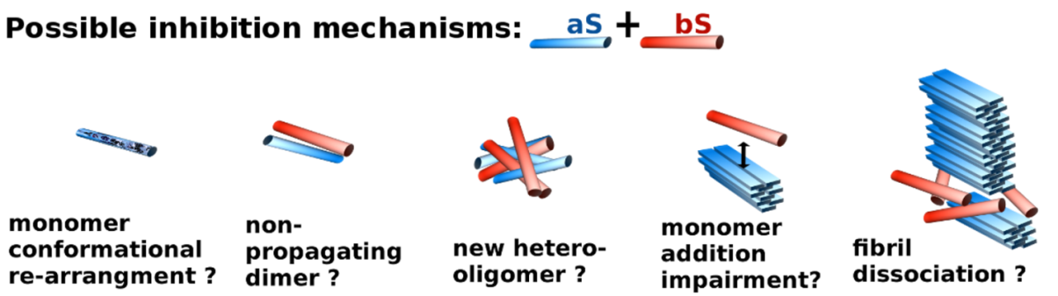

Studies of the inhibitors of aS revealed interactions of inhibitors such as phthalocyanine tetrasulfate (PcTs) with residues 3-9, 35-41 and its homolog phthalocyanine tetrasulfate-copper (II) complex PcTS-Cu2+ was interacting with residues 3-18, 38-51. Similarly beta-wrappin protein containing aS fragment encompassing residues 37-54 of aS was able to inhibit aggregation of aS at the multiple time points of the aggregation. Library of the peptides based on residues 45-54 was developed, and they were able to obtain the seqeunce which was inhibiting aS aggregation in ratio 1:1 (peptide:aS). Different inhibitors of aS (EGCG, dopamine and some designed peptides) were suggested to interact not with N-terminus but with C-terminus. Also peptides generated from fragments of aS NAC region, which is found in the core of the fibril (68-72 and 77-82), were shown to inhibit aS aggregation. Similarly to aS based peptides sequence of the bS was fragmented in search of the suitable inhibitor. It turned out that peptides made of residues 1-15 and 36-46 of bSyn interacted with aSyn and inhibited its aggregations decreased aS amyloid formation and oligomerization of aSyn. Interactions between the peptides from bSyn and the aSyn are confirmed by NMR. Peptide 36-46 of bSyn was able to recover the behavioral abnormalities of the Drosophila flies expressing aSyn A53T. 191 These facts suggests that there are specific regions in aS that are responsible for the aggregation, and targeting these fragments, is a valid and important strategy to drug development.

### Seeding and cross-seeding in neurodegenerative diseases

In the conformational disorder diseases such as: PD, AD, Huntington, fromtoteporal lobal degeneration, amyotrophic lateral sclerosis are diseases associated with the misfolding of the proteins and theirs accumulation in the nervous system. Interestingly, the misfolded nature of the diseases can be transmitted into thus far non-affected proteins in the prion-like manner, meaning that the cells and even areas in brain that were not unaffected before, by spreading of the misfolded protein can be infected by the misfolded proteins inducing accumulation of the misfolded proteins. It is postulated that the disease is being spread by misfolded species of proteins mostly oligomers, as they are able not only to induce disease, but also induce toxicity in the cells, which can be important factor in the progression of the neurodegenerative diseases.

One of the concepts emerging from studying many neurodegenerative diseases is idea of cross-seeding between the species in the diseases such as AD, PD, and Huntington disease. The main idea of this concept states that protein involved in these neurodegenerative diseases can induce aggregation of the proteins involved in different neurodegenerative disorder. For example aS involved in PD, can cross-seed tau involved in Huntington disease and Abeta involved in AD. Literature suggests that such events contribute to increased toxicity and more pronounced symptoms of disease.192-194 The mechanism of the cross-seeding is unknown, it thought that similarity between the sequences may induce the seeding effects, and that the beta sheet secondary structure of the seed may be important in inducing misfolding on the other chain. It is interesting in light of the inability of bsyn cannot be seeded with the aSyn fibril seeds, measured by concentration of soluble fraction195. bS is highly similar to aS, which suggests that bS on its own does not have tendencies to exist in the beta sheet structure. Furthermore, first 15 residues of bSyn have ability to protect cells (chick embryonic cortical neurons) against Abeta toxicity and oxidation stress, in contrast aS oligomers can induce seeding in the Abeta toxicity, and Abeta fibrils can cross-seed aS.196,197 Similarly in case of tau, coincubation of aS with tau induces increased aggregation while co-incubation of tau with bS or aS with deletion of the NAC residues 71-82 did not, which suggest that the formation of the beta-sheet structure is very important in seeding event.198 Described in this paragraph data suggest that bS has very different oligomerization properties and in unable to form conformation that can be propagates even when prompted with seeding.

# Chapter 2. Methods

In this chapter I will describe experimental methods used in my research. Procedures include: (2.1)Protein preparation (mutagenesis, protein expression and purification, spin labeling), experimentation procedures including sample preparation to the different techniques used, experimental design and methods such as Nuclear Magnetic Resonance (NMR), circular dichroism (CD), dynamic light scattering (DLS), SDS-page gel, native gel, chromatography (size exclusion column (SEC)), Electrospray ionization mass spectrometry (ESI-MS), aggregation assays (Thioflavin T (ThT)), TEM (tomography electron microscopy), 2.2 detailed description of the PRE experiments procedure. (2.3) Biological methods and procedures include cell culture maintenance, toxicity assay, immunostaining and visualization with fluorescent microscope. (2.5) Analysis and computational methods.

## 2.1. Expression, purification and biophysical methods.

### 2.1.1. Mutagenesis, expression and purification

Mutants of αS and βS, were prepared by site-directed mutagenesis using AccuPrime pfx from Invitrogen. To obtain N-terminal acetylated forms of proteins co-expression with NatB plasmid cloning N-Acetylotransferase B was performed, αS described previously for αS, same approach was used for βS.199 Protein purification was performed according to the previous protocols.200

### 2.1.2. NMR experiments

#### 2.1.2.1. PRE experiments/controls

For all PRE experiments we used following buffer: 10mM MES, pH 6, without salt addition and with 10% D2O required for NMR experiments. Αs we shown before charged residues have effect on formation of the transient complexes, so according to our previous finding we decided not to use salt.55 Samples were prepared αS follow: lyophilized samples of 14N-MTSL-cysteine mutants or 15N non-modified proteins (αS or βS) were separately dissolved. First, samples were passed through 100kDa filter to remove higher order oligomers, then they were concentrated using 3kDa filters to be able to dilute sample to final concentration of 250uM of each protein. Usage of this relatively low concentration of the spin-label sample was chosen to minimize the non-specific interactions. Final sample volume was 350uL, which is volume of the Shigemi tube in which experiments were performed. Total sample concentration used was 500uM, where 250uM was non-modified 15N protein and the other 250 was 14N-MTSL labeled, cysteine mutant. We mixed non-modified 15N-αS with αS-cysteine and βS cysteine mutants, similarly we mixed non-modified 15N βS with αS-cysteine and βS-cysteine mutants, and thus detection was on non-modified proteins. Diamagnetic samples were prepared by reducing samples with 10x excess of Ascorbic Acid and later 5x buffer exchange using 3kDa cutoff filters from Millipore Inc. Changes in the samples concentration did not have significant effect on the changes in diamagnetic control. All the controls have similar pattern and are in range of the experimental error (data not shown).

All 1H-R2 of paramagnetic and diamagnetic (reduced) sample were acquired on 600 Varian at 15 °C using previously published pulse sequence and protocols.55,201,202 Inter-chain paramagnetic relaxation enhancement rate (PRE rate – Γ2) is residues specific difference of the 1H-R2 of paramagnetic and diamagnetic samples. Increased 1H-R2 relaxation rates on the 15N visible chain indicates that the NMR blind 14N-MTSL labeled protein is in the proximity of specific residues in the NMR 15N labeled visible chain. Para- and diamagnetic 1H-R2 were analyzed and processed using nmrpipe203 and sparky.204 For all experiments 10 relaxation delays were used: 12, 32, 104, 12, 124, 64, 48, 94, 64, 20 ms. Two data points (12 ms, 64 ms) were repeated in the experiment for obtaining good statistics for the error analysis. Errors of Γ2 were calculated using error propagation, errors were below 2 Hz. PRE experiments in the concentration used did not give rise to high background PRE values.

#### 2.1.2.2. NMR PRE titration experiments.

For PRE titration experiments we used protocol described before.205,206 After measuring spin label sample concentration we concentrated it to low volume > 32 uL and we were adding sample to the 350uL of 250uM 15N sample of either αS or βS; the changes in the sample volume were less that 10% of the overall sample volume. We made following ratio of the 14N-spin labeled samples to 15N NMR visible samples for αS titration: 0, 0.25, 0.5, 0.75, 1, 1.5, in case of βS we went up to ratio 2. αS in this ratio exhibited shifts in the HSQC spectra, thus we removed this point from the analysis. We run 6 data points ranging from 12-125 msec with first point repeated twice for statistics. The PRE profiles for titration did not show significant contributions to the PRE values from the non-interactive regions.

**PRE titration fitting and analysis.** Increase in the 1HN Γ2app values due to paramagnetic relaxation enhancement, was fitted using equation:

, where *x* is the concentration of 14N-αS (T44C-MTSL) in solution, Γ2free – represents paramagnetic relaxation enhancement for unbound protein, and which values should be close to 0, and Γ2bound represents maximum saturation value. Fitting scheme was based on work of laboratiories of Bax206 and Clore205 The χ-squared statistic measuring the difference between the observed and predicted increase in 1H-R2 for residues whose 5th titration point exhibited PRE values higher that 15 Hz was optimized using the R statistics package minpack.lm, via Levenberg-Marquardt algorithm.207 The resulting fit was robust to small changes in Γ2free, KD, and Γ2bound and provided us with strengths of the interactions at the specific sites for αS/αS and αS/βS complexes (SI.table 1&2). Saturation of the titration profiles can be reached at high concentration of ligand, however usage of high concentrations of MTSL labeled samples causes artifacts arising from solvent-PRE effects208. To minimize artifacts we perform experiments at low ligand concentration, and to estimate *Kd* we use nonlinear regression model with three parameters Γ2,free, Γ2bound and *Kd*.

We also fit the *Kd* values by modifying conventional equation for fitting chemical shifts changes to obtain  *Kd*. We used following equation:

Where [P] is total concentration of 15N labeled protein, [L] is variable ligand concentration 14N-MTSL labeled protein, Γ2,maxis maximum PRE value that can be obtained in the experiment, and Γ20 is the baseline PRE value, which was set to 0.5Hz when plotting. In general the *Kd* calculated with this methods are lower, so they overestimate binding for both homo- and hetero-complexes. However both methods results *Kd* values show that the αS/βS hetero-complex exhibit stronger binding than αS/αS homo-complexes.

#### 2.1.2.3. NMR assignments

Assignments on βS and Ac- αS were performed using protocol described elsewhere.200 Experiments were performed on 350uM 15N and 13C labeled sample with 10%D2O in 10mM MES buffer pH 6 with 100mM NaCl. Secondary structure propensities were extracted using SSP program by Julie Forman-Kay.209 If the values are positive then this region has helical propensities, if the values are negative then the beta-sheet propensities are more pronounced.

#### 2.1.2.4. RDC experiments

For aligning medium we used C8E5-octanol bicelle aligning medium in 100mM NaCl, 10mM MES buffer pH 6. (Ruckert and Otting 2000). Reagents: C8E5 and 1-octanol are purchased from Sigma. The quadrupolar deuterium splitting constants are measured prior to experiment to ensure correct medium obtained. Sample was prepared by dissolving lyophilized protein in buffer and passed through 100 kD and 3kD filters. Concentration of the protein was adjusted to 250 µM. Media splitting was added to final volume 5%. High resolution HSQC_IPAP spectra in the absence or in the presence of an alignment medium were collected. (Ottiger, Delaglioet al. 1998).

#### 2.1.2.5. NMR relaxation experiments.

All NMR 15N backbone relaxation data were recorded on Varian 600 MHz using pulse sequences including longitudinal relation rate R1 (Farrow, Muhandiram et al. 1994), transverse relaxation rates R2CPMG (Farrow, Muhandiram et al. 1994). Dr. Seho Kim modified pulse sequences for R1 and R2 by adding steady state pulse at the beginning of the pulse sequence, to avoid the increase in the relaxation rates due to the protein solvent exchange. Individual FIDs were then processed by NMRPipe (Delaglio, Grzesiek et al.1995) and was analyzed by Sparky using a single exponential decaying function plugged in (Goddard and Kneller). The detailed fitting methods are described by Farrow et al.(Farrow, Muhandiram et al. 1994).

### 2.1.3. Thioflavin T (ThT).

ThT assay is an assay to monitor formation of cross-beta structure, which is secondary structure found in fibril. 5-10 mg of lyophilized acetylated form of αS and βS was dissolved in Phosphate Buffer Saline, centrifuged for 10 min in 14000 rpm to remove big oligomers, and purified using size exclusion chromatography (Superdex 75 GL 10/300, from GE Healthcare Life Sciences), later protein was concentrated using 3kDa centrifugal units (Millipore Inc). Experiment set up was used αS previously described.200

### 2.1.4. Electrospray ionization mass spectroscopy (ESI-MS).

ESI-MS experiments were performed αS described previously.210 Samples were prepared in 10mM Ammonium Acetate, pH 6 in final concentration 50uM, by using 100 kDa and 3kDa filters.

### 2.1.5. Dynamic light scattering (DLS).

DLS measurements were carried out using a Zetasizer Nano ZS (Malvern Instruments, UK). Data was collected using a 3 mW He-Ne laser light at a 633 nm wavelength back scattered light at an angle of 173°. Autocorrelation functions were determined from 6 correlation functions, with an acquisition time of 10 s per correlation function. Sample concentration was 200uM.

### 2.1.6. Negative straining TEM.

Fibrils were visualized using a JEM-100CXII manufactured by JEOL in electron imaging facility with assistance of Dr. Valentin Starovoytov. Negative staining TEM was performed using single droplet procedure211 at ambient temperature. Micrographs were recorded at a magnification of 100,000. All of the chemicals are purchased from Sigma.

## Paramagnetic relaxation enhancement (PRE) experiments

### Paper citation information.

Paper presents detailed description of the PRE methods, that was widely used in the research performed, as well as provides insight on many methods of the labeling and concerns that were considered while performing experiments. Paper was prepared for Methods in Molecular Biology volume on methods for the study of protein aggregation and amyloid formation. Citation information:

### PRE experiment description

Many devastating neurodegenerative diseases are associated with proteins that convert from their normal soluble forms to amyloid fibrils that accumulate in the brain, and the mechanism by which this occurs remains poorly understood. It is critically important to characterize the species formed during the very early stages of aggregation, as increasing evidence suggests that small protein oligomers may be more toxic than the final fibrillar aggregates. Atomic characterization of domain-domain interactions or inter-chain interactions at the earliest times is therefore key to understanding the structural transformation from monomer to fibril. Describing the dimer encounter complex is extremely challenging as these self-associated species are transient and exist at very low populations. In addition, proteins involved in neurodegenerative disease are often intrinsically disordered proteins (IDPs) such as α-synuclein, the primary protein in the Lewy bodies of patients with Parkinson’s, or Aβ, the main component of amyloid plaques in Alzheimer’s disease.

Inter-chain NMR paramagnetic relaxation enhancement (PRE) experiments allow the direct visualization and characterization of lowly populated transient encounter complexes in IDPs and establish the nature of the inter-chain interactions that may be present in the self-assembly process. 1H inter-chain NMR PRE experiments are performed by making 1:1 mixtures of 15N labeled protein and 14N paramagnetic singly spin labeled protein and detecting broadened resonances on the 15N labeled NMR visible sample that arise from the paramagnetic spin label on the 14N chain. This experiment limits observation of PREs to inter-chain interactions only as the 14N protein that contains the paramagnetic spin label is NMR blind, thereby making detection of intra-chain PREs impossible. The observed inter-chain transverse PRE rate on the 15N labeled sample arises from the interaction of the paramagnetic center and the nucleus of interest, is proportional to <r-6>, and can provide distance information up to approximately 25Ǻ with an MTSL spin label. Detection is very sensitive to lowly populated states and the transient dimer interactions can be detected under equilibrium monomer conditions established in the 1:1 15N labeled and paramagnetic spin labeled protein. The protocol for performing the inter-chain PRE experiments consists of six stages, including: (a) preparation of NMR 15N labeled protein, (b) preparation of 14N protein with single cysteine mutants, (c) preparation of paramagnetic NMR sample, (d) preparation of diamagnetic sample, (e) experimental acquisition, and (f) data analysis (Figure 1).

Figure. Procedure and basic theoretical principle behind the inter-chain paramagnetic relaxation enhancement experiments.

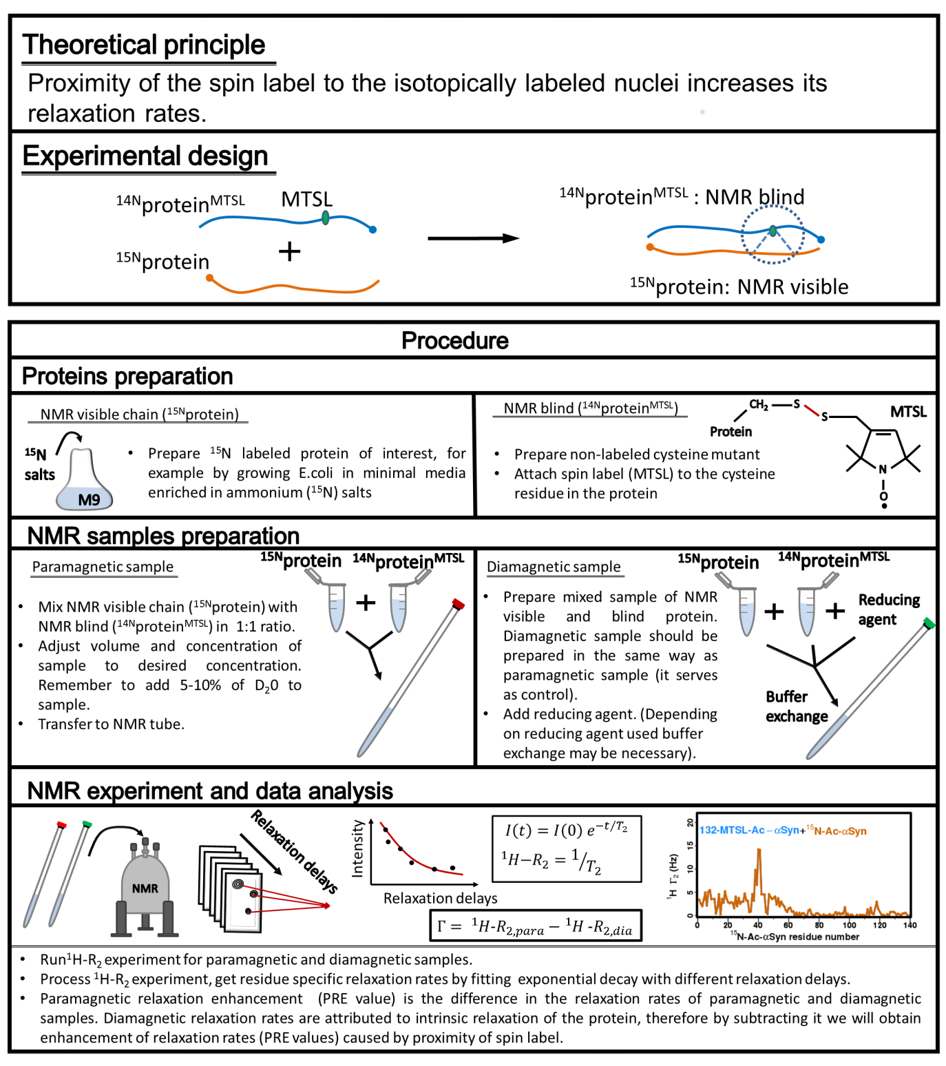

### Materials

All solutions should be prepared using ultrapure water (prepared by purifying deionized water purifier with sensitivity of 18 MΩcm). Filter all the solutions through a 22 μm filter. All the buffers that will be used for HPLC/FPLC have to be filtered and degassed. Follow closely all the regulations for waste disposal.

Equipment: NMR spectrometer (field suitable for 2D experiments); FPLC or HPLC; desalting column; NMR tubes; protein preparation set-up; buffer exchange set-up.

**Protein labeling scheme and purification components.**

1. 15N labeled protein (NMR visible chain). Grow cells, expressing protein of interest in M9 minimal media with addition of 15N ammonium salt to ensure uniform 15N labeling. Follow standard purification procedure for the protein of interest.
2. Unlabeled (14N, NMR blind) – cysteine mutant. Grow single cysteine mutant in Luria Broth (LB) medium. Follow standard purification procedure for the protein of interest (*see* **Notes 1-3**).

**Spin labeling of cysteine mutants.**

1. Unlabeled (14N, NMR blind) – cysteine mutant. Prepared as in point 2.1.2
2. Spin label. The most widely used spin label is MTSL (S-(1-oxyl-2,2,5,5-tetramethyl-2,5-dihydro-1H-pyrrol-3-yl)methyl methanesulfonothioate). The protocol described here assumes that MTSL will be used, but there are also different spin labels that can be used (*see* **Note 4**).
3. Acetone.
4. Standard buffers pH >7, (suggested buffers: PBS pH 7.4, Tris pH 7.7).
5. Reducing agent: dithiothreitol (DTT). Prepare stock of 1M DTT in water, filter through 22 μM filters. 1M DTT stock can be stored at -20°C (stable for ~1year).

**Paramagnetic sample preparation.**

1. Protein (as described above) solution in the desired buffer, with 10% D2O in the final volume for NMR experiments (*see* **Notes 5-6**).

**Diamagnetic sample preparation.**

1. Use the same sample as the paramagnetic sample with the addition of a reducing agent, for example: dithiothreitol (DTT), β-mercaptoethanol (BME), ascorbate acid or sodium ascorbate (*see* **Note 7**).

### Methods

**Spin labeled protein preparation (MTSL-14N labeled cysteine mutant).**

1. Dissolve 5-10 mg of 14N labeled single cysteine mutant in buffer with pH higher than 7 (suggested buffers: PBS pH 7.4, Tris pH 7.7).
2. Add 20 times molar ratio of DTT to solution.
3. Incubate for 4-6 hours in the cold room to remove cysteine disulfide bonds.
4. Inject sample into desalting column according to the manufacturer’s specifications. Our laboratory uses GE™ Healthcare HiPrep™ 26/10, but other desalting columns can be used (*see* **Note 8**).
5. Immediately add 5 x excess of freshly prepared MTSL spin label solution (10 mg of MTSL in 400 uL of acetone).
6. Incubate in the dark overnight (4°C) on a shaking platform; the sample is light sensitive.
7. Remove excess spin label either by dialysis or buffer exchange (*see* **Note 9**).
8. Lyophilize the protein or concentrate it for immediate NMR sample preparation.

**Paramagnetic sample preparation.**

1. Mix 15N labeled protein with 14N MTSL labeled protein in a 1:1 ratio to the desired final concentration. Buffer should contain 10% D2O for NMR experiments. NMR experiments require sample concentrations of at least 0.1 mM for a small, unfolded protein. There are also upper limits to the concentration for the inter-chain PRE experiments (*see* **Note 6**).

**Diamagnetic sample preparation.**

1. Reduce the paramagnetic samples with 10 x excess of chosen reducing agent. Depending on the selection of reducing agent the sample may require buffer exchange (*see* **Note 7**).

**NMR experiment acquisition - 1H-R2 experiments of para- and diamagnetic samples.**

1. Two identical experiments will be performed, one with the paramagnetic sample and the second with the diamagnetic sample.
2. Contributions of the PRE effect to the relaxation rates are measured by detecting line broadening on the 15N labeled NMR visible chain via standard 1HN transverse relaxation experiments (1H-R2) *(1)*. 1HN transverse relaxation experiments require acquisition of spectra with multiple time points (relaxation delays). eq. (1). For unfolded proteins optimal relaxation delay times are from 10 ms to at least 160ms. T2 is obtained by fitting data obtained at multiple relaxation delays to eq. 1.

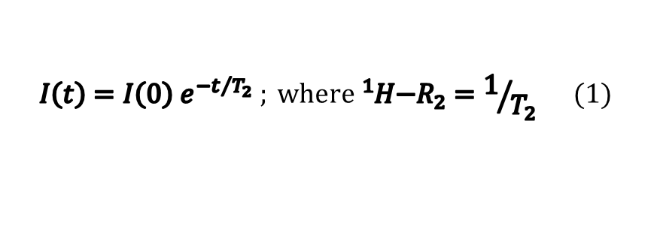

For the calculation of error we measure duplicate time points (at least two) and use a standard error propagation routine.

**PRE data analysis – obtaining paramagnetic relaxation enhancement rates (PRE rates, Γ).**

1. Analyze the relaxation experiments using a standard processing procedure for relaxation experiments to obtain paramagnetic and diamagnetic relaxation rates (1H-R2, para and 1H-R2,dia). Diamagnetic relaxation rates (1H-R2,dia) are attributed to the intrinsic relaxation of the nuclei, while the paramagnetic relaxation rates (1H-R2,para) are the sums of the intrinsic relaxation rates and the enhancement of relaxation caused by the proximity of the spin label. Thus, the paramagnetic relaxation enhancement rate (PRE rate - Γ) is the difference of the relaxation rates of the paramagnetic and diamagnetic samples (eq. 2).

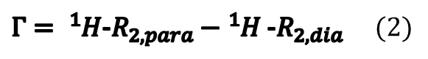

Direct correlation of PRE rates to distances is complicated due to the fact that the residue is experiencing a weighted average of all possible populations of the complex (*see* **Notes 10-11**). Due to the <r-6> dependence, the populations that have closer distances are more heavily weighted.

1. To obtain a detailed analysis of transient interactions it is necessary to incorporate spin labels at many different positions. It is suggested that spin labels be placed at approximately every 10-30 residues for intra-chain PRE experiments, and inter-chain PRE require similar or even more extensive spacing of spin labels (*see* **Note 12**).

### Notes

1. *Cysteine mutation requirements for PRE experiments.* Many of the spin labels that are used in the PRE experiments are thiol specific, which means that they interact specifically with cysteines to form disulfide bonds. For the interchain-PRE scheme to work successfully a single cysteine has to be present in the protein. Therefore site directed mutagenesis schemes may have to be applied to either remove intrinsic cysteines and/or to introduce single cysteine mutations into the protein *(2,3,4,5)*.
2. *Testing protein functionality upon mutation and spin labeling.* The PRE approach using site directed mutagenesis has many advantages, but introducing mutations and MTSL modifications could cause changes in the protein function and structure. Thus it is recommended that a functionality test be performed on the mutated and/or MTSL spin labeled proteins.
3. *Detection of distances in PRE experiments.* The positions of the spin labels should be chosen with care both to minimize the effect of the mutation on protein structure or function, as well as to optimize detection of the inter-chain PRE effect. Typically the spin label is able to enhance relaxation rates of the nuclei for distances up to approximately 25Ǻ. Trial and error may be required for optimal selection of spin label positions. We recommend starting with spin labels near the termini as well as central regions of the protein to obtain preliminary results and then fine tune around the interactive positions.
4. *Selection of the spin label*. Commonly used are cysteine specific and nitroxide derivatives (for example: MTSL, TEMPO - ((2,2,6,6-Tetramethylpiperidin-1-yl)oxy), PROXYL – (3-(2-Iodoacetamido)-2,2,5,5-tetramethyl-1-pyrrolidinyloxy)), or metal chelating groups (S-(2-pyridylthio)-cysteaminyl-EDTA, which in the paramagnetic form chelates Mn2+, and the diamagnetic form chelates Ca2+) *(6,7,8)*. We use MTSL because it is small, generally stable and the reaction is highly cysteine specific and efficient.
5. *Optimize solution conditions to obtain maximum PRE effect*. PRE experiments are able to detect lowly populated interactions, even as low as 0.5-5% *(9)*. However, for weakly interactive species in IDPs it is extremely important to optimize buffer conditions and the experimental setup. For example many of the weak and transient interactions are stabilized through electrostatic interactions, so optimizing the ionic strength of the experiment will be important. Optimization includes selection of buffer concentration and type, ionic strength, ligand, and temperature *(10,11)*.
6. *Selection of sample concentration.* Sample concentration is another important variable in inter-chain PRE experiments. For weakly associating proteins, increasing the concentration of the spin labeled protein may lead to an increase in non-specific interactions driven by diffusion. We recommend using a low concentration of spin labeled sample on the order of 0.5 mM or less to avoid collisional non-specific interactions *(6)*. We mix 0.25 mM NMR visible chain with 0.25 mM NMR blind-spin labeled chain to be able to detect PRE and avoid non-specific interactions arising from collisional diffusion.
7. *Selection of paramagnetic sample reducing agent.* There are many reducing agents that can be used to reduce the paramagnetic form of the spin label to the diamagnetic form. Options include β-mercaptoethanol (BME), dithiothreitol (DTT), and ascorbate ions (either as ascorbic acid or sodium ascorbate). BME and DTT break disulfide bonds and thus they are able to cleave the MTSL spin label attached to the cysteine. Ascorbate reduces the nitroxides to hydroxylamine with no cleavage of the MTSL *(12)*. Another option is to obtain the diamagnetic analogue of MTSL, MTS (1-Acetyl-2,2,5,5-tetramethyl-3-pyrroline-3-methyl)-methanethiosulfonate), and attach this compound to the cysteine using the protocol described above. The drawbacks of BME and DTT are that elimination of the spin label results in different para- and diamagnetic samples. Additionally, DTT is pH sensitive and the reaction needs to be performed at pH higher than 7. We recommend using ascorbate ions to obtain the diamagnetic form of the protein as the MTSL spin label will remain and the paramagnetic and diamagnetic samples will thus be more identical. Care needs to be taken as ascorbic acid changes the pH of the sample (pH changes vary depending on the buffer), while sodium ascorbate changes the ionic strength of the sample (by ~ 5mM). In order to readjust the pH or ionic strength buffer exchange may be necessary. Buffer exchange may change the sample concentration and para- and diamagnetic sample concentrations may not be identical.
8. *Preparation of the spin labeled sample –usage of desalting column.* To prepare for the paramagnetic spin labeling reaction there are two important steps. 1) First all disulfide bonds that may have been formed between the cysteine containing monomers need to be removed. This is achieved by incubating the sample with the reducing agent DTT for a few hours. 2) Second, after the reduction of disulfide bonds it is critical that all DTT be removed from solution before the spin label reaction is performed. Thus, for fast and complete removal of DTT from the protein solution a desalting column should be used. The spin labeling reaction will not work in the presence of DTT (see note 7 for preparation of diamagnetic sample), and there is a danger that the reaction will not go to 100% completion and the reaction product will be diamagnetic, not paramagnetic as desired.
9. *Completion of spin labeling reaction.* To test if the MTSL spin labeling is complete MALDI spectra of the sample can be acquired. Incomplete spin labeling, even at small percentages, will diminish the PRE values *(13)*.
10. *Comparison of 1H-R2 values of diamagnetic sample (with reduced spin label) and non-labeled sample.* Comparison of the diamagnetic sample with the wild type unlabeled 14N sample is a further check that the diamagnetic sample has maintained its integrity and that the conformational ensemble of the diamagnetic protein is similar to the unlabeled protein as sampled by 1H-R2 values *(11)*. If there are big differences in the 1H-R2 values of the diamagnetic sample and the non-spin labeled control, it could mean that the sample is degrading or aggregating and should not be used.
11. *Interpretation of the PRE rates - protein and spin label flexibility.* Issues regarding the flexibility of spin labels and the effect on the PRE rates are thoroughly described in a highly recommended review by Iwahara and Clore *(6)*. If the protein belongs to the class of IDPs, or if the protein exists in more than one form, then the PRE rates are weighted averages over the interactions. PRE distances scale between the unpaired electron and the nucleus as <r-6> and thus the fragments that have shorter distances will dominate the PRE rates.
12. *Spin label sampling for mapping of hetero-interactions.* To obtain a good sampling of protein contacts it is important to have an appropriate number of spin labels across the protein. Papers describing the density of spin labels for intra-chain PRE experiments suggest placing a spin label every 10-30 residues *(14,15,16,17,18)*. For inter-chain PRE experiments we suggest at least the same spacing of spin labels per chain.

## Biological methods

All the biological experiments were performed in laboratory of Dr. M. Maral Mouradian, with assistance of Dr. Run Yan.

### Cell culture maintenance

Two strains of the Human neuroblastoma undifferentiated SH-SY5Y cells were used in the research: native and stable transfected with aS. For the maintenance of the culture 10% Fetal Serum Bovine (Life Sciences) with 90% of Dulbecco’s modifies Eagle’s medium (DMEM) with L-Glutamine, sodium pervade and L-glucose (4.5 g/L) (Sigma or Corning). Stably expression aS cells requires of aS plasmid preservation 250 μg/ml of G418 antibiotic in the final culture (Sigma). Cells were maintained in the tissue-culture plates from Sigma or Corning, in 37°C in incubator which maintained CO2 at the level of 5%. Cells were grown until 70-80% confluence between each pass. For stably expressing aS cells, cells after pass should not be in the concentration lower than 15% as they would not recover, since aS expressing cells are more vulnerable. Pass of the cells were performed in the sterile conditions ensured by: (a) turning on UV lamp in the hood at least for 5 min before the usage, (b) turning on the blower in the hood (2 min) before the work, (c) careful sterilization of the work area and any of the items that were placed in the hood with 70% ethanol. Procedure for the cell pass (sub-culturing):

1. Solutions used in the cell sub-culturing have to be wormed up to 37°C.
2. Prepare new plate to which cells will be transferred. Label with care with the date, cell line name, dilution from the previous plate, and all the additional information that will be necessary in the experiment. If different procentage of the FBS was used that also needs to be noted.
3. Concentration of the cells on the plate is 70-80% as checked by the optical microscopy.
4. Removal of the medium using vacuum device in the hood.
5. Washing cells with 10 ml of PBS. (5 sec)
6. Addition of 1ml of 0.05% trypsin-EDTA solution, for 1 min or until the cells will start to dis-attach from the plate (it looks like big chunks of the cells were flowing on the plate). It might be helpful to tap the plate few times to help them to dis-attach.
7. Add 9 ml of the 10% FBS+DMEM medium to final volume 10 ml, to stop trypsin reaction. By pipetting media up and down remove clusters of the cells so the cells that will be transferred to new plate will not be growing in clumps but can be separated.
8. Transfer the cells to the new plate. Eukaryotic cells usually divide every ~24h, so plan experiment accordingly. Usually cells should not be split in ratio higher that 1:20.
9. Monitor cell under the microscope, they should be round and singular not in clumps.

### Cell toxicity assay – LDH assay.

LDH assay is commercially available calorimetric assay which measures amount of the released lactate dehydrogenase which is cytosolic enzyme which concentration is indicative of toxicity. I used Kits from Roche and Pierce. Cell toxicity assay was used to check effect of different protein variants, and oligomeric species on the cell lines.

Protocol:

1. Sub-culture the cells into 96 well plate. At the time of starting treatment cells needs to be 40-60% of the area. Make suitable calculation; take into account reduced surface on which cells will be grown. Media for growth DMEM +10% FBS. Cells need to be sub-cultured on the plate at least 12h before the treatment, to ensure theirs recovery.
2. Few hours before the treatment (2-16h) incubate cells in DMEM without any FBS added (100uL) to ensure that all the cells will be synchronized in the cell cycle. Incubating with DMEM has also advantage of keeping cells at the desired density.
3. Add 100uL of the DMEM +2% FBS to the cells, final concentration of the FBS is 1%, it could be even lower for the short treatments. FBS is generating the reading using LDH assay, thus too high concentration of the FBS is not recommended.
   * Note:Multiple washing removes the cells from the plate and changes theirs morphology. They are not healthy, so number of washing should be reduced to minimum. That is the reason why I add 100uM of DMEM to the cells without removing solution first.
4. Add treatment to the cells. Treatment in my case meant different species of aS or bS, but in general it could be anything: proteins, inhibitors, chemical compounds. Concentration of the treatment should be adjusted by performing concentration dependent assay. In my case I was varying concentration from the nM to uM range for the oligomers. Each of the samples will need to be repeated at least 4 times for statistic.
5. Controls that will need to be included in the assay: background control: buffer, negative control: untreated cells, positive control, cells which are releasing 100% LDH, that is either treated with 10% triton or with lysis buffer used on the cells. I used triton methods, but I was not satisfied with results so I will start using lysis method.
6. Incubate plate for desired amount of time. Monitor cells for the signs of changes in the morphology. I was using times from 24-72h of incubation.
7. Prepare the solution according to the manufacturer protocol. Protocols will vary depending which LDH kit is used.
8. Transfer 50 uL of the media from cells to the new plate and add LDH assay mix.
9. Start time measurement (15-20C). Maximum time that can be used is 30 min. Protect from light. Stop solution can be used if necessary (I did not use it).
10. Get the reading at the wavelength excitation 490 nm. It is recommended to obtain the readings at the multiple time points.
11. Calculate the cell toxicity according to provided equations from the protocol.

### Immuno-staining and cell imaging

Preparation of the coverslips

1. Cells for the imaging need to grow on the coverslips. To prepare coverslips incubate them at least overnight in 1% collagen in 37C. Coverslips have to be covered with collagen, they cannot float on the surface. Using forceps place them on the bottom of the plate.
2. Remove collagen from the plate. Dry the coverslips. If the coverslips attach to the bottom of the plate add some PBS to facilitate theirs removal.

Cells considerations

1. For the treatment there will be used 2 coverslips per experiments, as one coverslip with be treated with 1% triton in PFA to extract soluble fractions from the cells, other coverslip will be without extractions.
2. Controls. Cell without any treatment will have to be also used (extracted and non-extracted). Cells treated with monomers are also correct controls in my case.
3. Native cells vs. cells stably expressing aS. It is better to get results on the native cells than on the cells stably expressing aS, as they are more reliable and uniform, but it is not possible to get results with the native cells cells stably expressing aS are available for use.
4. As the treatment here is long the cells at the start of the treatment should be at density of 25%.
5. Before starting the treatment cells should be given time to recover after subculturing. At least 12 h should be given to the cells to recover, but more time is better.
6. Transfer the cells to the smaller plate before starting treatment.

Fixing and staining

Necessary materials

* 4% PFA in 4°C refrigerator
* PBS
* 0.5% triton in PBS
* 1% of triton in PFA
* Stock 100% donkey serum in restriction enzyme stored in refrigerator
* 1’ Antibody (flag 1:300/myc 1:1000)
* 12’ antibody in donkey serum
* 0.01% ThioS. (10mg in 10g, and then dilute 10x )
* DAPI

Note: Caution needs to be applied when using preparing solution of triton, as it is highly viscous. It is helpful to cut the end of the tip and then pipette triton in. Also while putting into the solution it needs to be pipetted in an out multiple times.

Protocol

1. Wash cells with PBS.
2. Stain with 0.01% ThioS for 8 min.
3. Wash with PBS
4. Choose cells which will be non- and extracted.
   1. Extraction cells: Add 500uL if 4% PFA +1% triton.
   2. Normal cells: Add 500uL if 4% PFA.
   3. Incubate both samples in 37C for 13 min. From now on cells will be done in the same way.
5. Wash with PBS 10s.
6. Permeabilize with 500uL (or 250uL)of 0.5% triton x100 in PBS. Incubate for 10 min in 37C.
7. Block with 350 uL of 5% Donkey Serum 37C, 20 min.
8. Add 1’ antibody 350uL, cover with foil, incubate in 4C overnight.

NOTE: Collect Antibody to reuse it!

1. Wash with 500 ul PBS 3x, 5 min. Ambient temperature.
2. Add 350uL of 2’ Antibody (1:1000) cover with foil incubate in 4C for 1h.
3. Wash with 500 ul PBS 3x, 5 min. Ambient temperature.
4. Add DAPI 1.5uL +1 ml of PBS, 1.5 min in Ambient temperature
5. Now can work on the bench.
6. Mount the coverslips onto the glass. Cells should face the inside of the glass. Add 5-10uL of the mounting buffer (depending on how much time I have for drying).
7. Add dried coverslip on the top with cells facing the mounting buffer. Remove bubbles carefully, by pressing with forceps on the glass. Don’t press to hard.
8. Dry in the cold room, until coverslips are not moving anymore.

Comments:

* At the step with PFA cells with disattach. Be very gentle at all steps to avoid disturbance of the cells and to have something to look at.
* Keep the cells in the PBS if removed solution so they do not dry out.
* ThioS is giving strong and sometimes non-specific signal that is why we perform this step as first, so there are multiple washing before the imaging.

Imaging

1. Turn on UV lamp in the microscope at least 20 min before usage of the microscope.
2. Turn microscope on.
3. Check if the objective lens is clean. Wash it using specific washing solution.
4. Wash coverslips using ethanol and kim wipes.
5. Turn on imaging program AxioVisionRels4.7
6. Turn on multidimensional acquisition. We will be using channels for the DAPI (blue), aS (Red) and ThioS (green).
7. Go to settings on the top channel: pick objective 63x. Activate selection. Objective 63x is oil objective. Read the labels on the objective to make sure that you picked correct objective.
8. Turn on laser light.
9. Switch the colors of the laser using screw below the objective.
10. Apply drop oil on top of the oil objective.
11. Secure the sample on the racks on top of the objective.
12. Start moving the objective up and touch the sample with the drop of oil on the top of the objective. Be careful not to rise sample. Observe the samples on the DAPI channel. If you are in the correct axis the picture will look sharp, then you know you are in plane of the sample.
13. Start acquisition. For the ThioS and aS channels gain should be the same in the all samples. It is better to use the gain that is slightly to low, as the higher gain is not giving the information about the intensity of the color, as all the colors are saturated.
14. Save the pictures you applied.
15. To clean up:
    1. Turn off the light
    2. Wash oil of the objective – carefully to avoid lens damage.
    3. Put objective in low position.
    4. Switch objective to no objective position
    5. Turn off microscope.
    6. Turn off UV lamp.

# Chapter 3. Comparison of acetylated and non-acetylated bS

Recent article by Bartels et al. re-discovered N-terminal acetylation in aSyn in vivo. Similarly to aSyn, bSyn is also acetylated212, but all biophysical experiments were performed on non-acetylated form of the protein213-215. Our preliminary data on the acetylated bSyn are showing formation of the transient helix in the first 11 residues of the bSyn existing for 20% of the time. Influence of the acetylation has also longer range effect. Acetylated has both increased of the β-sheet propensities and is more flexible in residues 44-47 and 117-125 and 128-130. It is worth noting that these fragments in the aSyn are important for the inter-chain interactions in the aSyn. Upon addition of non-labeled bSyn to the N15 labeled bSyn, HSQC intensities profile is changed. C-terminal has increased intensities and N-terminal peak intensities are less, which could signify more intermediate exchange in the N-terminal residues, and more fast exchange in the C-terminal, that could signify inter-chain interactions of bSyn. We hypothesize that the acetylation induces changes in the bSyn ensemble, which are favoring inter-chain interactions in bSyn. Our goal is to characterize the monomeric ensemble of bSyn and analyze how the acetylation affect inter-chain interactions within bSyn, and its higher order self assembly.

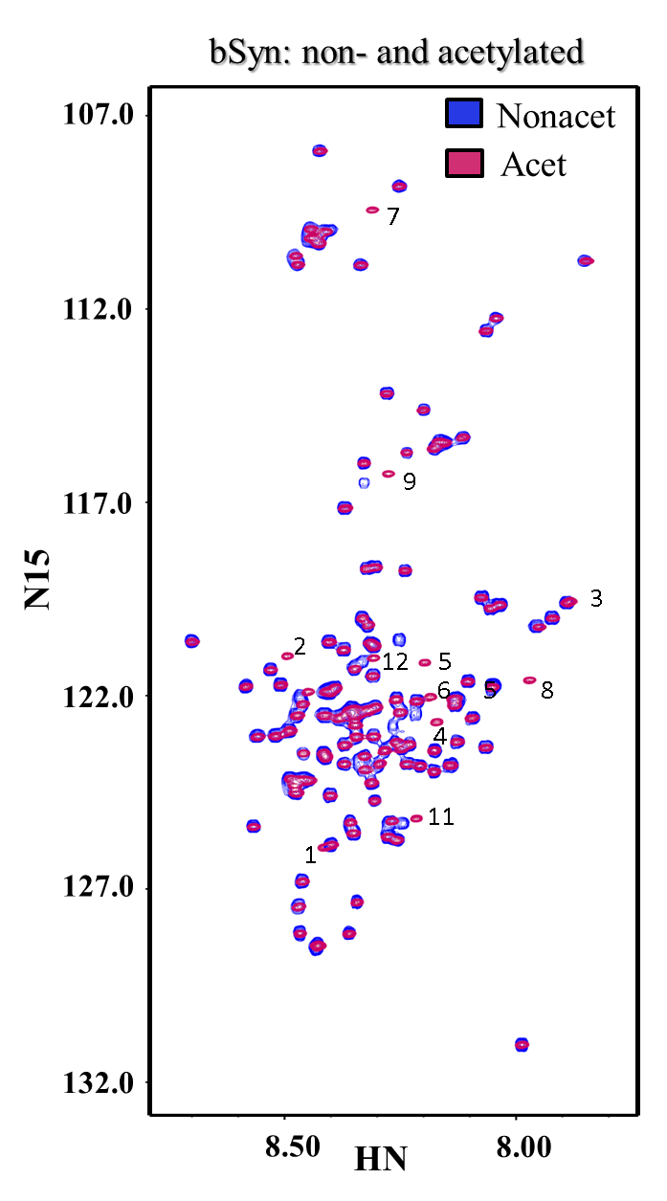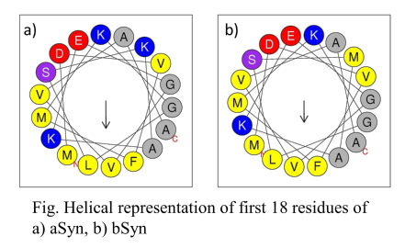More detailed description:

(For the comparison with aSyn) N-terminal helix formation encompassing first 11 residues according to the SSP, while in aSyn only 9-residues. Also on the HSQC of bSyn 12 residues are affected by the acetylation, while on the aSyn HSQC only 9 residues are affected. Helical wheel analysis shows that the Met at the residue 10 expands the hydrophobic phase of bSyn sequence, which is consistent with fact, that bSyn will exhibit slightly higher helical propensities in the beginning of the N-terminal than aSyn. (Maybe stronger binds membranes?)

In general acet-bSyn has on average no pronounced secondary structure in N-terminal and NAC, and it has β-sheet propensities in the C-terminal. It seems like there are three distinctive regions in the C-terminal: 95-101, 102-116, 116-126. N-terminal and NAC have positive and negative values without any pronounced trend. Overall the acet-bSyn, except for the initiating helix and residues 38-42, 63-68 and 115-117, has more β-sheet propensities. Long range effect on the secondary structure: decrease in the Cα chemical shifts in the N-terminal in fragment C-terminal in residues 123-130 is the most significant increase of the β-sheet propensities in the overall more β-sheet like protein. Additional regions with more β-sheet: 31-36, 44-47, 70-82, 88-93, 111-112, which could mean that the protein is even more extended/compact (?). Is it β-sheet or polyproline II? If polyproline does it inter-convert between polyproline I and II?

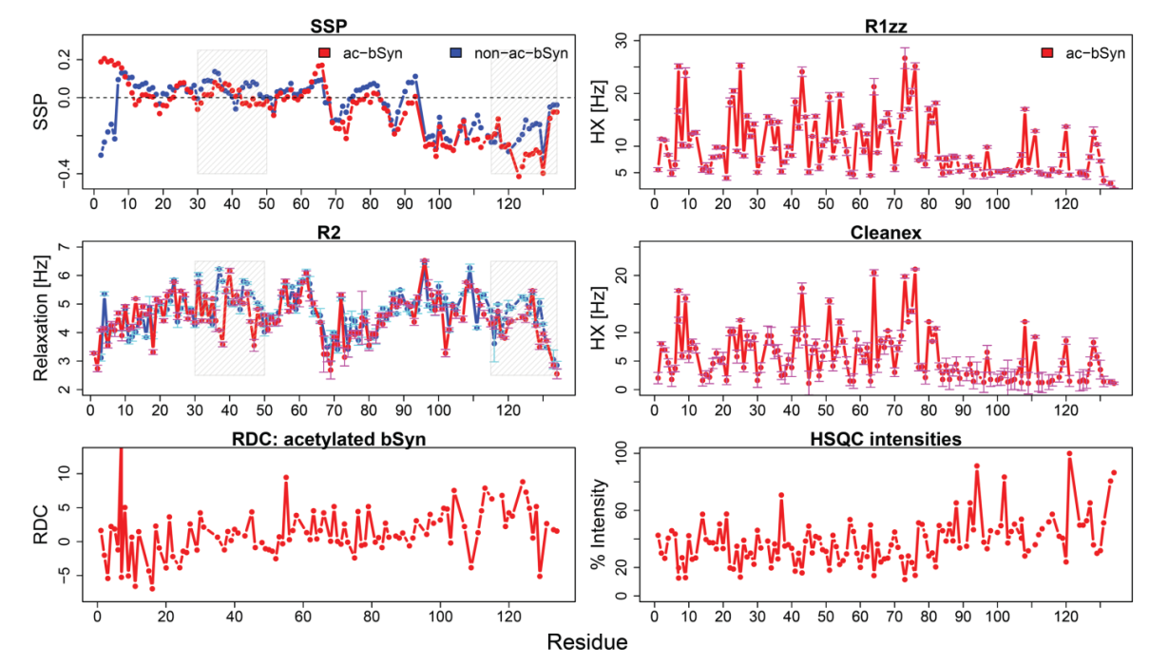Dynamics (R2): Overall the NAC seems to be more flexible than the rest of the protein, while the N- and C-terminal seems to be more rigid. There seems to be negative correlation between the rigidity and β-sheet formation in the NAC and the C-terminal. Surprisingly, acetylation- no effect on the dynamics of the N-terminal (the same with aSyn). Non-acet overall seems to be more rigid. Residues more rigid in non-acetylated: 36-38, 44-49, 66-70, 72, 75-76, 102, 104-107, 112-115, 117-125, 128-130. Stretches 44-49, 117-125, 128-130 correspond to the region with less β-sheet propensities in the non-acetylated sample. Acetylated is more rigid in the residues 10-13, and 40.

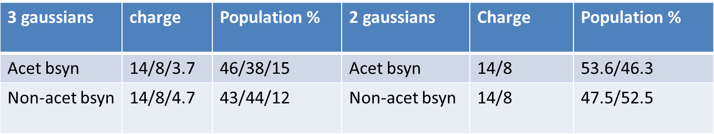RDC (Acet bSyn): First 10 residues are broadened in the aligning media. My data shows similar RDC pattern observed by Sung and Eliezer 2007. N-terminal and NAC have values close to 0, while in the C-terminal three regions with increased amplitude of the RDC values, encompassing residues: 92-107, 111-119, 120-126. There was suggestion that the bulkiness of the residues can influence the RDC values, here that is not the case. However the regions correspond somewhat to the ordered regions from the SSP values: 95-101, 102-116, 116-126, which means that in my case the RDCs are mirroring the chemical shifts values.

HSQC intensities: C-terminal has higher intensities than N-terminal. Does it mean more broadening due to the intermediate exchange in the N-terminal.

HX (cleanex, R1zz): In Acet-bSyn are clusters with high HX in the protein, and there are regions with almost no exchange. Fragments with high HX values: 2-4, 6-12, 17-20, 22-29,31-36, 39-44, 46-47, 49-56, 59-62, 64-69, 71-76, 80-82, 107-111, 118-120, 127-130. Possibly region of lower exchange in the N-terminal can act as linkers, between operating regions. HX in the RDC media is 2.5 times smaller than in the solution. But overall pattern of the HX is the same. Protein dynamics not seemed to be affected by media.

# Chapter 4. Toxic bS mutant characterization: P123H and V70M.

In this chapter I will describe my work on the two mutants of bS:V70M and P123H which are implicated to be involved in the respectively sporadic and familiar cases of the diffuse Lewy body disease. Mutations in the bS sequence renders it more toxic and affect lysosomal pathway of the cell, however it does not induce formation of the Lewy Body like inclusions. Possibly it affects its oligomerization and aggregation propensities. In this chapter I will describe my work on these mutants that provides insight on reasons for non-toxicity of bS.

## 3.1. P123H mutant

Data from this paper was submitted to ….

## 3.2. V70M mutant

V70M mutation of bS is located in the NAC region of the bS.

# Chapter 5. Dimers.

Unveiling transient protein-protein interactions that modulate inhibition of alpha-synuclein aggregation by beta-synuclein, a pre-synaptic protein that co-localizes with alpha-synuclein.

Maria K. Janowska, Kuen-Phon Wu and Jean S. Baum

Abstract

α-Synuclein (αS) pathology in Parkinson’s disease is linked to self-association of αS intrinsically disordered proteins into pathogenic oligomeric species and highly ordered amyloid fibrils. Developing effective therapeutic strategies against this debilitating disease is critical and βS, a pre-synaptic protein that co-localizes with αS, can act as an inhibitor of αS assembly. Despite the potential importance of βS as an inhibitor of αS, the nature, location and specificity of the molecular interactions between these two proteins is unknown. Here we use NMR paramagnetic relaxation enhancement experiments, to demonstrate that βS interacts directly with αS in a transient dimer complex with high specificity and weak affinity. Inhibition by βS arises from transient αS/βS heterodimer species that exist primarily in head- to- tail configurations while αS aggregation arises from a more heterogeneous and weaker range of transient interactions that include both head-to-head and head-to-tail configurations. Our results highlight that intrinsically disordered proteins can interact directly with one another at low affinity and that the transient interactions that drive inhibition versus aggregation are distinct by virtue of their plasticity and specificity.

Protein aggregation is the origin of a wide variety of human neurodegenerative diseases including Parkinson’s, Alzheimer’s, Huntington’s and Creutzfeldt-Jakob disease.216,217 Parkinson’s disease (PD), a highly debilitating illness, is the second most prevalent of the late onset neurodegenerative diseases and affects as many as 6 million people worldwide.218 Αs life expectancy continues to increase, neurodegenerative diseases like Parkinson’s are becoming increasingly common and a threat to global public health. The diagnostic hallmark of PD is a deposit called a Lewy body that is primarily composed of the pre-synaptic intrinsically disordered protein α-synuclein (αS). Fibril formation of αS is also implicated in other neurodegenerative diseases, including multiple system atrophy and dementia with Lewy bodies, referred to as synucleinopathies. Although the function of αS is not clearly defined it is thought to be involved in promoting SNARE complex assembly,219-221 in regulation of the synaptic vesicle pool,222,223 and in remodeling membranes.224,225 The origin of αS pathology in neurodegenerative disease is clearly linked to the self-association of the intrinsically disordered αS monomers into pathogenic oligomeric species and highly ordered amyloid fibrils.

One approach to developing effective therapeutic strategies against this debilitating disease is to identify inhibitors of αS aggregation. Small molecule inhibitors of αS have been proposed226-230 along with proteins that interfere with αS assembly such as heat shock proteins (Hsp40, Hsp70, Hsp90, αB-crystallin),231,232 and the intrinsically disordered β-synuclein (βS), a homologue of αS with which it co-localizes. A number of studies have established a neuroprotective role for βS.165,170,172,176,177,189,191,233,234 Masliah and co-workers have shown that βS is expressed at similar levels as, or more abundantly than, αS in the central nervous system, however the ratio of βS to αS at the mRNA level is significantly decreased in diseased brains, suggesting a regulatory role within the synuclein family.165 *In vivo* it has been shown that over-expression of αS with βS in mouse models significantly decreases the number of plaques formed235 and that intracerebral injection of the lenti-βS virus reduces the formation of αS inclusions in transgenic mice.169 *In vitro*, it has been shown that the presence of βS withαS slows its aggregation.169,170,172,189,235,236 Despite the fact that βS has a very similar sequence to αS, it does not form fibrils on its own,185,189,237,238 but may form aggregates whose toxicity is debated.239,240 The *in vivo* data clearly suggest that βS plays an important regulatory role in inhibition of αS pathology but at this stage there is no molecular information about the nature, location and specificity of the protein-protein interactions that initiate the inhibition of αS by βS.

To understand the mechanism by which the intrinsically disordered protein βS interacts with αS, we use NMR to map, at the individual residue level, the monomer-monomer interactions that lead to inhibition (αS/βS) or promotion (αS/αS) of aggregation. Despite the importance of these interactions, the molecular details are extremely difficult to obtain due to their transient nature and low population. Paramagnetic relaxation enhancement experiments (PRE) offer an excellent tool for characterization of weak and transient interactions because they are able to probe states that exist at low populations (even 0.5-5%) and exhibit short life times (250-500 μs).202,241 Here we use inter-chain NMR PRE experiments to identify weak transient complexes of αS and βS to discriminate between aggregation promoting versus aggregation inhibiting transient interaction.55 We show that αS homo-dimers sample a heterogeneous range of population distributions, including head- to- head and head- to- tail configurations while αS/βS hetero-dimers exist primarily in head- to- tail configurations.

We have broadened our analysis by applying inter-chain NMR PRE titration experiments previously used on folded proteins205 to intrinsically disordered proteins. These experiments allow us to obtain residue specific dissociation constants that inform us about the specificity and affinity of dimer interactions in different regions of the transient disordered complexes. These results show that the hetero-dimer transient head- to- tail interactions between αS and βS span a wider range of residues in the C-terminus of βS and are approximately 5 times stronger than the interactions observed in the homo-dimer αS species suggesting a kinetic trap which delays or inhibits the formation of αS fibrils. The novel insight presented in this paper not only defines contact maps between two intrinsically disordered proteins but also links the positions and strengths of the interactions within the homo and hetero-complexes with distinct pathways that lead to aggregation versus inhibition.

**Results**

***βS inhibits αS fibril formation in a dose dependent manner.*** αS and βS are part of the synuclein family that can be described by three regions of the protein: the N-terminus that contains KTKXGV repeats and forms helices at membranes,48,90,242 the non-amyloid-βS component (NAC) region, and the highly acidic and solubilizing C-terminus (Fig.1). αS and βS have similar sequences, particularly at the N-terminus, but very different fibrillation and oligomerization properties (Fig.1). The N-terminus for all synucleins is highly conserved, with only 6 substitutions between αS and βS sequences. In contrast, the C-terminus is the least conserved region with more prolines and more negatively charged residues with a net charge of -12 in αS and -15 in βS. βS has an 11 residue deletion in the NAC region that was thought to be important in preventing fibril formation but substitution of this region into βS does not recover the fibrillation potential of αS.237,238

Similarly to αS it has been established that the physiological form of βS and its pathological mutants *in vivo* are N-terminally acetylated.150 All experiments in this study are performed on the acetylated forms of the protein that we will refer to as αS and βS. Αs all previous characterization of βS was performed on non-acetylated protein,170,189,190,237 we use NMR and other biophysical approaches to determine whether N-terminal acetylation affects the conformation or oligomerization state of the protein. NMR and other biophysical techniques including dynamic light scattering (DLS) and circular dichroism (CD) show that acetylated βS, similarly to acetylated αS, is primarily monomeric and unfolded (Supplementary Fig. 1). Secondary structure propensities indicate the formation of a transient N-terminal helix relative to the non-acetylated form of βS similarly to αS (Supplementary Fig.1). In addition, the C-terminus of acetylated βS is more extended that the C-terminus of acetylated αS consistent with previous results on non-acetylated protein.243 Electrospray ionization mass spectroscopy (ESI-MS) experiments (Supplementary Fig.1) show that acetylated βS can populate an extended and a compact form with a higher population of extended conformation relative to acetylated αS.

Upon addition of acetylated βS to acetylated αS, fibril formation is inhibited in a dose dependent manner, consistent with previous findings for the non-acetylated forms of the proteins (Fig.2A).189 The *in vitro* Thioflavin T (ThT) fibril formation experiments indicate that at least a 1:1 stoichiometry is required for partial inhibition, and *in vivo* studies have shown that βS is expressed at similar level or more abundantly than αS suggesting that the stoichiometry may be consistent with the regulatory role of βS on αS aggregation *in vivo*. Most striking is a significant change in the rate of the elongation phase and in the total ThT intensity as well as a small change in the lag phase. Previous work has shown that ThT can be used as a semiquantitative method to estimate relative amounts of fibril formed, although caution should be applied in interpreting ThT intensities.244,245 In this case the inhibition of fibril formation is supported by Transmission Electron Microscopy (TEM) data which shows significant changes in fibril morphology of αS/βS relative to fibrils of αS alone (Fig. 2B-D). βS does not form fibrils but does form amorphous aggregates similar to what has been described in the literature for non-acetylated βS, and the αS/βS mixture forms significantly fewer fibrils as seen in TEM.189

***Mapping of residue specific transient interactions in* αS/αS *homo- and* αS/βS *hetero-dimer complexes using NMR inter-chain PRE experiments.*** ThT fluorescence experiments and TEM data (Fig.2) have established that βS alters the aggregation kinetics of αS however there has been no evidence to date of a direct interaction between these proteins. To determine the existence of, and to characterize transient inter-chain interactions between homo-dimers (αS/αS, βS/βS) and hetero-dimers (αS/βS, βS/αS), inter-chain NMR paramagnetic relaxation enhancement experiments were performed. In this experiment, in which NMR blind 14N-MTSL labeled protein is mixed with NMR visible (15N) unmodified protein, the broadening of the signal is limited only to residues on the NMR visible chain that interact with the MTSL labels on the NMR invisible chain (Supplementary Fig.2).55,202,241,246

NMR PRE experiments were performed on all four combinations of possible homo- and hetero-dimers including αS15NαSMTSL, αS15NβSMTSL, βS15NαS MTSL, βS15NβSMTSL to determine first, whether there is evidence for direct residue specific transient interactions and secondly to establish the location of the interactions. The results of Fig. 3 are striking as they show immediately that the four combinations of possible hetero and homo-dimers have different transient interaction profiles (Fig.3 and Supplementary Fig.3). There is evidence for interactions between the homo-dimer complexes of αS, and the hetero-dimer complexes of αS and βS; interactions between βS are essentially non-existent. We have introduced four spin labels along the sequence at positions 11, 44, 90 and 132 for αS and 11, 44, 80, 134 for βS to probe interactions in the N, NAC and C-terminal regions. Experimental results are presented as heat maps (Fig.3A-D), where each strip shows color-coded values of residue-specific inter-chain paramagnetic relaxation enhancement rates (PRE rate - Γ) induced by the proximity of the MTSL label to another chain. Under the conditions of the experiment, αS and βS do not form fibrils or oligomers; therefore dimer detection arises as a result of low populations of dimers existing in equilibrium with the monomer precursor (for αS lack of higher order species in the sample has been confirmed by ESI-IMS-MS experiments199 and for hetero-species this has been confirmed with ESI-MS.

***αS populates a heterogeneous range of transient complexes while αS/βS hetero-complexes sample primarily head-to–tail non-propagating interactions.*** The heat map for the αS/αS homo-dimer shows strong interactions between the N-terminal αS-MTSL labeled positions A11 and T44 with the N-terminal region 36 to 44, and the C-terminal region 124 to 140 (Fig. 3A). Earlier studies by our group55 on αS showed transient inter-chain interactions between the N- and C- termini (N-C), but by increasing the number and positions of the MTSL spin labels we now observe new inter-chain interactions between the N-termini showing that αS can populate multiple dimer configurations. In noticeable contrast, the αS/βS hetero-dimers show strong interactions between the N-terminal αS-MTSL labeled positions A11 and T44 and the C-terminus from residues 105 to 134 and extremely weak N-N terminal interactions between 37 and 41 (Fig. 3B). According to the heat map, the hetero-dimer interactions between the N-terminus of αS and the C-terminus of βS appear to be more extensive and stronger (residues 105-134 compared to residues 124-140 in αS/αS homo-dimers) (Fig. 3A-C) than those in αS. βS shows extremely minimal interactions with itself supporting the view that βS does not form fibrils (Fig. 3D).

A schematic representation of the dominant homo and hetero-dimer interactions shows that both N-N and N-C configurations are sampled by the αS homo-dimers while only N-C terminal interactions are sampled in the αS/βS hetero-dimers (Fig. 3E, 3F). The favorable interactions of the N-terminal hydrophobic region 36 to 44 of αS with itself (N-N), and with the C-terminus of αS and βS suggests that it acts as a ‘hot spot’ for aggregation initiation. In the αS homo-complexes, the interactions detected by N- and C-terminal probes show symmetry, implying that the interactions we observe are not experimental artifacts. The NMR PRE data show that αS homo-dimers can sample a heterogeneous range of populations, including head- to- head and head- to- tail configurations while αS/βS hetero-dimers sample only head- to- tail dimers suggesting that the hetero-dimers have a more limited range of possible conformational preferences for the dimer species.

***Aggregation versus inhibition of αS by βS is due to a balance between specificity and affinity of transient interactions.*** The inter-chain NMR PRE experiments described above are powerful as they provide us with direct evidence for the existence of transient interactions and allow us to pinpoint the specific residues involved in these encounter complexes, however the specificity and affinity of the interactions remains unknown. We extend an approach proposed before205,206 to study transient encounter complexes of folded proteins to obtain residue-specific equilibrium dissociation constants (*KD*) for transient encounter complexes of IDPs. Experiments are performed by titration of 15N labeled αS with MTSL-labeled 14N-αS, and KDs are obtained by fitting the intermolecular transverse 1H relaxation rates to a titration curve (see methods) (Fig.4).

NMR PRE titration experiments and data analysis is complex as KDs are anticipated to be weak due to the disordered nature of the monomers. The titration curves are grouped according to their profiles and three different types of patterns emerged (Fig. 4.A-C). Representative examples of titration curves arising from interactions between αS-44-MTSL and residues 38-41 of the N-terminus (Fig. 4A), and residues 125-140 of the C-terminus (Fig.4B), show that they are distinct from one another. The titration curves for the N-N interactions show a linear dependence between PRE values and concentration indicating non-specific interactions at this site, while interactions with the C-terminal 125-140 exhibit non-linear titration curves suggesting specific interactions. The range of KD values in this group is between KD ~ 100 μM (range 30-350 μM) using the data analysis described in methods. While we observe both non-specific (N-N) (Fig.4A) and specific interactions (N-C) (Fig.4B) in homo-αS complexes, the hetero-complexes Ac-αS/βS (Fig.4C) have only specific N-C interactions. The titration profiles of αS-44-MTSL with βS in the region 115-134 have a narrower range of KD values (KD ~ 100 μM, range 40-350 μM) than those associated with the KD values of αS-44-MTSL αS with its own C-terminus (KD ~ 500 μM- range 90-1200 μM) suggesting more uniform behavior across this region and higher specificity and affinity by approximately 5 fold (Supplementary Tables 1&2). The differences between the strengths of the interactions and the range of residues over which the interactions are occurring is seen clearly in the 3D plots where the interaction regions in αS are more rugged while the interactions between αS and βS are smoother, more uniform and extend over a wider range of residues (Fig. 4D-E).

Discussion

βS plays a role in the inhibition of αS aggregation but the mechanism by which this occurs and the stage in the aggregation pathway at which βS first interacts with αS has been unknown. We demonstrate that the monomer species of αS and βS interact directly with one another at specific sites suggesting that inhibition may begin at the very earliest stages of the fibril formation process. The molecular interactions and affinities obtained in the NMR PRE experiments described here support the view that early stages of aggregation versus inhibition may be due to a balance between conformational heterogeneity, specificity and affinity. Early stages of aggregation in αS may be promoted by sampling or searching co-existing conformational structures with weak transient affinities, including both non-specific head- to- head and weak specific head- to- tail dimers (Fig.5A). In contrast early stages of inhibition may be favored by sampling only head- to- tail interactions with higher affinity and specificity within the αS/βS hetero-complex (Fig.5B) while dis-favoring head- to –head αS/βS hetero-dimer interactions.

Head- to- tail interactions exist in both the homo- and hetero-dimer complexes, which is strongly suggestive that they may play a regulatory role on αS folding or misfolding. In light of the fact that the fibril state of αS assembles into in-register parallel cross-β-structure247,248 and that hetero-αS/βS fibrils do not exist189 , the NMR data suggests that head-to-tail αS/βS dimers would have to undergo conformational rearrangement to reach the final fibril form thereby delaying or inhibiting the kinetics of fibril formation. We propose that the αS homo-complex is more aggregation prone than the αS/βS complex for two reasons: first, αS can sample head- to- head interactions that are potentially aggregating promoting while the αS/βS complex does not sample these; second, the head- to- tail αS complex has weaker, lower affinity interactions relative to the αS/βS complex suggesting that the conformational rearrangement towards a more aggregation prone species is more easily accessible to the αS/αS homo-complex.

Despite the fact that both the αS/αS homo-dimer and αS/βS hetero-dimer sample head- to –tail interactions, there are notable differences in terms of the strength of the interactions and the range over which the interactions extend. For both homo- and hetero-dimers the interaction of the αS “hot spot” with the C-terminus of either αS or βS extends over ~20-30 residues, suggesting that the dimers are flexible and are able to probe a big surface area, possibly adopting multiple dimer conformations. In addition, the αS and βS C-termini are highly negatively charged and contain aromatic and hydrophobic residues suggesting that initial interactions are mediated by electrostatics, which are anchored and stabilized through the hydrophobic and aromatic interactions.

Using NMR PRE titration experiments we demonstrate that interactions between the C-terminus of βS with the N-terminus of αS are approximately 5 times stronger and more extensive than the interactions of the C-terminus of αS with its own N-terminus. This increased specificity and affinity may be attributed to a higher content of negative C-terminal charges thereby enhancing electrostatic interactions, and a higher proportion of proline residues thereby altering the conformational ensembles sampled by the C-terminus. NMR and ESI data indicate that the C-terminal of βS has a higher population of more extended species (Supplementary Fig.1) and may therefore provide a more accessible surface area for interactions with the N-terminus “hot spot’ of αS. These differences suggest that small changes in the binding surface, even in these highly dynamic IDP complexes, can lead to substantial changes in interactivity that can modulate the pathway of protein aggregation versus inhibition.

In conclusion, our studies highlight that transient and weak interactions are important for protein recognition pathways of IDPs that lead to diseases such as amyloidosis where the proteins self-associate and propagate to highly ordered fibrils. Work by Radford *et. al**249* have shown that weak interactions are also important for folded proteins in directing aggregation versus inhibition. By performing NMR inter-chain PRE titration experiments we have identified and characterized the strength and affinity of transient interactions between αS and βS, both IDPs. As IDPs are highly flexible, obtaining this information at the residue specific level is critical as the binding affinities are likely to behave in a non-cooperative manner across the protein.250 Our data support this view and highlight the variable nature of the binding affinities, within and between αS and βS, that result in aggregation promoting versus aggregation inhibiting configurations.

Knowledge about the distinct dissociation constants of different interaction regions provides a new framework for thinking about therapeutic intervention by providing direct information about which regions to target for small molecule intervention and about the conformational features that may be most effective at intervention. There have been some small molecule inhibitors that have targeted the N-terminus of αS but now we based on our detailed molecular understanding of αS/βS interactions we can optimize the surface interactions to design novel more powerful inhibitors.227-229,251-254 In addition, the powerful methods used here to identify the early stages of interaction of αS by βS can be extended to design inhibitors by biologics and can be applied even more widely to study other cross amyloid interactions, such as those between αS and amyloid- β-protein, or αS and tau, that have been shown to play a critical role in cross-seeding in neurodegenerative disease.194,249,255-257

Methods:

1. Mutagenesis, expression and purification

Cysteine mutants of αS (A11C, T44C) and βS (A11C, T44C, A80C, A134C), were prepared by site-directed mutagenesis using AccuPrime pfx from Invitrogen. To obtain N-terminal acetylated forms of αS and βS proteins, co-expression with the NatB plasmid cloning N-Acetyltransferase B was performed, as described previously.199 Protein purification was performed according to previous protocols.200 Similarly, MTSL spin label conjugation to cysteine mutants was performed using previously established protocols.55

1. PRE experiments/controls

All NMR PRE experiments were performed in 10mM MES, pH 6, without addition of salt and with 10% D2O required for NMR experiments. NMR inter-chain PRE experiments were performed by mixing NMR blind 14N-MTSL labeled protein with NMR visible 15N unmodified protein.55 Samples were prepared as follows: lyophilized samples of 14N-MTSL-cysteine mutants or 15N non-modified proteins (αS or βS) were separately dissolved. Samples were passed through a 100kDa filter to remove higher order oligomers, and then concentrated using 3kDa filters to be able to dilute the sample to a final concentration of 250uM. Low sample concentration was chosen to minimize non-specific interactions. The total sample concentration was 500uM, with 250uM non-modified 15N protein and 250 μM 14N-MTSL labeled protein. All combinations of proteins were mixed in order to see all possible interactions. Diamagnetic samples were prepared by reducing samples with 10x excess of Ascorbic Acid and 5x buffer exchange using 3kDa cutoff filters from Millipore Inc. All the controls have similar patterns and are in the range of experimental error. Additionally, the pattern for the reduced diamagnetic control is consistent with the pattern for the mixture of 14N and 15N non-modified samples. The 1H-15N HSQC of the cysteine mutants with the reduced spin label did not disrupt the HSQC pattern of αS and βS.

All 1H-R2 measurements of paramagnetic and diamagnetic (reduced) samples were acquired on a 600 MHz Varian at 15 °C using previously published pulse sequence and protocols.55,201,202 The inter-chain paramagnetic relaxation enhancement rate (PRE rate – Γ2) is the residue specific difference of the 1H-R2 values of the paramagnetic and diamagnetic samples. Increased 1H-R2 relaxation rates on the 15N visible chain indicates that the NMR blind 14N-MTSL labeled protein is in the proximity of specific residues in the NMR 15N labeled visible chain. Para- and diamagnetic 1H-R2 were analyzed and processed using nmrpipe203 and sparky.204 For all experiments 10 relaxation delays were used: 12, 32, 104, 12, 124, 64, 48, 94, 64, 20 ms. Two data points (12 ms, 64 ms) were repeated in the experiment for obtaining good statistics for the error analysis. Errors of Γ2 were calculated using error propagation, and errors were below 2 Hz. All of the interactions that were considered significant were at least 2 times higher than the mean value, and all of them were higher than the 3rd quantile and 8Hz.

3. NMR PRE titration experiments.

For NMR PRE titration experiments we used protocols described before.205,206 Spin label sample concentrations were reduced to low volume > 32 uL and were added to 350uL of 250uM 15N sample of either αS or βS; the changes in the sample volume were less that 10% of the overall sample volume. For αS titrations we used the following ratio of 14N- αS-44-MTSL labeled samples to 15N NMR visible samples: 0, 0.25, 0.5, 0.75, 1, 1.5, and in the case of βS we went up to ratio of 2. αS in this ratio exhibited shifts in the HSQC spectra, thus we removed this point from the analysis. We ran 6 data points ranging from 12-125 ms with the first point repeated twice for statistics. The PRE profiles during the titration did not show significant contributions from the non-interactive regions. The relaxation rates for the non-interactive NAC region for the titration ratio 15N/14N equal to 1.5 are well below 8 Hz.

4. NMR PRE titration fitting and analysis.

Titration curves of 14N-MTSL labeled protein with 15N protein were fit using equation (1):

, (1)

where *x* is the concentration of 14N-αS (T44C-MTSL) in solution, Γ2free – represents paramagnetic relaxation enhancement for free protein, and Γ2bound represents the maximum observed saturation value. The fitting scheme was based on the papers by Bax206 and Clore.205 We used a nonlinear regression model with three fitting parameters Γ2,free, Γ2bound and *Kd*. The χ-squared statistic that measures the difference between the observed and predicted increase in 1HNΓ2app was optimized using the R statistics package minpack.lm, via the Levenberg-Marquardt algorithm.207 The resulting fit was robust to small changes in Γ2free, KD, and Γ2bound and provided us with residue specific KD values between  14N-αS-44-MTSL and 15N-αS or 15N-βS. The *Kd* calculations were performed for residues whose 5th titration point had PRE values higher that 15 Hz (Supplementary table 1&2). Results are summarized in the supplementary tables 1&2.

6. Thioflavin T (ThT) aggregation assays.

ThT assay is an assay to monitor formation of cross-beta structure, which is the secondary structure found in fibrils. Experimental set up for measuring time dependent aggregation with ThT has been previously described.200 5-10 mg of lyophilized αS and βS was dissolved in Phosphate Buffer Saline, centrifuged for 10 min. at 14000 rpm to remove big oligomers, and purified using size exclusion chromatography (Superdex 75 GL 10/300, from GE Healthcare Life Sciences). Protein was subsequently concentrated using 3kDa centrifugal units (Millipore Inc). Final concentration of αS and/or βS was 70 μM. Addition of βS to αS were performed in multiples of 70 μM. Concentrations of the proteins were chosen based on findings by Uversky et al.189on non-acetylated protein. Concentrations were αS and βS alone, and αS +1xβS, and Ac-αS+3xβS. Each sample was repeated at least4 times to ensure suitable statistics, and data on the plot is average of 4 or 5 repeats.

Legends



**Fig.1.** **Sequence alignment of αS and βS shows high similarity between proteins.** Sequence differences are color-coded according to the hydrophobicity index shown in the bottom right (red-hydrophobic, blue-hydrophilic). Identical residues are shown by dots in βS sequence and deletions are shown by dashes. The line above the sequence shows the N-(blue), NAC (grey) and C-terminal regions (pink).

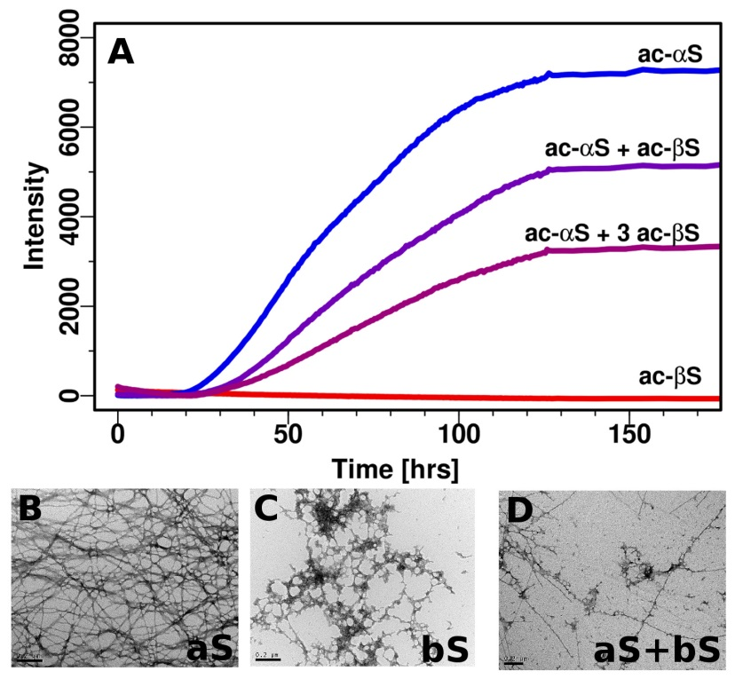

**Fig.2. Aggregation inhibiton of αS by βS as monitored by ThT and TEM.** (A) βS is able to inhibit fibril formation of αS in a dose dependent manner (measured at 37°C with shaking). Negatively stained electron micrographs (scale 200 nm) (B-D) of (B) αS fibrils (C) βS amorphous aggregates (D) co-incubated αS with βS.

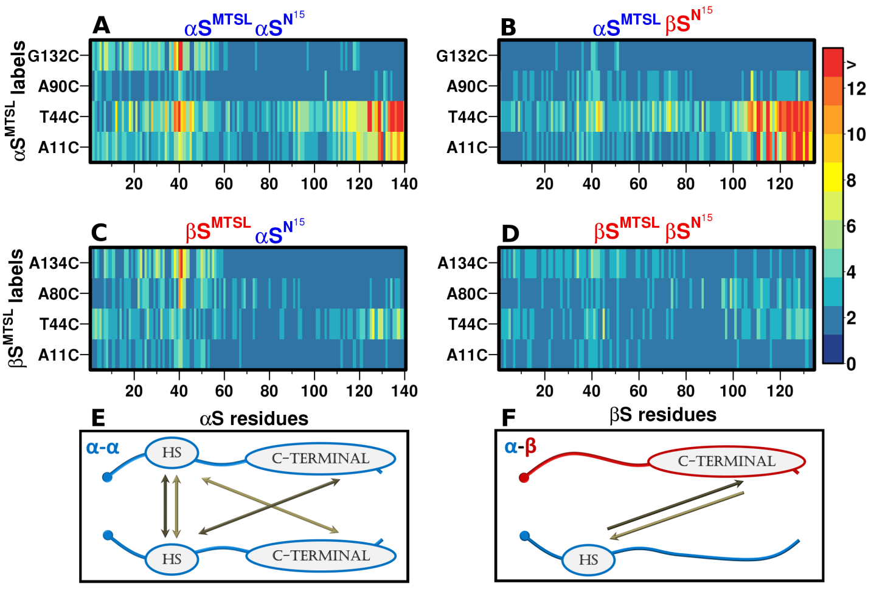**Fig.3. Contact maps of αS/αS homo-dimers and αS/βS hetero-dimers show distinctive interaction profiles.** Contact maps of transient dimers, shown as heat maps where each strip represents the color coded value of the residue-specific inter-chain paramagnetic relaxation enhancement rate (PRE rate - HNΓ2) induced by the proximity of the MTSL label to the residues in the indicated protein. Contact maps (A-D): figures A-D show four heat maps for all possible permutations of the spin label and NMR detectable chains of αS and βS: (A) 14N-αS-MTSL/15N-αS, (B) 14N-αS-MTSL/15N-βS, (C) 14N-βS-MTSL/15N-αS, (D) 14N-βS-MTSL/15N-βS. Contact maps show the PRE values colored in accordance with the legend; residues that do not exhibit interactions are colored blue and interactions higher than 12 Hz are colored red. Each strip on the contact maps corresponds to the spin label (y-axis). In one strip there are bins which correspond to the residue number on the NMR visible chain (x-axis). (E-F) Schematic representations of possible interactions of homo αS/ αS and hetero- αS/βS synuclein dimers. (E) αS/αS corresponds to interactions from contact map (A), (F) αS/βS corresponds to contact map (B-C); no homo-dimer for βS is shown as we observe no inter-chain interactions between βS chains. HS in the schematics stands for interactive “Hot Spot”.

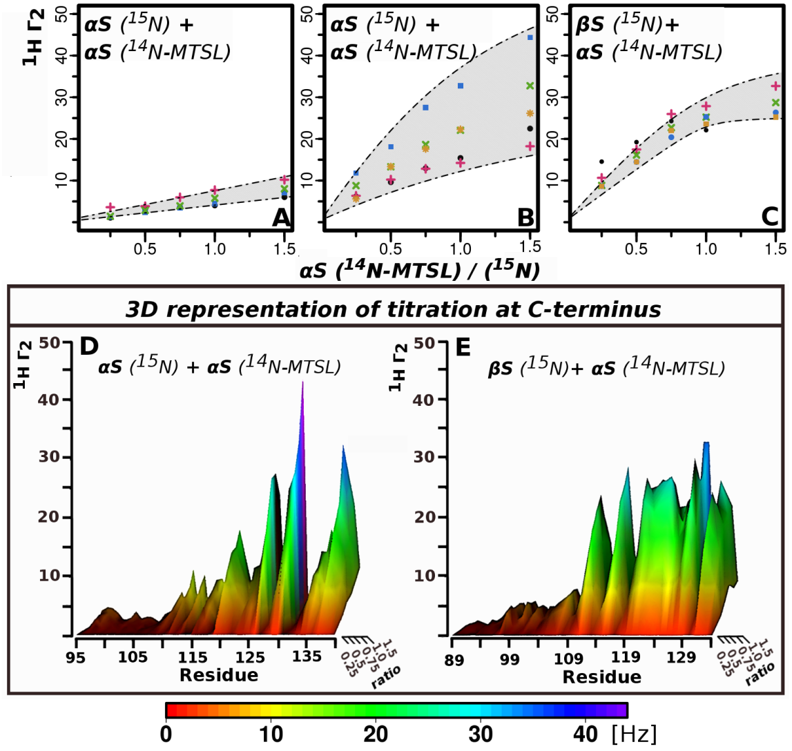

**Fig.4.** **Residue specific binding affinities for transient αS/βS hetero-complexes show higher specificity and affinity than αS/αS homo-complexes.** (A-C) Representative examples of titration curves from PRE titration profiles of αS-44-MTSL to 15N-αS and 15N-βS. Illustration of how the KD is obtained from fitting the PRE titration data as a function of the molar ratio of 14N-αS-T44C-MTSL labeled to 15N-αS (A-B) and to 15N-βS (C).: (A) αS residues 38-41 show a linear dependence between PRE values and concentration indicating non-specific interactions at these site, (Residues colors: 38 - black, 39- blue, 40 - pink, 41 – green), (B) αS residues 125-140 exhibit non-linear titration curves indicating specific interactions. (Residues colors: 125 - orange, 130 - blue, 135 - pink, 137 - green, 139 - black), (C) βS residues 109-134 interact strongly and more uniformly with αS-44-MTSL (Residues colors: 115 – green, 120-orange, 121-blue, 129 – pink, 131 - black). Shaded areas indicate the range of possible KD values. Titration profiles for αS/βS show a higher degree of saturation consistent with more specificity and higher affinity than those for αS/ αS (D-E) 3D representation of titration curves in the C-terminus (D) 15N-αS C-terminus titrated with T44C-MTSL labeled 14N-αS (E) 15N-βS C-terminus titrated with T44C-MTSL labeled 14N-αS titration. The x-axis shows the C-terminal residues of both αS and βS after sequence alignment, the z- axis depicts the PRE values, the y- axis the ratio of T44C-MTSL labeled 14N-αS to 15N sample concentration. Surface is colored using a rainbow palette, where low HNΓ2 values are red and the highest values are purple (according to legend below the plot).

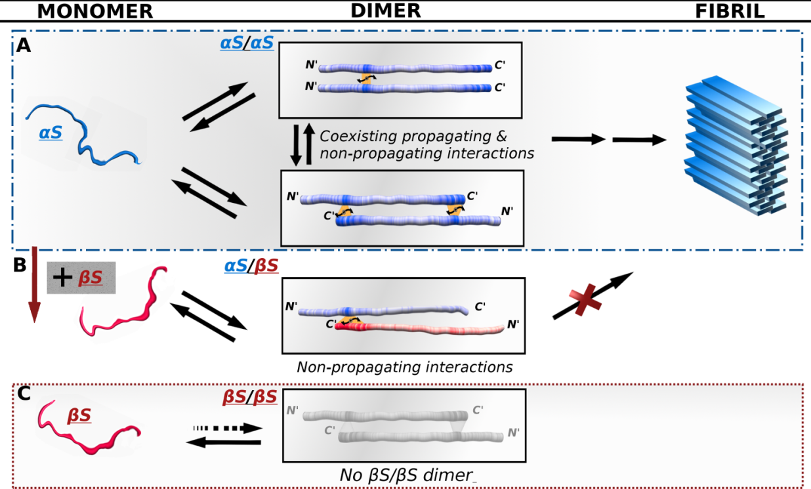

**Fig.5.** **Schematic model of αS/αS and αS/βS transient interactions suggest a new molecular view of inhibition routes to αS aggregation.** (A) αS/αS homo-dimer interactions: head-to-head aggregation prone interactions at residues 36-44 co-exist with head-to-tail inhibitory interactions at residues 125-140. (B) αS/ βS hetero-dimer interactions: head- to- tail inhibitory interactions span a broader range of C-terminal residues 115-134 with higher affinity. (C) No interactions are observed between monomer chains of βS. Protein chains are color-coded according to the interactivity of the regions as shown in Supplementary Fig.3. The NMR data show that αS homo-dimers can sample a heterogeneous range of poulations including N-to-N and N- to C-terminal configurations while αS/βS hetero-dimers sample only N- to C- terminal configurations with higher affinity and specificity. In light of the fact that the fibril form of αS forms β-strands that assemble into in register parallel β-sheets this would suggest that the N-C terminal dimers would have to undergo conformational rearrangement to reach the final fibril form, thereby delaying or inhibiting the kinetics of fibril formation.

**Supplementary information**

Unveiling transient protein-protein interactions that modulate inhibition of alpha-synuclein aggregation by beta-synuclein, a pre-synaptic protein that co-localizes with alpha-synuclein.

Maria K. Janowska, Kuen-Phon Wu and Jean S. Baum

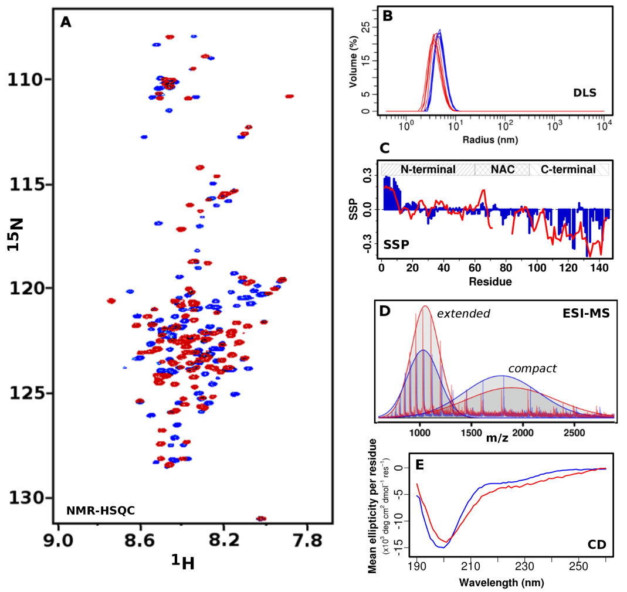

**Supplementary Fig.1.** Comparison of monomer conformational features of acetylated αS and acetylated βS**.** (A) 1H-15N-HSQC spectra of αS and βS at 15°C and pH 6. (B) DLS spectra showing that αS and βS both have hydrodynamic radii in the range of 5-6 nm. No oligomers were detetected and proteins are monomeric (>99%). (C) SSP indicates that N-terminal acetylation induces transient N-terminal helix formation in βS that is similar to acetylated αS; the transient helix in βS spans residues 1 to 12. (D) ESI-MS shows that both αS and βS are 100% acetylated and that both proteins can exist in compact and extended conformations (indicated by fitting two Gaussians). αS has a 59% compact/ 41% extended ratio while βS has a 46% compact/ 54% extended ratio. (E) Circular Dichroism spectra indicate that both αS and βS have very similar profiles consistent with unfolded nature of the protein.



**Supplementary Fig. 2***.* Schematic ofexperimental design for NMR PRE experiments. (A) 4 spin labels were introduced on each of the chains of the proteins, indicated by red box in the sequence of the protein. A->C and T->C mutants were selected in order to minimize effects of mutations. (B) Two different species are mixed in a 1:1 ratio: the NMR visible (15N protein) and the NMR invisible MTSL spin labeled 14N-protein. If the spin label is in the proximity to the 15N labeled chain, the relaxation rates are increased (C) Example of the data representation. The top plot shows the relaxation enhancement rates (PRE rate - Γ) detected on the NMR visible chain (15N). The lower plot shows the interactions in a pseudo contact map representation with the four spin labeled positions mapped against the 15N residues in the protein. The contact map is represented as a heat map with the color index shown in the inset.

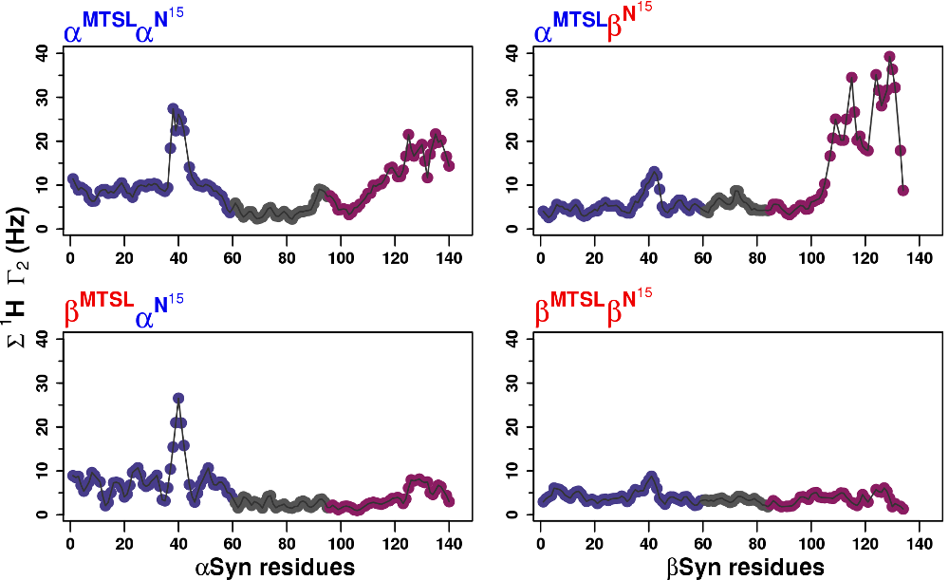

**Supplementary Fig.3.** Interactive regions of dimeric complexes. Summation of the PRE rates as a function of residue indicate that (A) in αS homo-dimeric complexes interactions occur at the N and C-termini. (B) In βS/αS hetero-dimer complexes, interactions with αS are mediated primarily through the C-terminus. (C) In the αS/βS hetero-dimer interactions are mediated by the αS N-terminus. (D) in βS homo-dimer there are essentially no interactions . In all plots N-terminus is plotted violet, NAC is grey and C-terminus is pink.

Supplementary Table 1. *KD* values for αS/αS homodimer as fitted χ-squared statistic using equation (1).

|  |  |  |  |
| --- | --- | --- | --- |
| **α/α homo-dimer** | | | |
| **residue number** | **KD [μM]** | **Γ2bound [Hz]** | **Γ2free [Hz]** |
| 119 | 151.5 ± 22.6 | 24.8±1.4 | 0.1±0.4 |
| 124 | 269.7± 115.3 | 26.6± 5.5 | -0.1±0.9 |
| 125 | 397.8±143.7 | 56± 11.5 | -0.6±1.1 |
| 126 | 87.1 ± 59.4 | 33.9± 6.9 | -0.4±3.5 |
| 129 | 157.4±53.2 | 41.2± 5.4 | -0.2±1.7 |
| 130 | 719.7±216.1 | 128.1±26.1 | 0.4±1.1 |
| 135 | 241.2± 45.4 | 29.2±2.5 | 0.1±0.5 |
| 137 | 1219.8+-/858.6 | 133.9±72.7 | 0.9±1.2 |
| 139 | 934.3±532.1 | 75.5±31.2 | 0.6±0.8 |

Supplementary Table 2. *KD* values for αS/βS hetero-dimer as fitted using χ-squared statistic.

|  |  |  |  |  |
| --- | --- | --- | --- | --- |
| **α/β hetero-dimer** | | | |  |
| **residue number** | **KD [μM]** | **Γ2bound [Hz]** | **Γ2free [Hz]** | |
| 111 | 36.8±34.2 | 22.5±3.5 | -0.2±3.6 | |
| 112 | 107.8±39.4 | 22.6±2.4 | -0.3±1.4 | |
| 115 | 348.8±111.1 | 60.7±9.1 | 0±1.7 | |
| 116 | 84.8±29.4 | 19.2±1.7 | -0.2±1.2 | |
| 118 | 141.3±34 | 23.4±1.8 | -0.3±0.9 | |
| 119 | 140.5±88.4 | 35.3±7.3 | -0.9±3.5 | |
| 120 | 338.3±166.7 | 55.3±12.7 | 0.1±2.4 | |
| 121 | 187±56 | 40.1±4.4 | -0.5±1.6 | |
| 124 | 54.7±31.5 | 29.3±3.6 | -0.2±3.1 | |
| 125 | 98.3±31.9 | 28±2.5 | -0.3±1.6 | |
| 126 | 105.3±21.2 | 29.9±1.7 | -0.2±1 | |
| 127 | 36.8±34.2 | 22.5±3.5 | -0.2±3.6 | |
| 128 | 90.7±56.2 | 38.2±6.3 | 0±4.2 | |
| 129 | 133.5±63.6 | 40.7±6.2 | -0.7±3.1 | |
| 131 | 80.7±21.8 | 32.3±2.2 | 0.1±1.6 | |
| 133 | 142.6±20.1 | 31.2±1.4 | -0.2±0.7 | |

Supplementary Methods

1. NMR experiments. Assignments on βS and αS were performed using the protocol described elsewhere.200 Backbone atom assignments were established in acetylated βS for all residues except for the prolines. Acetylation of the protein facilitated assignment of the first few residues, which are highly flexible in the non-acetylated form of the protein. Experiments were performed on 350uM 15N and 13C labeled sample with 10%D2O in 10mM MES buffer pH 6 with 100mM NaCl. Secondary structure propensities were extracted using the SSP program by Julie Forman-Kay.209 If the values are positive then this region has helical propensities, if the values are negative then the beta-sheet propensities are more pronounced.

2.Electrospray ionization mass spectroscopy (ESI-MS). ESI-MS experiments were performed in order to determine the population distributions of the monomeric ensembles of αS and βS using methods described previously.210 Samples were prepared in 10mM Ammonium Acetate, pH 6 in final concentration 50uM, by using 100 kDa and 3kDa filters.

3.Dynamic light scattering (DLS). DLS measurements were carried out using a Zetasizer Nano ZS (Malvern Instruments, UK). Data was collected using a 3 mW He-Ne laser light at a 633 nm wavelength back scattered light at an angle of 173°. Autocorrelation functions were determined from 6 correlation functions, with an acquisition time of 10 s for one correlation function. The sample concentration was 200uM.

4.Negative straining TEM. Fibrils were visualized using a JEM-100CXII manufactured by JEOL. Negative staining TEM was performed using a single droplet procedure211 at ambient temperature. Micrographs were recorded at a magnification of 100,000. All of the chemicals are purchased from Sigma.

1. Salt dependence. PRE are highly sensitive to the electrostatics. Both aSyn and bSyn have highly negatively charged C-terminus, and both positively and negatively charged N-terminus, thus it is highly susceptible to variation in the charges. (Further discussed in K-P Wu unpublished data) Plot shown below shows high correlation of salt concentration with PRE values of 15N aSyn with aSyn-G132C-MTSL (A) 100mM salt, (B) 0 mM salt



1. Diamagnetic control looks shares the pattern of the mixed non-MTSL labeled sample. (A) Diamagnetic 15N aSyn+ N14 aSyn-dia-MTSL-a11C (red), vs N15 aSyn + N14 aSyn without any spin label (black).



1. Insensitivity of other experiments to addition of excess of either aSyn or bSyn. (A) Overlay of HSQCs bSyn (black)and bSyn 5x addition of aSyn (blue). (B) Overlay of HSQCs aSyn (black) and aSyn 4x addition of aSyn (pink). (C) ESI-MS spectra of aSyn and subtracted from it ESI-MS spectrum of bSyn (negative values). On second panel has the same scheme as on panel one with additionally overlaid ESI-MS spectrum of mixture of 1:1 mixture of aSyn and bSyn. On third panel in black there is reversed plot from the first panel with overlaid mixture sample. As shown population of aSyn, and bSyn are not significantly affected by addition of the other protein. While in bSyn the extended form seems to compact slightly in aSyn compact population seems to be more affected upon addition of bSyn. (D) Hydrogen exchange values (HX) were plotted color coded into the HSQC spectra of bSyn and bSyn with 5x excess of aSyn. Generally, HX values of bSyn are not significantly affected by addition of aSyn. HX values were color-coded on the HSQC spectra to show that the high values of the HX are clustered. On the HSQC for the unfolded proteins similar residue types (ex. Gly) are not widely spread, they have similar chemical shifts, thus we show that the HX is highly correlated, as it was reported before, with the residue type.



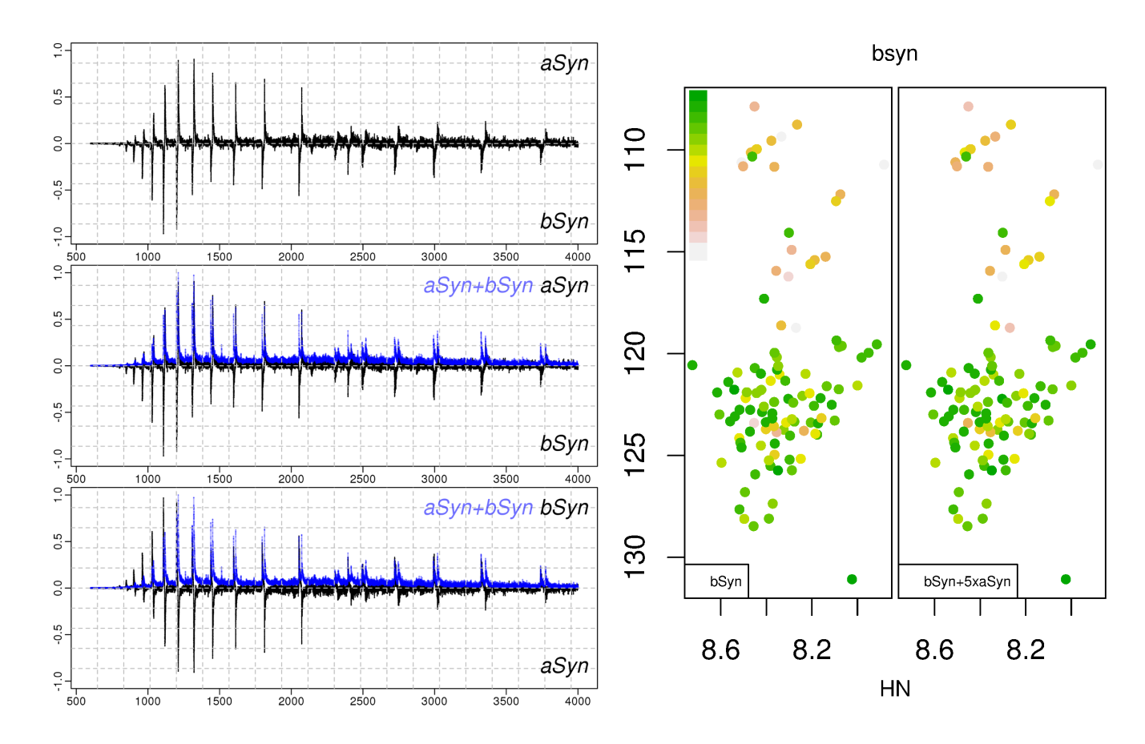

1. ThioflavinT of aSyn compared with the most interactive mutant. Plot below is showing ThioT fluorescence assay, monitoring fibril formation of aSyn and aSyn MTSL labeled cysteine mutant T44C in paramagnetic and diamagnetic form. Results are average of 5 independent runs for each type of the sample. Results here are showing that aSyn has similar aggregation rates with diamagnetic form of T44C-MTSL labeled mutant. Paramagnetic form of the same mutant has diminished aggregation rates, which we attribute to the ThioT fluorescence quenching by unpaired spin label on MTSL.



1. Statistical distribution of PRE values. Statistical distributions of the PRE values per each spin label are showed on the violins plots. Violin plots mixture of the boxplots (red, with white line for median), and density distribution plots. Information presented on violin plots gives us important insight about significance of interactions, and show that results we obtained do not exhibit significant amount of non-specific interactions. If first 2 quartiles boxplots are skewed, it means values with low PRE frequency are more frequently populated. The more elongated and broad top of violin plot is the higher interactions this spin label exhibits. For, symmetric violin plots median (white line) is in the middle of the shape; there is no difference in distribution between values below and above median, which suggest no significant interactions probed by this spin label, and its small magnitude and range, suggests small number of non-specific interactions. Such shape of the violin plot is mostly for bSyn homo-dimer, or rather lack thereof. In elongated boxplots, we attributed values from up to 3rd quartiles to the background coming from non-specific interactions and experimental error. PRE values, that we consider as significant lay in outlier range or eventually that were higher that 3rd quartile of the boxplot. Thus boxplots help us see that the interactions that we consider significant are mostly in the outliers region, thus the probability of them occurring accidentally is low, since we exclude possibility of error that high. Additionally, violin plots show us that some spin label positions are more likely to interact. For example G132C is interacting significantly only in the homodimer not in the heterodimer.



# Chapter 6. Oligomers

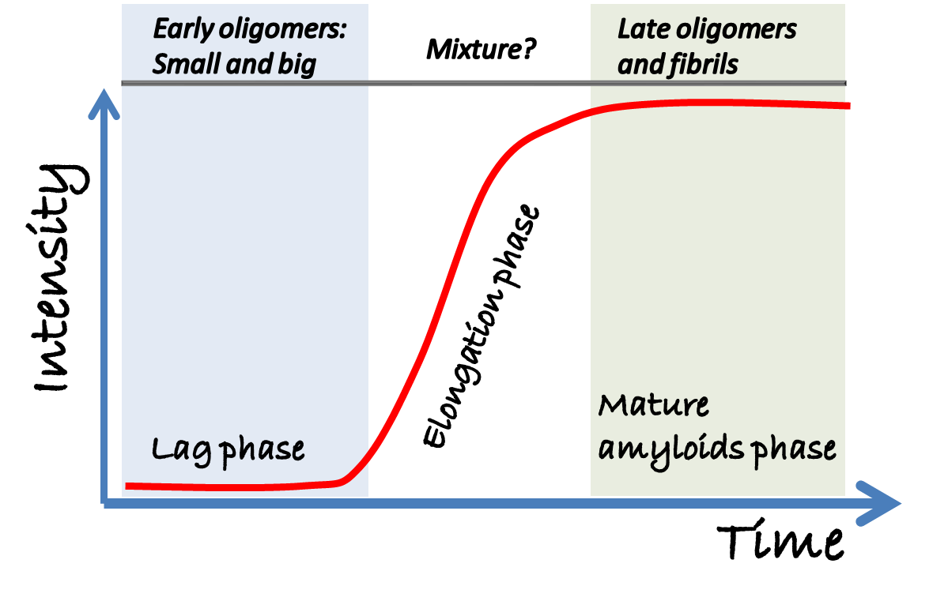

Oligomers coexisting with fibril – purified with 100kD filter.

5h of incubation 37C shaking. Purification with SEC.

We prepared different typed of oligomers that are generated in different stages of aggregation. Early oligomers are formed in the nucleation phase of the aggregation. Second type of oligomers that we purified coexists with the fibril, and we will call them late oligomers. To obtain early oligomers we purified oligomers before the fibrils are formed at 5h of incubation, late oligomers were purified, after turbidity of the sample increased, which is indicative for fibril formation.

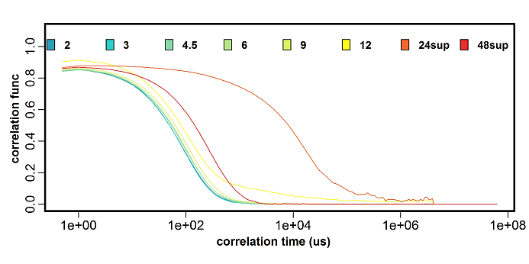

**Fig. .** Size of the oligomers at different incubation times. 12 mg/ml of aSyn were incubated it in 37C with shaking. 5uL aliquotes of the samples at the different timepoints and dilute to ~50uM sample, which is appropriate concentration for the DLS measurments. For each sample 3 measurment were taken with 10s averaging. Here we present data as the correlation function at the different times of the incubation, which is colored according to the legend on the top.

Slope of the line indicate polydispersity, that is how heterogenious sample is

Where the drop starts indicate molecuar weight

To determine how sizes of aSyn oligomers are changing in the aggreation pathway we dissolved 12 mg/ml of aSyn and we incubated it in 37C with shaking. We took aliquotes of the samples at the different timepoints. We diluted aliquote that we took from the stock to ~50uM sample, which is appropriate concentration for the DLS measurments. As we show above correlation function for the first 9 hours of the incubation is almost unaffected suggesting, no changes in size of the oligomers or their heterogeneity. At 12 h of the incubation sample increases the size and polydispersity, but there is still no fibril, as monitored by the turbidity changes. At the 24 and 48 sample sample is turbid signifiying that the fibril is present. Thus to obtain reasonable DLS reading we pelleted the fibril for 10 min in 14000 rpm and performed experiments on the supernatant. Oligomers that are present in the sample at 24h are highly heterogenious and have high sizes, and the 48h of incubation size of the oligomers decreased comparing to the 24h supernatant, but they are still bigger than the early oligomers. Additionally we tested sample fluorescence with ThioT and only samples at 24 and 48 hours showed increased fluorescence intensity. Results presented here show that there is transition from early to late oligomers upon aggregation pathway, suggesting transition in the oligomers. These data are consistent with results by Dobson, who suggested that there is transition in the oligomers, on the aggregation pathway. Oligomers size upon aSyn incubation is increasing slightly as well as polydispersity, and at the certain point there is big transition to the fibril-like oligomers.

Oligomers that were present at the early stages of the incubation were not observed at the later stages. Similar results were found upon different time incubation of the asyn, and running it with superose 6 – at 5 there were small/ and big oligomers as separated by superose, and at the 14h of the incubation, no oligomers were present at the profiles. These facts are suggesting that the early and late oligomers, are distinctly different from each other.

**Fig. .** LDH toxicity assay with oligomers. 3 different types of the oligomers were coincubated with SH-SY5Y cells for 24h: early oligomers: small and big, and late oligomers. Also we coincubated fibril with the cells.

In the next step we seek to find if the oligomers are toxic to the SH-SY5Y cells. We incubated the cells for 24h with the concentration of oligomers 5uM for early small and late oligomers, and 1.5uM for the big early oligomers. Only late oligomers show cell toxicity after 24 of incubation. It is possible that the early oligomers would exhibit toxicity after incubation for the loner time. These results suggest again that early and late oligomers are different, since they have different aggregation propensities.

Late oligomers characterization

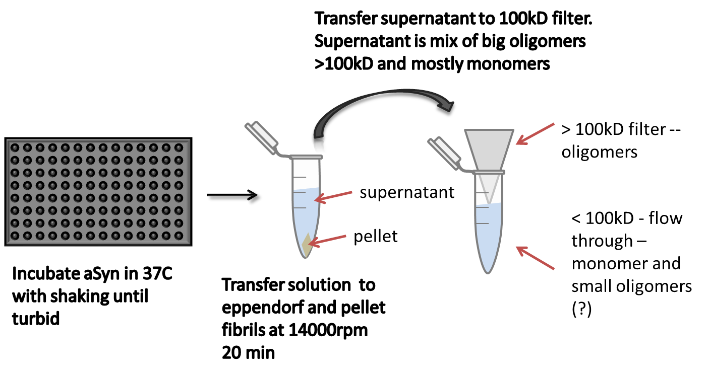

Preparation of late oligomers. Samples dissolved in 10mM MES, no salt, purified by SEC column, concentrated with 3kD filter Amicon (4ml), to final concentration of 1x150uM. 100uL of 150uM samples, 4 repeats od each 14 h incubation, shaking 600rpm with beads. Samples of the same kind were mixed together and spun down for 20 min at this point at 14000rpm. Supernatant was carefully taken to the separate Eppendorf, pellet dissolved in 10mM MES. 200uL of the supernatant form the previous step was injected into SEC-MALS (superdex200). Running buffer 10mM mes no salt. Flow rate 0.5. Column was carefully equilibrated overnight with flow =0.1ml/min, later hour before first injection flow rate was changed to 0.5 ml/min.



Time (min)

Intensity at 280 nm

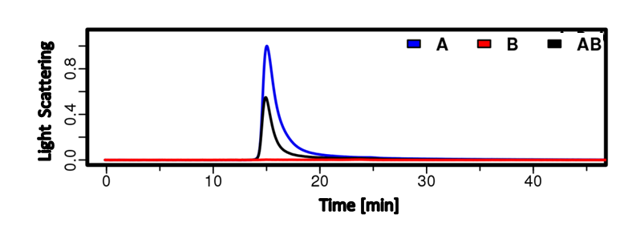

SEC and raleigh light scattering profiles revealed that less oligomers when aSyn is coincubated with bSyn. Suggesting that bSyn prevents formation oligomers by aSyn.

**Fig. .** Oligomers formation of aSyn. bSyn and mixture aSyn+bsyn. (a) SEC profilem intensity at 280 nm. (b) raleigh ratio.

To check if the averaged secondary structure of oligomers differs we run CD. Indeed aSyn > 100kD oligomers are beta sheet rich (indicated by the minimum at 218 nm), while coincubation of the aSyn with bSyn keeps aSyn unfolded. Addionally there is less oligomers formed upon coincubation of aSyn with bSyn. aSyn/bSyn oligomers seems to have more helical structure than the oligomers for aSyn alone. bSyn is not forming enough oligomers to be able to separate them, which is consistent with readings from SEC-MALS.



**Fig. .** CD wavelength profiles of late oligomers mixture of asyn bSyn and mixture.

Another comparison of secondary structure. As we can see supernatant of aSyn is mixture of unfolded monomers and beta rich oligomers. bSyn is unfolded, it doesn’t form oligomers. AB mixture is more unfolded than aSyn alone, there is less oligomers formed, and they are not the same as oligomes of aSyn alone.





**Fig. .** CD wavelength profiles of late oligomers mixture of asyn bSyn and mixture.

Early oligomers characterization



Legend . Three different runs of aSyn oligomers formation for non-acet aSyn. 12 mg/ml of aSyn was incubated for 6h with shaking at 37C. Samples were injected into superose 6 column. Small and big oligomers are formed. It seems that small oligomers are more populated than the large oligomers.

Legend. Non-Acet aSyn, bSyn, and aSyn+bSyn oligomers formation for non-acet aSyn. In total 12 mg/ml of protein per sample was dissolved in PBS was incubated for 6h with shaking at 37C. Later samples were injected into superose 6 column. No normalization here! It seems like there is no significant sequestration…



Legend. Close up of the previous SEC profile. aSyn forms small and big oligomers. bSyn forms only big oligomers, aSyn/bSyn mixture has both small and big oligomers, but there is more big oligomers formed.



Legend. SEC profiles for acetylated samples. Absorbance at 215 nm. 12 mg protein per sample was dissolved. Similarly to non-acet samples aSyn can form small and big oligomers, while bSyn forms only big oligomers. Here added P123H, which also form only big oligomers, but the amount of oligomers formed is increased comparing to the other samples. Data normalized to 1 under the curve

Comparison of secondary structure and stability of early and late oligomers

Legend. CD wavelength scan of fifferent aSyn oligomers before and after the melt. Third column show the melting curve for each type of oligomers. Melting was monitored at 218nm wavlength since it is minium for the beta sheet.



**Fig. .** CD wavelength spectrum different aSyn oligomers. Small and big oligomers are early oligomers, while A>100kD are late oligomers.

Different oligomeric species have different average secondary structure. aSyn small oligomers and aSyn big oligomers have similar secondary structure, but they have different melting properties. Small oligomers of aSyn have higher melting temperature (~55C )than big oligomers (~40C) of aSyn. Late oligomers of aSyn are more bSheet, than early oligomers, but they have similar melting properties as big fraction of the early oligomers. Oligomers generated with different methods are however heterogeneous as the polydispersity value (DLS) is high. We attempted to check the stability of the oligomers by doing melt of different aSyn oligomeric species. As a result we are able to tell that the oligomers are melting in the different ways, melt induced changes in the secondary structure of the oligomers, and decreased its polydisperity, but not in the sizes, suggesting that in this heterogeneous oligomeric sample there are more stable (which act as core) and less stable oligomers. Sizes of the oligomers generated are high > 600kDa as suggested by gels.

Oligomers of mix AB small and A small are different. Also big type of oligomers of all types are different proteins A, B, AB. Showing that the early and late oligomers are different and second of all than aSyn and bSyn, p123h oligomers are different from each other, and lastly that coincubation of aSyn with bSyn changes the oligomers that are generates. CD spectra for coincubated AB is not simple addition of CD spectrum of A oligomers and B oligomers, suggesting changes in the oligomeric ensemble of asyn, upon incubation with bSyn.





Fig. . Increased 1/intensities in the HSQC of sample coincubated with oligomers for 24h. Concentration of the oligomers 50uM, and concentration of the monomers700uM.



In the next step we sought to check how the oligomers will change the monomeric ensemble of aSyn. We mixed small oligomers separated by the superose 6 size exclusion column (monomers N15 sample with small oligomers). Sample started aggregating – after the experiments I spun down the sample – there were fibrils.

HSQC spectra collected at the initial time point and after 24 hours showed changes in the intensities of the peaks mostly in the N-terminal and NAC, but not in the C-terminus. These results are showing that the oligomers are able to induce aggregation of the monomeric aSyn, even without shaking – so the oligomers are on the pathway to the aggregation. PRE profiles for the dimer interactions, interestingly showed similarly that whicle N-terminus will be more interactive, also it showed increased interactions of the region around 80, which is suggesting that the monomeric interactive regions are being maintained in the oligomers.

1. Johnson, M., Coulton, A. T., Geeves, M. a. & Mulvihill, D. P. (2010). Targeted amino-terminal acetylation of recombinant proteins in E. coli. *PloS one* **5**, e15801.

2. Spillantini, M. G. & Goedert, M. (2000). The alpha-synucleinopathies: Parkinson's disease, dementia with Lewy bodies, and multiple system atrophy. *Ann N Y Acad Sci* **920**, 16-27.

3. Stefanis, L. (2012). alpha-Synuclein in Parkinson's Disease. *Cold Spring Harb Perspect Med* **2**, a009399.

4. Hindle, J. V. (2010). Ageing, neurodegeneration and Parkinson's disease. *Age and ageing* **39**, 156-61.

5. Spillantini, M. G., Crowther, R. A., Jakes, R., Cairns, N. J., Lantos, P. L. & Goedert, M. (1998). Filamentous alpha-synuclein inclusions link multiple system atrophy with Parkinson's disease and dementia with Lewy bodies. *Neurosci Lett* **251**, 205-8.

6. Spillantini, M. G., Crowther, R. A., Jakes, R., Hasegawa, M. & Goedert, M. (1998). alpha-synuclein in filamentous inclusions of Lewy bodies from Parkinson's disease and dementia with Lewy bodies. *Proceedings of the National Academy of Sciences of the United States of America* **95**, 6469-6473.

7. Breydo, L., Wu, J. W. & Uversky, V. N. (2012). Α-synuclein misfolding and Parkinson's disease. *Biochimica et biophysica acta* **1822**, 261-85.

8. Fink, A. L. (2006). The aggregation and fibrillation of alpha-synuclein. *Accounts of Chemical Research* **39**, 628-634.

9. Lashuel, H. A., Overk, C. R., Oueslati, A. & Masliah, E. (2013). The many faces of alpha-synuclein: from structure and toxicity to therapeutic target. *Nature Reviews Neuroscience* **14**, 38-48.

10. Maroteaux, L., Campanelli, J. T. & Scheller, R. H. (1988). SYNUCLEIN - A NEURON-SPECIFIC PROTEIN LOCALIZED TO THE NUCLEUS AND PRESYNAPTIC NERVE-TERMINAL. *Journal of Neuroscience* **8**, 2804-2815.

11. Shibayamaimazu, T., Okahashi, I., Omata, K., Nakajo, S., Ochiai, H., Nakai, Y., Hama, T., Nakamura, Y. & Nakaya, K. (1993). Cell and Tissue Distribution and Developmental-Change of Neuron-Specific 14 Kda Protein (Phosphoneuroprotein-14). *Brain Research* **622**, 17-25.

12. Jakes, R., Spillantini, M. G. & Goedert, M. (1994). Identification of 2 Distinct Synucleins from Human Brain. *FEBS letters* **345**, 27-32.

13. Iwai, A., Masliah, E., Yoshimoto, M., Ge, N., Flanagan, L., de Silva, H. A., Kittel, A. & Saitoh, T. (1995). The precursor protein of non-A beta component of Alzheimer's disease amyloid is a presynaptic protein of the central nervous system. *Neuron* **14**, 467-75.

14. Bottner, M., Zorenkov, D., Hellwig, I., Barrenschee, M., Harde, J., Fricke, T., Deuschl, G., Egberts, J. H., Becker, T., Fritscher-Ravens, A., Arlt, A. & Wedel, T. (2012). Expression pattern and localization of alpha-synuclein in the human enteric nervous system. *Neurobiol Dis* **48**, 474-80.

15. Barbour, R., Kling, K., Anderson, J. P., Banducci, K., Cole, T., Diep, L., Fox, M., Goldstein, J. M., Soriano, F., Seubert, P. & Chilcote, T. J. (2008). Red blood cells are the major source of alpha-synuclein in blood. *Neurodegener Dis* **5**, 55-9.

16. Davidson, W. S., Jonas, A., Clayton, D. F. & George, J. M. (1998). Stabilization of alpha-synuclein secondary structure upon binding to synthetic membranes. *Journal of Biological Chemistry* **273**, 9443-9449.

17. Bisaglia, M., Tessari, I., Mammi, S. & Bubacco, L. (2009). Interaction Between alpha-Synuclein and Metal Ions, Still Looking for a Role in the Pathogenesis of Parkinson's Disease. *Neuromolecular Medicine* **11**, 239-251.

18. Chandra, S., Gallardo, G., Fernandez-Chacon, R., Schluter, O. M. & Sudhof, T. C. (2005). Alpha-synuclein cooperates with CSPalpha in preventing neurodegeneration. *Cell* **123**, 383-96.

19. da Costa, C. A., Ancolio, K. & Checler, F. (2000). Wild-type but not Parkinson's disease-related ala-53 --> Thr mutant alpha -synuclein protects neuronal cells from apoptotic stimuli. *J Biol Chem* **275**, 24065-9.

20. Murphy, D. D., Rueter, S. M., Trojanowski, J. Q. & Lee, V. M. Y. (2000). Synucleins are developmentally expressed, and alpha-synuclein regulates the size of the presynaptic vesicular pool in primary hippocampal neurons. *Journal of Neuroscience* **20**, 3214-3220.

21. Dev, K. K., Hofele, K., Barbieri, S., Buchman, V. L. & van der Putten, H. (2003). Part II: alpha-synuclein and its molecular pathophysiological role in neurodegenerative disease. *Neuropharmacology* **45**, 14-44.

22. Maries, E., Dass, B., Collier, T. J., Kordower, J. H. & Steece-Collier, K. (2003). The role of alpha-synuclein in Parkinson's disease: Insights from animal models. *Nature Reviews Neuroscience* **4**, 727-738.

23. Jin, H., Kanthasamy, A., Ghosh, A., Yang, Y., Anantharam, V. & Kanthasamy, A. G. (2011). alpha-Synuclein negatively regulates protein kinase Cdelta expression to suppress apoptosis in dopaminergic neurons by reducing p300 histone acetyltransferase activity. *J Neurosci* **31**, 2035-51.

24. Uversky, V. N. (2003). A protein-chameleon: Conformational plasticity of alpha-synuclein, a disordered protein involved in neurodegenerative disorders. *Journal of Biomolecular Structure & Dynamics* **21**, 211-234.

25. Uversky, V. N. & Fink, A. L. (2004). Conformational constraints for amyloid fibrillation: the importance of being unfolded. *Biochimica Et Biophysica Acta-Proteins and Proteomics* **1698**, 131-153.

26. Bartels, T., Choi, J. G. & Selkoe, D. J. (2011). α-Synuclein occurs physiologically as a helically folded tetramer that resists aggregation. *Nature* **477**, 107-110.

27. Wang, W., Perovic, I., Chittuluru, J., Kaganovich, a., Nguyen, L. T. T., Liao, J., Auclair, J. R., Johnson, D., Landeru, a., Simorellis, a. K., Ju, S., Cookson, M. R., Asturias, F. J., Agar, J. N., Webb, B. N., Kang, C., Ringe, D., Petsko, G. a., Pochapsky, T. C. & Hoang, Q. Q. (2011). A soluble  -synuclein construct forms a dynamic tetramer. *Proceedings of the National Academy of Sciences*.

28. Binolfi, A., Theillet, F. X. & Selenko, P. (2012). Bacterial in-cell NMR of human alpha-synuclein: a disordered monomer by nature? *Biochemical Society Transactions* **40**, 950-U292.

29. Fauvet, B., Fares, M. B., Samuel, F., Dikiy, I., Tandon, A., Eliezer, D. & Lashuel, H. A. (2012). Characterization of Semisynthetic and Naturally N-alpha-Acetylated alpha-Synuclein in Vitro and in Intact Cells IMPLICATIONS FOR AGGREGATION AND CELLULAR PROPERTIES OF alpha-SYNUCLEIN. *Journal of Biological Chemistry* **287**, 28243-28262.

30. Fauvet, B., Mbefo, M. K., Fares, M.-B., Desobry, C., Michael, S., Ardah, M. T., Tsika, E., Coune, P., Prudent, M., Lion, N., Eliezer, D., Moore, D. J., Schneider, B., Aebischer, P., El-Agnaf, O. M., Masliah, E. & Lashuel, H. a. (2012). Alpha-synuclein in the central nervous system and from erythrocytes, mammalian cells and E. coli exists predominantly as a disordered monomer. *The Journal of biological chemistry* **287**, 15345-64.

31. Kang, L. J., Moriarty, G. M., Woods, L. A., Ashcroft, A. E., Radford, S. E. & Baum, J. (2012). N-terminal acetylation of alpha-synuclein induces increased transient helical propensity and decreased aggregation rates in the intrinsically disordered monomer. *Protein Science* **21**, 911-917.

32. Maltsev, A. S., Ying, J. F. & Bax, A. (2012). Impact of N-Terminal Acetylation of alpha-Synuclein on Its Random Coil and Lipid Binding Properties. *Biochemistry* **51**, 5004-5013.

33. Trexler, A. J. & Rhoades, E. (2012). N-terminal acetylation is critical for forming a-helical oligomer of a-synuclein. *Protein Science* **21**, 601-605.

34. Dettmer, U., Newman, A. J., Luth, E. S., Bartels, T. & Selkoe, D. (2013). In vivo crosslinking reveals principally oligomeric forms of alpha-synuclein and beta-synuclein in neurons and non-neural cells. *Journal of Biological Chemistry*.

35. Weinreb, P. H., Zhen, W., Poon, A. W., Conway, K. A. & Lansbury, P. T., Jr. (1996). NACP, a protein implicated in Alzheimer's disease and learning, is natively unfolded. *Biochemistry* **35**, 13709-15.

36. Bussell, R. & Eliezer, D. (2003). A structural and functional role for 11-mer repeats in alpha-synuclein and other exchangeable lipid binding proteins. *Journal of Molecular Biology* **329**, 763-778.

37. Uversky, V. N., Li, J. & Fink, A. L. (2001). Evidence for a partially folded intermediate in alpha-synuclein fibril formation. *Journal of Biological Chemistry* **276**, 10737-10744.

38. Munishkina, L. A., Fink, A. L. & Uversky, V. N. (2009). Accelerated Fibrillation of alpha-Synuclein Induced by the Combined Action of Macromolecular Crowding and Factors Inducing Partial Folding. *Current Alzheimer Research* **6**, 252-260.

39. Wu, K. P., Weinstock, D. S., Narayanan, C., Levy, R. M. & Baum, J. (2009). Structural Reorganization of alpha-Synuclein at Low pH Observed by NMR and REMD Simulations. *Journal of Molecular Biology* **391**, 784-796.

40. Hong, D.-P., Xiong, W., Chang, J.-Y. & Jiang, C. (2011). The role of the C-terminus of human α-synuclein: intra-disulfide bonds between the C-terminus and other regions stabilize non-fibrillar monomeric isomers. *FEBS letters* **585**, 561-6.

41. Park, S. M., Jung, H. Y., Kim, T. D., Park, J. H., Yang, C. H. & Kim, J. (2002). Distinct roles of the N-terminal-binding domain and the C-terminal-solubilizing domain of alpha-synuclein, a molecular chaperone. *J Biol Chem* **277**, 28512-20.

42. Weinreb, P. H., Zhen, W. G., Poon, A. W., Conway, K. A. & Lansbury, P. T. (1996). NACP, a protein implicated in Alzheimer's disease and learning, is natively unfolded. *Biochemistry* **35**, 13709-13715.

43. Giasson, B. I., Uryu, K., Trojanowski, J. Q. & Lee, V. M. Y. (1999). Mutant and wild type human alpha-synucleins assemble into elongated filaments with distinct morphologies in vitro. *Journal of Biological Chemistry* **274**, 7619-7622.

44. Soppa, J. (2010). Protein acetylation in archaea, bacteria, and eukaryotes. *Archaea (Vancouver, B.C.)* **2010**.

45. Uversky, V. N. (2002). Natively unfolded proteins : A point where biology waits for physics. *Protein science : a publication of the Protein Society* **11**, 739-56.

46. Uversky, V. N. (1993). Use of fast protein size-exclusion liquid chromatography to study the unfolding of proteins which denature through the molten globule. *Biochemistry* **32**, 13288-98.

47. Dunker, A. K., Lawson, J. D., Brown, C. J., Williams, R. M., Romero, P., Oh, J. S., Oldfield, C. J., Campen, A. M., Ratliff, C. R., Hipps, K. W., Ausio, J., Nissen, M. S., Reeves, R., Kang, C. H., Kissinger, C. R., Bailey, R. W., Griswold, M. D., Chiu, M., Garner, E. C. & Obradovic, Z. (2001). Intrinsically disordered protein. *Journal of Molecular Graphics & Modelling* **19**, 26-59.

48. Eliezer, D., Kutluay, E., Bussell, R. & Browne, G. (2001). Conformational properties of alpha-synuclein in its free and lipid-associated states. *Journal of Molecular Biology* **307**, 1061-1073.

49. Allison, J. R., Varnai, P., Dobson, C. M. & Vendruscolo, M. (2009). Determination of the Free Energy Landscape of alpha-Synuclein Using Spin Label Nuclear Magnetic Resonance Measurements. *Journal of the American Chemical Society* **131**, 18314-18326.

50. Salmon, L., Nodet, G., Ozenne, V., Yin, G., Jensen, M. R., Zweckstetter, M. & Blackledge, M. (2010). NMR Characterization of Long-Range Order in Intrinsically Disordered Proteins. *Journal of the American Chemical Society* **132**, 8407-8418.

51. Bertoncini, C. W., Jung, Y. S., Fernandez, C. O., Hoyer, W., Griesinger, C., Jovin, T. M. & Zweckstetter, M. (2005). Release of long-range tertiary interactions potentiates aggregation of natively unstructured alpha-synuclein. *Proceedings of the National Academy of Sciences of the United States of America* **102**, 1430-1435.

52. Bernado, P., Bertoncini, C. W., Griesinger, C., Zweckstetter, M. & Blackledge, M. (2005). Defining long-range order and local disorder in native alpha-synuclein using residual dipolar couplings. *Journal of the American Chemical Society* **127**, 17968-17969.

53. Dedmon, M. M., Lindorff-Larsen, K., Christodoulou, J., Vendruscolo, M. & Dobson, C. M. (2005). Mapping long-range interactions in alpha-synuclein using spin-label NMR and ensemble molecular dynamics simulations. *Journal of the American Chemical Society* **127**, 476-7.

54. Cho, M. K., Kim, H. Y., Bernado, P., Fernandez, C. O., Blackledge, M. & Zweckstetter, M. (2007). Amino acid bulkiness defines the local conformations and dynamics of natively unfolded alpha-synuclein and tau. *Journal of the American Chemical Society* **129**, 3032-+.

55. Wu, K. P. & Baum, J. (2010). Detection of Transient Interchain Interactions in the Intrinsically Disordered Protein alpha-Synuclein by NMR Paramagnetic Relaxation Enhancement. *Journal of the American Chemical Society* **132**, 5546; PMCID: PMC3064441.

56. Kang, L., Wu, K.-P., Vendruscolo, M. & Baum, J. (2011). The A53T mutation is key in defining the differences in the aggregation kinetics of human and mouse α-synuclein. *Journal of the American Chemical Society* **133**, 13465-70.

57. Rao, J. N., Jao, C. C., Hegde, B. G., Langen, R. & Ulmer, T. S. (2010). A Combinatorial NMR and EPR Approach for Evaluating the Structural Ensemble of Partially Folded Proteins. *Journal of the American Chemical Society* **132**, 8657-8668.

58. Lee, J. C., Lai, B. T., Kozak, J. J., Gray, H. B. & Winkler, J. R. (2007). alpha-Synuclein tertiary contact dynamics. *Journal of Physical Chemistry B* **111**, 2107-2112.

59. Cho, M. K., Nodet, G., Kim, H. Y., Jensen, M. R., Bernado, P., Fernandez, C. O., Becker, S., Blackledge, M. & Zweckstetter, M. (2009). Structural characterization of alpha-synuclein in an aggregation prone state. *Protein Science* **18**, 1840-1846.

60. Bussell, R. & Eliezer, D. (2001). Residual structure and dynamics in Parkinson's disease-associated mutants of alpha-synuclein. *Journal of Biological Chemistry* **276**, 45996-46003.

61. Sung, Y.-H. & Eliezer, D. (2008). Residual structure, backbone dynamics, and interactions within the synuclein family. **372**, 689-707.

62. Narayanan, C., Weinstock, D. S., Wu, K. P., Baum, J. & Levy, R. M. (2012). Investigation of the Polymeric Properties of alpha-Synuclein and Comparison with NMR Experiments: A Replica Exchange Molecular Dynamics Study. *Journal of Chemical Theory and Computation* **8**, 3929-3942.

63. Dyson, H. J. & Wright, P. E. (2005). Intrinsically unstructured proteins and their functions. *Nature Reviews Molecular Cell Biology* **6**, 197-208.

64. Hoyer, W., Cherny, D., Subramaniam, V. & Jovin, T. M. (2004). Impact of the acidic C-terminal region comprising amino acids 109-140 on alpha-synuclein aggregation in vitro. *Biochemistry* **43**, 16233-42.

65. Bertoncini, C. W., Jung, Y.-S., Fernandez, C. O., Hoyer, W., Griesinger, C., Jovin, T. M. & Zweckstetter, M. (2005). Release of long-range tertiary interactions potentiates aggregation of natively unstructured alpha-synuclein. *Proceedings of the National Academy of Sciences of the United States of America* **102**, 1430-5.

66. Yap, T. L., Pfefferkorn, C. M. & Lee, J. C. (2011). Residue-specific fluorescent probes of alpha-synuclein: detection of early events at the N- and C-termini during fibril assembly. *Biochemistry* **50**, 1963-5.

67. McClendon, S., Rospigliosi, C. C. & Eliezer, D. (2009). Charge neutralization and collapse of the C-terminal tail of alpha-synuclein at low pH. *Protein Science* **18**, 1531-1540.

68. Uversky, V. N., Li, J. & Fink, a. L. (2001). Evidence for a partially folded intermediate in alpha-synuclein fibril formation. *The Journal of biological chemistry* **276**, 10737-44.

69. Uversky, V. N., Li, J., Souillac, P., Millett, I. S., Doniach, S., Jakes, R., Goedert, M. & Fink, A. L. (2002). Biophysical properties of the synucleins and their propensities to fibrillate: inhibition of alpha-synuclein assembly by beta- and gamma-synucleins. *The Journal of biological chemistry* **277**, 11970-8.

70. Uversky, V. N., Lee, H.-J. J., Li, J., Fink, A. L. & Lee, S.-J. J. (2001). Stabilization of partially folded conformation during alpha-synuclein oligomerization in both purified and cytosolic preparations. *The Journal of biological chemistry* **276**, 43495-8.

71. Uversky, V. N., Li, J. & Fink, a. L. (2001). Metal-triggered structural transformations, aggregation, and fibrillation of human alpha-synuclein. A possible molecular NK between Parkinson's disease and heavy metal exposure. *The Journal of biological chemistry* **276**, 44284-96.

72. Uversky, V. N., Li, J. & Fink, A. L. (2001). Pesticides directly accelerate the rate of alpha-synuclein fibril formation: a possible factor in Parkinson's disease. *Febs Letters* **500**, 105-108.

73. Uversky, V. N., Li, J., Bower, K. & Fink, A. L. (2002). Synergistic effects of pesticides and metals on the fibrillation of alpha-synuclein: Implications for Parkinson's disease. *Neurotoxicology* **23**, 527-536.

74. Bertoncini, C. W., Fernandez, C. O., Griesinger, C., Jovin, T. M. & Zweckstetter, M. (2005). Familial mutants of alpha-synuclein with increased neurotoxicity have a destabilized conformation. *Journal of Biological Chemistry* **280**, 30649-30652.

75. Conway, K. A., Harper, J. D. & Lansbury, P. T. (1998). Accelerated in vitro fibril formation by a mutant alpha-synuclein linked to early-onset Parkinson disease. *Nature Medicine* **4**, 1318-1320.

76. Li, J., Uversky, V. N. & Fink, A. L. (2001). Effect of familial Parkinson's disease point mutations A30P and A53T on the structural properties, aggregation, and fibrillation of human alpha-synuclein. *Biochemistry* **40**, 11604-11613.

77. Li, J., Uversky, V. N. & Fink, A. L. (2002). Conformational behavior of human alpha-synuclein is modulated by familial Parkinson's disease point mutations A30P and A53T. *Neurotoxicology* **23**, 553-567.

78. El-Agnaf, O. M., Jakes, R., Curran, M. D. & Wallace, A. (1998). Effects of the mutations Ala30 to Pro and Ala53 to Thr on the physical and morphological properties of alpha-synuclein protein implicated in Parkinson's disease. *Febs Letters* **440**, 67-70.

79. Greenbaum, E. A., Graves, C. L., Mishizen-Eberz, A. J., Lupoli, M. A., Lynch, D. R., Englander, S. W., Axelsen, P. H. & Giasson, B. I. (2005). The E46K mutation in alpha-synuclein increases amyloid fibril formation. *Journal of Biological Chemistry* **280**, 7800-7807.

80. Wu, K. P., Kim, S., Fela, D. A. & Baum, J. (2008). Characterization of conformational and dynamic properties of natively unfolded human and mouse alpha-synuclein ensembles by NMR: Implication for aggregation. *Journal of Molecular Biology* **378**, 1104-1115.

81. Fredenburg, R. A., Rospigliosi, C., Meray, R. K., Kessler, J. C., Lashuel, H. A., Eliezer, D. & Lansbury, P. T. (2007). The impact of the E46K mutation on the properties of alpha-synuclein in its monomeric and oligomeric states. *Biochemistry* **46**, 7107-7118.

82. Rospigliosi, C. C., McClendon, S., Schmid, A. W., Ramlall, T. F., Barre, P., Lashuel, H. A. & Eliezer, D. (2009). E46K Parkinson's-Linked Mutation Enhances C-Terminal-to-N-Terminal Contacts in alpha-Synuclein. *Journal of Molecular Biology* **388**, 1022-1032.

83. Ulmer, T. S., Bax, A., Cole, N. B. & Nussbaum, R. L. (2005). Structure and dynamics of micelle-bound human alpha-synuclein. *The Journal of biological chemistry* **280**, 9595-603.

84. Eliezer, D., Kutluay, E., Bussell, R. & Browne, G. (2001). Conformational properties of alpha-synuclein in its free and lipid-associated states. *Journal of molecular biology* **307**, 1061-73.

85. Bartels, T., Ahlstrom, L. S., Leftin, A., Kamp, F., Haass, C., Brown, M. F. & Beyer, K. (2010). The N-terminus of the intrinsically disordered protein alpha-synuclein triggers membrane binding and helix folding. *Biophys J* **99**, 2116-24.

86. Eliezer, D., Kutluay, E., Bussell, R., Jr. & Browne, G. (2001). Conformational properties of alpha-synuclein in its free and lipid-associated states. *J Mol Biol* **307**, 1061-73.

87. Croke, R. L., Sallum, C. O., Watson, E., Watt, E. D. & Alexandrescu, A. T. (2008). Hydrogen exchange of monomeric alpha-synuclein shows unfolded structure persists at physiological temperature and is independent of molecular crowding in Escherichia coli. *Protein Sci* **17**, 1434-45.

88. Trexler, A. J. & Rhoades, E. (2009). alpha-Synuclein Binds Large Unilamellar Vesicles as an Extended Helix. *Biochemistry* **48**, 2304-2306.

89. Jao, C. C., Hegde, B. G., Chen, J., Haworth, I. S. & Langen, R. (2008). Structure of membrane-bound alpha-synuclein from site-directed spin labeling and computational refinement. *Proceedings of the National Academy of Sciences of the United States of America* **105**, 19666-19671.

90. Ulmer, T. S., Bax, A., Cole, N. B. & Nussbaum, R. L. (2005). Structure and dynamics of micelle-bound human alpha-synuclein. *Journal of Biological Chemistry* **280**, 9595-9603.

91. Bernstein, S. L., Liu, D. F., Wyttenbach, T., Bowers, M. T., Lee, J. C., Gray, H. B. & Winkler, J. R. (2004). alpha-synuclein: Stable compact and extended monomeric structures and pH dependence of dimer formation. *Journal of the American Society for Mass Spectrometry* **15**, 1435-1443.

92. Frimpong, A. K., Abzalimov, R. R., Uversky, V. N. & Kaltashov, I. A. (2010). Characterization of intrinsically disordered proteins with electrospray ionization mass spectrometry: conformational heterogeneity of alpha-synuclein. *Proteins-Structure Function and Bioinformatics* **78**, 714-22.

93. Pivato, M., De Franceschi, G., Tosatto, L., Frare, E., Kumar, D., Aioanei, D., Brucale, M., Tessari, I., Bisaglia, M., Samori, B., de Laureto, P. P. & Bubacco, L. (2012). Covalent α-Synuclein Dimers: Chemico-Physical and Aggregation Properties. *PloS one* **7**, e50027.

94. Celej, M. S., Sarroukh, R., Goormaghtigh, E., Fidelio, G. D., Ruysschaert, J. M. & Raussens, V. (2012). Toxic prefibrillar alpha-synuclein amyloid oligomers adopt a distinctive antiparallel beta-sheet structure. *Biochemical Journal* **443**, 719-26.

95. Uversky, V. N., Lee, H. J., Li, J., Fink, A. L. & Lee, S. J. (2001). Stabilization of partially folded conformation during alpha-synuclein oligomerization in both purified and cytosolic preparations. *Journal of Biological Chemistry* **276**, 43495-43498.

96. Zhou, W. & Freed, C. R. (2004). Tyrosine-to-cysteine modification of human alpha-synuclein enhances protein aggregation and cellular toxicity. *Journal of Biological Chemistry* **279**, 10128-35.

97. Goldberg, M. S. & Lansbury, P. T. (2000). Is there a cause-and-effect relationship between alpha-synuclein fibrillization and Parkinson's disease? *Nature Cell Biology* **2**, E115-E119.

98. Conway, K. A., Lee, S. J., Rochet, J. C., Ding, T. T., Harper, J. D., Williamson, R. E. & Lansbury, P. T. (2000). Accelerated oligomerization by Parkinson's disease linked alpha-synuclein mutants. *Molecular Basis of Dementia* **920**, 42-45.

99. Masliah, E., Rockenstein, E., Veinbergs, I., Mallory, M., Hashimoto, M., Takeda, A., Sagara, Y., Sisk, A. & Mucke, L. (2000). Dopaminergic loss and inclusion body formation in alpha-synuclein mice: Implications for neurodegenerative disorders. *Science* **287**, 1265-1269.

100. Amer, D. A. M., Irvine, G. B. & El-Agnaf, O. M. A. (2006). Inhibitors of alpha-synuclein oligomerization and toxicity: a future therapeutic strategy for Parkinson's disease and related disorders. *Experimental Brain Research* **173**, 223-233.

101. Kayed, R., Head, E., Thompson, J. L., McIntire, T. M., Milton, S. C., Cotman, C. W. & Glabe, C. G. (2003). Common structure of soluble amyloid oligomers implies common mechanism of pathogenesis. *Science* **300**, 486-489.

102. Wolfe, K. J. & Cyr, D. M. (2011). Amyloid in neurodegenerative diseases: friend or foe? *Semin Cell Dev Biol* **22**, 476-81.

103. Haass, C. & Selkoe, D. J. (2007). Soluble protein oligomers in neurodegeneration: lessons from the Alzheimer's amyloid beta-peptide. *Nat Rev Mol Cell Biol* **8**, 101-12.

104. Caughey, B. & Lansbury, P. T. (2003). Protofibrils, pores, fibrils, and neurodegeneration: Separating the responsible protein aggregates from the innocent bystanders. *Annual Review of Neuroscience* **26**, 267-298.

105. Dobson, C. M. (1999). Protein misfolding, evolution and disease. *Trends Biochem Sci* **24**, 329-32.

106. Lee, J., Culyba, E. K., Powers, E. T. & Kelly, J. W. (2011). Amyloid-β forms fibrils by nucleated conformational conversion of oligomers. *Nature chemical biology* **7**, 600-607.

107. Cremades, N., Cohen, S. I. A., Deas, E., Abramov, A. Y., Chen, A. Y., Orte, A., Sandal, M., Clarke, R. W., Dunne, P., Aprile, F. A., Bertoncini, C. W., Wood, N. W., Knowles, T. P. J., Dobson, C. M. & Klenerman, D. (2012). Direct Observation of the Interconversion of Normal and Toxic Forms of alpha-Synuclein. *Cell* **149**, 1048-1059.

108. Apetri, M. M., Maiti, N. C., Zagorski, M. G., Carey, P. R. & Anderson, V. E. (2006). Secondary structure of alpha-synuclein oligomers: characterization by raman and atomic force microscopy. *Journal of Molecular Biology* **355**, 63-71.

109. Lee, J.-H., Lee, I.-H., Choe, Y.-J., Kang, S., Kim, H. Y., Gai, W.-P., Hahn, J.-S. & Paik, S. R. (2009). Real-time analysis of amyloid fibril formation of alpha-synuclein using a fibrillation-state-specific fluorescent probe of JC-1. *The Biochemical journal* **418**, 311-23.

110. Gsponer, J., Haberthur, U. & Caflisch, A. (2003). The role of side-chain interactions in the early steps of aggregation: Molecular dynamics simulations of an amyloid-forming peptide from the yeast prion Sup35. *Proc Natl Acad Sci U S A* **100**, 5154-9.

111. Cheon, M., Chang, I., Mohanty, S., Luheshi, L. M., Dobson, C. M., Vendruscolo, M. & Favrin, G. (2007). Structural reorganisation and potential toxicity of oligomeric species formed during the assembly of amyloid fibrils. *PLoS Comput Biol* **3**, 1727-38.

112. Dusa, A., Kaylor, J., Edridge, S., Bodner, N., Hong, D. P. & Fink, A. L. (2006). Characterization of oligomers during alpha-synuclein aggregation using intrinsic tryptophan fluorescence. *Biochemistry* **45**, 2752-2760.

113. Bolognesi, B., Kumita, J. R., Barros, T. P., Esbjorner, E. K., Luheshi, L. M., Crowther, D. C., Wilson, M. R., Dobson, C. M., Favrin, G. & Yerbury, J. J. (2010). ANS binding reveals common features of cytotoxic amyloid species. *ACS Chem Biol* **5**, 735-40.

114. Outeiro, T. F., Putcha, P., Tetzlaff, J. E., Spoelgen, R., Koker, M., Carvalho, F., Hyman, B. T. & McLean, P. J. (2008). Formation of toxic oligomeric alpha-synuclein species in living cells. *PloS one* **3**, e1867.

115. Campioni, S., Mannini, B., Zampagni, M., Pensalfini, A., Parrini, C., Evangelisti, E., Relini, A., Stefani, M., Dobson, C. M., Cecchi, C. & Chiti, F. (2010). A causative link between the structure of aberrant protein oligomers and their toxicity. *Nat Chem Biol* **6**, 140-7.

116. Kim, H. Y., Cho, M. K., Kumar, A., Maier, E., Siebenhaar, C., Becker, S., Fernandez, C. O., Lashuel, H. A., Benz, R., Lange, A. & Zweckstetter, M. (2009). Structural Properties of Pore-Forming Oligomers of alpha-Synuclein. *Journal of the American Chemical Society* **131**, 17482-17489.

117. Tsigelny, I. F., Sharikov, Y., Wrasidlo, W., Gonzalez, T., Desplats, P. A., Crews, L., Spencer, B. & Masliah, E. (2012). Role of alpha-synuclein penetration into the membrane in the mechanisms of oligomer pore formation. *Febs Journal* **279**, 1000-1013.

118. Danzer, K. M., Haasen, D., Karow, A. R., Moussaud, S., Habeck, M., Giese, A., Kretzschmar, H., Hengerer, B. & Kostka, M. (2007). Different species of alpha-synuclein oligomers induce calcium influx and seeding. *Journal of Neuroscience* **27**, 9220-9232.

119. Cole, N. B., Murphy, D. D., Grider, T., Rueter, S., Brasaemle, D. & Nussbaum, R. L. (2002). Lipid droplet binding and oligomerization properties of the Parkinson's disease protein alpha-synuclein. *Journal of Biological Chemistry* **277**, 6344-6352.

120. Winner, B., Jappelli, R., Maji, S. K., Desplats, P. a., Boyer, L., Aigner, S., Hetzer, C., Loher, T., Vilar, M., Campioni, S., Tzitzilonis, C., Soragni, A., Jessberger, S., Mira, H., Consiglio, A., Pham, E., Masliah, E., Gage, F. H. & Riek, R. (2011). In vivo demonstration that alpha-synuclein oligomers are toxic. *Proceedings of the National Academy of Sciences of the United States of America* **108**, 4194-9.

121. Conway, K. A., Lee, S. J., Rochet, J. C., Ding, T. T., Harper, J. D., Williamson, R. E. & Lansbury, P. T., Jr. (2000). Accelerated oligomerization by Parkinson's disease linked alpha-synuclein mutants. *Ann N Y Acad Sci* **920**, 42-5.

122. Conway, K. A., Lee, S. J., Rochet, J. C., Ding, T. T., Williamson, R. E. & Lansbury, P. T., Jr. (2000). Acceleration of oligomerization, not fibrillization, is a shared property of both alpha-synuclein mutations linked to early-onset Parkinson's disease: implications for pathogenesis and therapy. *Proc Natl Acad Sci U S A* **97**, 571-6.

123. Lashuel, H. A., Petre, B. M., Wall, J., Simon, M., Nowak, R. J., Walz, T. & Lansbury, P. T. (2002). alpha-synuclein, especially the Parkinson's disease-associated mutants, forms pore-like annular and tubular protofibrils. *Journal of Molecular Biology* **322**, 1089-1102.

124. Kaylor, J., Bodner, N., Edridge, S., Yamin, G., Hong, D.-p. & Fink, A. L. (2005). Characterization of Oligomeric Intermediates in a-Synuclein Fibrillation : FRET Studies of Y125W/Y133F/Y136F alpha-synuclein. *Journal of Molecular Biology* **353**, 357-372.

125. Ding, T. T., Lee, S. J., Rochet, J. C. & Lansbury, P. T. (2002). Annular alpha-synuclein protofibrils are produced when spherical protofibrils are incubated in solution or bound to brain-derived membranes. *Biochemistry* **41**, 10209-10217.

126. Pountney, D. L., Voelcker, N. H. & Gai, W. P. (2005). Annular alpha-synuclein oligomers are potentially toxic agents in alpha-synucleinopathy. Hypothesis. *Neurotoxicity Research* **7**, 59-67.

127. Zerovnik, E. (2011). Oligomerization preceding amyloid fibril formation: a process in common to intrinsically disordered and globular proteins. *Network* **22**, 154-61.

128. Munishkina, L. A., Phelan, C., Uversky, V. N. & Fink, A. L. (2003). Conformational behavior and aggregation of alpha-synuclein in organic solvents: modeling the effects of membranes. *Biochemistry* **42**, 2720-30.

129. Souza, J. M., Giasson, B. I., Chen, Q. P., Lee, V. M. Y. & Ischiropoulos, H. (2000). Dityrosine cross-linking promotes formation of stable alpha-synuclein polymers - Implication of nitrative and oxidative stress in the pathogenesis of neurodegenerative synucleinopathies. *Journal of Biological Chemistry* **275**, 18344-18349.

130. Krishnan, S., Chi, E. Y., Wood, S. J., Kendrick, B. S., Li, C., Garzon-Rodriguez, W., Wypych, J., Randolph, T. W., Narhi, L. O., Biere, A. L., Citron, M. & Carpenter, J. F. (2003). Oxidative dimer formation is the critical rate-limiting step for Parkinson's disease alpha-synuclein fibrillogenesis. *Biochemistry* **42**, 829-37.

131. Norris, E. H., Giasson, B. I., Ischiropoulos, H. & Lee, V. M. Y. (2003). Effects of oxidative and nitrative challenges on alpha-synuclein fibrillogenesis involve distinct mechanisms of protein modifications. *Journal of Biological Chemistry* **278**, 27230-27240.

132. Hodara, R., Norris, E. H., Giasson, B. I., Mishizen-Eberz, A. J., Lynch, D. R., Lee, V. M.-Y. M.-Y. & Ischiropoulos, H. (2004). Functional consequences of alpha-synuclein tyrosine nitration: diminished binding to lipid vesicles and increased fibril formation. *The Journal of biological chemistry* **279**, 47746-53.

133. Yamin, G., Glaser, C. B., Uversky, V. N. & Fink, A. L. (2003). Certain metals trigger fibrillation of methionine-oxidized alpha-synuclein. *Journal of Biological Chemistry* **278**, 27630-27635.

134. Jo, E. J., McLaurin, J., Yip, C. M., St George-Hyslop, P. & Fraser, P. E. (2000). alpha-synuclein membrane interactions and lipid specificity. *Journal of Biological Chemistry* **275**, 34328-34334.

135. Lee, H. J., Choi, C. & Lee, S. J. (2002). Membrane-bound alpha-synuclein has a high aggregation propensity and the ability to seed the aggregation of the cytosolic form. *Journal of Biological Chemistry* **277**, 671-678.

136. Wright, J. A., Wang, X. & Brown, D. R. (2009). Unique copper-induced oligomers mediate alpha-synuclein toxicity. *Faseb Journal* **23**, 2384-2393.

137. Haque, F., Pandey, A. P., Cambrea, L. R., Rochet, J.-C. & Hovis, J. S. (2010). Adsorption of alpha-Synuclein on Lipid Bilayers: Modulating the Structure and Stability ofProtein Assemblies. *Journal of Physical Chemistry B* **114**, 4070-4081.

138. Munishkina, L. A., Fink, A. L. & Uversky, V. N. (2008). Concerted Action of Metals and Macromolecular Crowding on the Fibrillation of alpha-Synuclein. *Protein and Peptide Letters* **15**, 1079-1085.

139. Uversky, V. N., Li, J. & Fink, A. L. (2001). Metal-triggered structural transformations, aggregation, and fibrillation of human alpha-synuclein - A possible molecular link between Parkinson's disease and heavy metal exposure. *Journal of Biological Chemistry* **276**, 44284-44296.

140. Santner, A. & Uversky, V. N. (2010). Metalloproteomics and metal toxicology of alpha-synuclein. *Metallomics* **2**, 378-392.

141. Lowe, R., Pountney, D. L., Jensen, P. H. & Gai, W. E. I. P. (2004). Calcium ( II ) selectively induces ␣ -synuclein annular oligomers via interaction with the C-terminal domain. 3245-3252.

142. Uversky, V. N., Yamin, G., Souillac, P. O., Goers, J., Glaser, C. B. & Fink, A. L. (2002). Methionine oxidation inhibits fibrillation of human alpha-synuclein in vitro. *Febs Letters* **517**, 239-244.

143. Glaser, C. B., Yamin, G., Uversky, V. N. & Fink, A. L. (2005). Methionine oxidation, alpha-synuclein and Parkinson's disease. *Biochimica Et Biophysica Acta-Proteins and Proteomics* **1703**, 157-169.

144. Zhou, W., Long, C., Reaney, S. H., Di Monte, D. A., Fink, A. L. & Uversky, V. N. (2010). Methionine oxidation stabilizes non-toxic oligomers of alpha-synuclein through strengthening the auto-inhibitory intra-molecular long-range interactions. *Biochimica Et Biophysica Acta-Molecular Basis of Disease* **1802**, 322-330.

145. Hong, D. P., Fink, A. L. & Uversky, V. N. (2008). Structural Characteristics of alpha-Synuclein Oligomers Stabilized by the Flavonoid Baicalein. *Journal of Molecular Biology* **383**, 214-223.

146. Lee, K. W., Chen, W., Junn, E., Im, J. Y., Grosso, H., Sonsalla, P. K., Feng, X. Y., Ray, N., Fernandez, J. R., Chao, Y., Masliah, E., Voronkov, M., Braithwaite, S. P., Stock, J. B. & Mouradian, M. M. (2011). Enhanced Phosphatase Activity Attenuates alpha-Synucleinopathy in a Mouse Model. *Journal of Neuroscience* **31**, 6963-6971.

147. Ohrfelt, A., Zetterberg, H., Andersson, K., Persson, R., Secic, D., Brinkmalm, G., Wallin, A., Mulugeta, E., Francis, P. T., Vanmechelen, E., Aarsland, D., Ballard, C., Blennow, K. & Westman-Brinkmalm, A. (2011). Identification of Novel α-Synuclein Isoforms in Human Brain Tissue by using an Online NanoLC-ESI-FTICR-MS Method. *Neurochemical research*.

148. Anderson, J. P., Walker, D. E., Goldstein, J. M., de Laat, R., Banducci, K., Caccavello, R. J., Barbour, R., Huang, J. P., Kling, K., Lee, M., Diep, L., Keim, P. S., Shen, X. F., Chataway, T., Schlossmacher, M. G., Seubert, P., Schenk, D., Sinha, S., Gai, W. P. & Chilcote, T. J. (2006). Phosphorylation of Ser-129 is the dominant pathological modification of alpha-synuclein in familial and sporadic Lewy body disease. *Journal of Biological Chemistry* **281**, 29739-29752.

149. Polevoda, B., Norbeck, J., Takakura, H., Blomberg, a. & Sherman, F. (1999). Identification and specificities of N-terminal acetyltransferases from Saccharomyces cerevisiae. *The EMBO journal* **18**, 6155-68.

150. Polevoda, B. & Sherman, F. (2003). N-terminal Acetyltransferases and Sequence Requirements for N-terminal Acetylation of Eukaryotic Proteins. *Journal of Molecular Biology* **325**, 595-622.

151. Starheim, K. K., Gromyko, D., Velde, R., Varhaug, J. E. & Arnesen, T. (2009). Composition and biological significance of the human Nalpha-terminal acetyltransferases. *BMC Proc* **3 Suppl 6**, S3.

152. Van Damme, P., Arnesen, T. & Gevaert, K. (2011). Protein alpha-N-acetylation studied by N-terminomics. *The FEBS journal* **278**, 3822-34.

153. Helbig, A. O., Gauci, S., Raijmakers, R., van Breukelen, B., Slijper, M., Mohammed, S. & Heck, A. J. R. (2010). Profiling of N-acetylated protein termini provides in-depth insights into the N-terminal nature of the proteome. *Molecular & cellular proteomics : MCP* **9**, 928-39.

154. Zabrocki, P., Bastiaens, I., Delay, C., Bammens, T., Ghillebert, R., Pellens, K., De Virgilio, C., Van Leuven, F. & Winderickx, J. (2008). Phosphorylation, lipid raft interaction and traffic of alpha-synuclein in a yeast model for Parkinson. *Biochimica et biophysica acta* **1783**, 1767-80.

155. Arnesen, T. (2011). Towards a functional understanding of protein N-terminal acetylation. *PLoS biology* **9**, e1001074.

156. Forte, G. M., Pool, M. R. & Stirling, C. J. (2011). N-terminal acetylation inhibits protein targeting to the endoplasmic reticulum. *PLoS Biol* **9**, e1001073.

157. Hwang, C.-S., Shemorry, A. & Varshavsky, A. (2010). N-terminal acetylation of cellular proteins creates specific degradation signals. *Science (New York, N.Y.)* **327**, 973-7.

158. Jornvall, H. (1975). Acetylation of Protein N-terminal amino groups structural observations on alpha-amino acetylated proteins. *J Theor Biol* **55**, 1-12.

159. Helbig, A. O., Rosati, S., Pijnappel, P. W. W. M., van Breukelen, B., Timmers, M. H. T. H., Mohammed, S., Slijper, M. & Heck, A. J. R. (2010). Perturbation of the yeast N-acetyltransferase NatB induces elevation of protein phosphorylation levels. *BMC genomics* **11**, 685.

160. Greenfield, N. J., Stafford, W. F. & Hitchcock-DeGregori, S. E. (1994). The effect of N-terminal acetylation on the structure of an N-terminal tropomyosin peptide and alpha alpha-tropomyosin. *Protein science : a publication of the Protein Society* **3**, 402-10.

161. Gast, K. & Fiedler, C. (2012). Dynamic and static light scattering of intrinsically disordered proteins. *Methods Mol Biol* **896**, 137-61.

162. El-Agnaf, O. M. A., Salem, S. A., Paleologou, K. E., Curran, M. D., Gibson, M. J., Court, J. A., Schlossmacher, M. G. & Allsop, D. (2006). Detection of oligomeric forms of alpha-synuclein protein in human plasma as a potential biomarker for Parkinson's disease. *Faseb Journal* **20**, 419-425.

163. Aurora, R. & Rose, G. D. (1998). Helix capping. *Protein Science* **7**, 21-38.

164. Chakrabartty, A., Doig, A. J. & Baldwin, R. L. (1993). Helix Capping Propensities in Peptides Parallel Those in Proteins. *Proceedings of the National Academy of Sciences of the United States of America* **90**, 11332-11336.

165. Rockenstein, E., Hansen, L. A., Mallory, M., Trojanowski, J. Q., Galasko, D. & Masliah, E. (2001). Altered expression of the synuclein family mRNA in Lewy body and Alzheimer's disease. *Brain Research* **914**, 48-56.

166. Beyer, K., Domingo-Sabat, M., Santos, C., Tolosa, E., Ferrer, I. & Ariza, A. (2010). The decrease of beta-synuclein in cortical brain areas defines a molecular subgroup of dementia with Lewy bodies. *Brain* **133**, 3724-33.

167. Beyer, K., Ispierto, L., Latorre, P., Tolosa, E. & Ariza, A. (2011). Alpha- and beta-synuclein expression in Parkinson disease with and without dementia. *Journal of the Neurological Sciences* **310**, 112-7.

168. Fan, Y., Limprasert, P., Murray, I. V. J., Smith, A. C., Lee, V. M. Y., Trojanowski, J. Q., Sopher, B. L. & La Spada, A. R. (2006). beta-synuclein modulates alpha-synuclein neurotoxicity by reducing alpha-synuclein protein expression. *Human Molecular Genetics* **15**, 3002-3011.

169. Hashimoto, M., Rockenstein, E., Mante, M., Crews, L., Bar-On, P., Gage, F. H., Marr, R. & Masliah, E. (2004). An antiaggregation gene therapy strategy for Lewy body disease utilizing beta-synuclein lentivirus in a transgenic model. *Gene Therapy* **11**, 1713-23.

170. Park, J. Y. & Lansbury, P. T., Jr. (2003). Beta-synuclein inhibits formation of alpha-synuclein protofibrils: a possible therapeutic strategy against Parkinson's disease. *Biochemistry* **42**, 3696-700.

171. Israeli, E. & Sharon, R. (2009). Beta-synuclein occurs in vivo in lipid-associated oligomers and forms hetero-oligomers with alpha-synuclein. *Journal of Neurochemistry* **108**, 465-74.

172. Tsigelny, I. F., Bar-On, P., Sharikov, Y., Crews, L., Hashimoto, M., Miller, M. A., Keller, S. H., Platoshyn, O., Yuan, J. X. & Masliah, E. (2007). Dynamics of alpha-synuclein aggregation and inhibition of pore-like oligomer development by beta-synuclein. *Febs Journal* **274**, 1862-77.

173. Hashimoto, M., Bar-on, P., Ho, G., Takenouchi, T., Rockenstein, E., Crews, L. & Masliah, E. (2004). beta-synuclein regulates Akt activity in neuronal cells - A possible mechanism for neuroprotection in Parkinson's disease. *Journal of Biological Chemistry* **279**, 23622-23629.

174. Snyder, H., Mensah, K., Hsu, C., Hashimoto, M., Surgucheva, I. G., Festoff, B., Surguchov, A., Masliah, E., Matouschek, A. & Wolozin, B. (2005). beta-Synuclein reduces proteasomal inhibition by alpha-synuclein but not gamma-synuclein. *Journal of Biological Chemistry* **280**, 7562-9.

175. Vigneswara, V., Cass, S., Wayne, D., Bolt, E. L., Ray, D. E. & Carter, W. G. (2013). Molecular ageing of alpha- and Beta-synucleins: protein damage and repair mechanisms. *Plos One* **8**, e61442.

176. da Costa, C. A., Masliah, E. & Checler, F. (2003). Beta-synuclein displays an antiapoptotic p53-dependent phenotype and protects neurons from 6-hydroxydopamine-induced caspase 3 activation: cross-talk with alpha-synuclein and implication for Parkinson's disease. *Journal of Biological Chemistry* **278**, 37330-5.

177. Lee, D., Paik, S. R. & Choi, K. Y. (2004). Beta-synuclein exhibits chaperone activity more efficiently than alpha-synuclein. *Febs Letters* **576**, 256-60.

178. Chandra, S., Fornai, F., Kwon, H. B., Yazdani, U., Atasoy, D., Liu, X. R., Hammer, R. E., Battaglia, G., German, D. C., Castillo, P. E. & Sudhof, T. C. (2004). Double-knockout mice for alpha- and beta-synucleins: Effect on synaptic functions. *Proceedings of the National Academy of Sciences of the United States of America* **101**, 14966-14971.

179. Greten-Harrison, B., Polydoro, M., Morimoto-Tomita, M., Diao, L., Williams, A. M., Nie, E. H., Makani, S., Tian, N., Castillo, P. E., Buchman, V. L. & Chandra, S. S. (2010). alphabetagamma-Synuclein triple knockout mice reveal age-dependent neuronal dysfunction. *Proc Natl Acad Sci U S A* **107**, 19573-8.

180. Anwar, S., Peters, O., Millership, S., Ninkina, N., Doig, N., Connor-Robson, N., Threlfell, S., Kooner, G., Deacon, R. M., Bannerman, D. M., Bolam, J. P., Chandra, S. S., Cragg, S. J., Wade-Martins, R. & Buchman, V. L. (2011). Functional alterations to the nigrostriatal system in mice lacking all three members of the synuclein family. *Journal of Neuroscience* **31**, 7264-74.

181. Ohtake, H., Limprasert, P., Fan, Y., Onodera, O., Kakita, A., Takahashi, H., Bonner, L. T., Tsuang, D. W., Murray, I. V., Lee, V. M., Trojanowski, J. Q., Ishikawa, A., Idezuka, J., Murata, M., Toda, T., Bird, T. D., Leverenz, J. B., Tsuji, S. & La Spada, A. R. (2004). Beta-synuclein gene alterations in dementia with Lewy bodies. *Neurology* **63**, 805-11.

182. Wei, J., Fujita, M., Nakai, M., Waragai, M., Watabe, K., Akatsu, H., Rockenstein, E., Masliah, E. & Hashimoto, M. (2007). Enhanced lysosomal pathology caused by beta-synuclein mutants linked to dementia with Lewy bodies. *Journal of Biological Chemistry* **282**, 28904-28914.

183. Fujita, M., Sugama, S., Sekiyama, K., Sekigawa, A., Tsukui, T., Nakai, M., Waragai, M., Takenouchi, T., Takamatsu, Y., Wei, J., Rockenstein, E., Laspada, A. R., Masliah, E., Inoue, S. & Hashimoto, M. (2010). A beta-synuclein mutation linked to dementia produces neurodegeneration when expressed in mouse brain. *Nature Communications* **1**, 110.

184. Giasson, B. I., Murray, I. V., Trojanowski, J. Q. & Lee, V. M. (2001). A hydrophobic stretch of 12 amino acid residues in the middle of alpha-synuclein is essential for filament assembly. *Journal of Biological Chemistry* **276**, 2380-6.

185. Roodveldt, C., Andersson, A., De Genst, E. J., Labrador-Garrido, A., Buell, A. K., Dobson, C. M., Tartaglia, G. G. & Vendruscolo, M. (2012). A Rationally Designed Six-Residue Swap Generates Comparability in the Aggregation Behavior of alpha-Synuclein and beta-Synuclein. *Biochemistry* **51**, 8771-8778.

186. Zibaee, S., Fraser, G., Jakes, R., Owen, D., Serpell, L. C., Crowther, R. A. & Goedert, M. (2010). Human beta-synuclein rendered fibrillogenic by designed mutations. *Journal of Biological Chemistry* **285**, 38555-67.

187. Yamin, G., Munishkina, L. A., Karymov, M. A., Lyubchenko, Y. L., Uversky, V. N. & Fink, A. L. (2005). Forcing nonamyloidogenic beta-synuclein to fibrillate. *Biochemistry* **44**, 9096-9107.

188. Rivers, R. C., Kumita, J. R., Tartaglia, G. G., Dedmon, M. M., Pawar, A., Vendruscolo, M., Dobson, C. M. & Christodoulou, J. (2008). Molecular determinants of the aggregation behavior of alpha- and beta-synuclein. *Protein Science* **17**, 887-98.

189. Uversky, V. N., Li, J., Souillac, P., Millett, I. S., Doniach, S., Jakes, R., Goedert, M. & Fink, A. L. (2002). Biophysical properties of the synucleins and their propensities to fibrillate: inhibition of alpha-synuclein assembly by beta- and gamma-synucleins. *Journal of Biological Chemistry* **277**, 11970-8.

190. Sung, Y. H. & Eliezer, D. (2007). Residual structure, backbone dynamics, and interactions within the synuclein family. *Journal of Molecular Biology* **372**, 689-707.

191. Shaltiel-Karyo, R., Frenkel-Pinter, M., Egoz-Matia, N., Frydman-Marom, A., Shalev, D. E., Segal, D. & Gazit, E. (2010). Inhibiting alpha-synuclein oligomerization by stable cell-penetrating beta-synuclein fragments recovers phenotype of Parkinson's disease model flies. *Plos One* **5**, e13863.

192. Masliah, E., Rockenstein, E., Veinbergs, I., Sagara, Y., Mallory, M., Hashimoto, M. & Mucke, L. (2001). beta-Amyloid peptides enhance alpha-synuclein accumulation and neuronal deficits in a transgenic mouse model linking Alzheimer's disease and Parkinson's disease. *Proceedings of the National Academy of Sciences of the United States of America* **98**, 12245-12250.

193. Mandal, P. K., Pettegrew, J. W., Masliah, E., Hamilton, R. L. & Mandal, R. (2006). Interaction between A beta peptide and alpha synuclein: Molecular mechanisms in overlapping pathology of Alzheimer's and Parkinson's in dementia with Lewy body disease. *Neurochemical Research* **31**, 1153-1162.

194. Clinton, L. K., Blurton-Jones, M., Myczek, K., Trojanowski, J. Q. & LaFerla, F. M. (2010). Synergistic Interactions between A beta, Tau, and alpha-Synuclein: Acceleration of Neuropathology and Cognitive Decline. *Journal of Neuroscience* **30**, 7281-7289.

195. Biere, A. L., Wood, S. J., Wypych, J., Steavenson, S., Jiang, Y., Anafi, D., Jacobsen, F. W., Jarosinski, M. A., Wu, G. M., Louis, J. C., Martin, F., Narhi, L. O. & Citron, M. (2000). Parkinson's disease-associated alpha-synuclein is more fibrillogenic than beta- and gamma-synuclein and cannot cross-seed its homologs. *Journal of Biological Chemistry* **275**, 34574-9.

196. Windisch, M., Hutter-Paier, B., Schreiner, E. & Wronski, R. (2004). Beta-Synuclein-derived peptides with neuroprotective activity: an alternative treatment of neurodegenerative disorders? *Journal of Molecular Neuroscience* **24**, 155-65.

197. Ono, K., Takahashi, R., Ikeda, T. & Yamada, M. (2012). Cross-seeding effects of amyloid beta-protein and alpha-synuclein. *Journal of Neurochemistry* **122**, 883-890.

198. Giasson, B. I., Forman, M. S., Higuchi, M., Golbe, L. I., Graves, C. L., Kotzbauer, P. T., Trojanowski, J. Q. & Lee, V. M. Y. (2003). Initiation and synergistic fibrillization of tau and alpha-synuclein. *Science* **300**, 636-640.

199. Kang, L. J., Moriarty, G. M., Woods, L. A., Ashcroft, A. E., Radford, S. E. & Baum, J. (2012). N-terminal acetylation of alpha-synuclein induces increased transient helical propensity and decreased aggregation rates in the intrinsically disordered monomer. *Protein Science* **21**, 911-917; PMCID; PMC3403430.

200. Kang, L. J., Wu, K. P., Vendruscolo, M. & Baum, J. (2011). The A53T Mutation is Key in Defining the Differences in the Aggregation Kinetics of Human and Mouse alpha-Synuclein. *Journal of the American Chemical Society* **133**, 13465-13470.

201. Donaldson, L. W., Skrynnikov, N. R., Choy, W. Y., Muhandiram, D. R., Sarkar, B., Forman-Kay, J. D. & Kay, L. E. (2001). Structural characterization of proteins with an attached ATCUN motif by paramagnetic relaxation enhancement NMR spectroscopy. *Journal of the American Chemical Society* **123**, 9843-9847.

202. Clore, G. M. & Iwahara, J. (2009). Theory, practice, and applications of paramagnetic relaxation enhancement for the characterization of transient low-population states of biological macromolecules and their complexes. *Chem Rev* **109**, 4108-39.

203. Delaglio, F., Grzesiek, S., Vuister, G. W., Zhu, G., Pfeifer, J. & Bax, A. (1995). Nmrpipe - a Multidimensional Spectral Processing System Based on Unix Pipes. *Journal of Biomolecular Nmr* **6**, 277-293.

204. Goddard, T. D., Kneller, D. G. SPARKY 3.

205. Fawzi, N. L., Doucleff, M., Suh, J. Y. & Clore, G. M. (2010). Mechanistic details of a protein-protein association pathway revealed by paramagnetic relaxation enhancement titration measurements. *Proceedings of the National Academy of Sciences of the United States of America* **107**, 1379-1384.

206. Fitzkee, N. C., Masse, J. E., Shen, Y., Davies, D. R. & Bax, A. (2010). Solution Conformation and Dynamics of the HIV-1 Integrase Core Domain. *Journal of Biological Chemistry* **285**, 18072-18084.

207. Elzhov, T. M., Katharine M.; Spiess Andrej-Nikolai; Bolker, B. (2013). minpack.lm: R interface to the Levenberg-Marquardt nonlinear least-squares algorithm found in MINPACK, plus support for bounds.

208. Tang, J., Orlicky, S., Mittag, T., Willems, A., Chen, G., Mercurio, F., Shilton, B., Forman-Kay, J., Sicheri, F. & Tyers, M. (2007). SCF ubiquitin ligase mechanics: multisite substrate recognition and higher order structure. *Febs Journal* **274**, 4-4.

209. Marsh, J. A., Singh, V. K., Jia, Z. C. & Forman-Kay, J. D. (2006). Sensitivity of secondary structure propensities to sequence differences between alpha- and gamma-synuclein: Implications for fibrillation. *Protein Science* **15**, 2795-2804.

210. Moriarty, G. M., Minetti, C. A., Remeta, D. P. & Baum, J. (2014). A revised picture of the Cu(II)-alpha-synuclein complex: the role of N-terminal acetylation. *Biochemistry* **53**, 2815-7.

211. Horne, R. W. & Cockayne, D. J. H. (1991). Negative Staining. *Micron and Microscopica Acta* **22**, 319-319.

212. Polevoda, B. & Sherman, F. (2002). The diversity of acetylated proteins. *Genome Biology* **3**, reviews0006.

213. Uversky, V. N., Li, J., Souillac, P., Millett, I. S., Doniach, S., Jakes, R., Goedert, M. & Fink, A. L. (2002). Biophysical properties of the synucleins and their propensities to fibrillate - Inhibition of alpha-synuclein assembly by beta- and gamma-synucleins. *Journal of Biological Chemistry* **277**, 11970-11978.

214. Yamin, G., Munishkina, L. A., Karymov, M. A., Lyubchenko, Y. L., Uversky, V. N. & Fink, A. L. (2005). Forcing nonamyloidogenic beta-synuclein to fibrillate. *Biochemistry* **44**, 9096-107.

215. Bertoncini, C. W., Rasia, R. M., Lamberto, G. R., Binolfi, A., Zweckstetter, M., Griesinger, C. & Fernandez, C. O. (2007). Structural characterization of the intrinsically unfolded protein beta-synuclein, a natural negative regulator of alpha-synuclein aggregation. *Journal of Molecular Biology* **372**, 708-22.

216. Soto, C. (2003). Unfolding the role of protein misfolding in neurodegenerative diseases. *Nature Reviews Neuroscience* **4**, 49-60.

217. Uversky, V. N., Oldfield, C. J. & Dunker, A. K. (2008). Intrinsically disordered proteins in human diseases: Introducing the D(2) concept. *Annual Review of Biophysics* **37**, 215-246.

218. de Lau, L. M. & Breteler, M. M. (2006). Epidemiology of Parkinson's disease. *Lancet Neurology* **5**, 525-35.

219. Cooper, A. A., Gitler, A. D., Cashikar, A., Haynes, C. M., Hill, K. J., Bhullar, B., Liu, K., Xu, K., Strathearn, K. E., Liu, F., Cao, S., Caldwell, K. A., Caldwell, G. A., Marsischky, G., Kolodner, R. D., Labaer, J., Rochet, J. C., Bonini, N. M. & Lindquist, S. (2006). Alpha-synuclein blocks ER-Golgi traffic and Rab1 rescues neuron loss in Parkinson's models. *Science* **313**, 324-8.

220. Burre, J., Sharma, M., Tsetsenis, T., Buchman, V., Etherton, M. R. & Sudhof, T. C. (2010). alpha-Synuclein Promotes SNARE-Complex Assembly in Vivo and in Vitro. *Science* **329**, 1663-1667.

221. Burre, J., Sharma, M. & Sudhof, T. C. (2014). alpha-Synuclein assembles into higher-order multimers upon membrane binding to promote SNARE complex formation. *Proc Natl Acad Sci U S A*.

222. Murphy, D. D., Rueter, S. M., Trojanowski, J. Q. & Lee, V. M. (2000). Synucleins are developmentally expressed, and alpha-synuclein regulates the size of the presynaptic vesicular pool in primary hippocampal neurons. *Journal of Neuroscience* **20**, 3214-20.

223. Wang, L., Das, U., Scott, D. A., Tang, Y., McLean, P. J. & Roy, S. (2014). alpha-Synuclein Multimers Cluster Synaptic Vesicles and Attenuate Recycling. *Current Biology*.

224. Jiang, Z., de Messieres, M. & Lee, J. C. (2013). Membrane remodeling by alpha-synuclein and effects on amyloid formation. *Journal of the American Chemical Society* **135**, 15970-3.

225. Varkey, J., Mizuno, N., Hegde, B. G., Cheng, N., Steven, A. C. & Langen, R. (2013). alpha-Synuclein oligomers with broken helical conformation form lipoprotein nanoparticles. *Journal of Biological Chemistry* **288**, 17620-30.

226. Lamberto, G. R., Torres-Monserrat, V., Bertoncini, C. W., Salvatella, X., Zweckstetter, M., Griesinger, C. & Fernandez, C. O. (2011). Toward the Discovery of Effective Polycyclic Inhibitors of alpha-Synuclein Amyloid Assembly. *Journal of Biological Chemistry* **286**, 32036-32044.

227. Meng, X. Y., Munishkina, L. A., Fink, A. L. & Uversky, V. N. (2009). Molecular Mechanisms Underlying the Flavonoid-Induced Inhibition of alpha-Synuclein Fibrillation. *Biochemistry* **48**, 8206-8224.

228. Rao, J. N., Dua, V. & Ulmer, T. S. (2008). Characterization of alpha-synuclein interactions with selected aggregation-inhibiting small molecules. *Biochemistry* **47**, 4651-6.

229. Lendel, C., Bertoncini, C. W., Cremades, N., Waudby, C. A., Vendruscolo, M., Dobson, C. M., Schenk, D., Christodoulou, J. & Toth, G. (2009). On the Mechanism of Nonspecific Inhibitors of Protein Aggregation: Dissecting the Interactions of alpha-Synuclein with Congo Red and Lacmoid. *Biochemistry* **48**, 8322-8334.

230. Horvath, I., Weise, C. F., Andersson, E. K., Chorell, E., Sellstedt, M., Bengtsson, C., Olofsson, A., Hultgren, S. J., Chapman, M., Wolf-Watz, M., Almqvist, F. & Wittung-Stafshede, P. (2012). Mechanisms of protein oligomerization: inhibitor of functional amyloids templates alpha-synuclein fibrillation. *Journal of the American Chemical Society* **134**, 3439-44.

231. Jones, D. R., Moussaud, S. & McLean, P. (2014). Targeting heat shock proteins to modulate alpha-synuclein toxicity. *Ther Adv Neurol Disord* **7**, 33-51.

232. Breydo, L., Wu, J. W. & Uversky, V. N. (2012). alpha-Synuclein misfolding and Parkinson's disease. *Biochimica Et Biophysica Acta-Molecular Basis of Disease* **1822**, 261-285.

233. Hashimoto, M., Bar-On, P., Ho, G., Takenouchi, T., Rockenstein, E., Crews, L. & Masliah, E. (2004). Beta-synuclein regulates Akt activity in neuronal cells. A possible mechanism for neuroprotection in Parkinson's disease. *Journal of Biological Chemistry* **279**, 23622-9.

234. Beyer, K., Ispierto, L., Latorre, P., Tolosa, E. & Ariza, A. (2011). Alpha- and beta-synuclein expression in Parkinson disease with and without dementia. *Journal of the Neurological Sciences* **310**, 112-117.

235. Hashimoto, M., Rockenstein, E., Mante, M., Mallory, M. & Masliah, E. (2001). beta-Synuclein inhibits alpha-synuclein aggregation: a possible role as an anti-parkinsonian factor. *Neuron* **32**, 213-23.

236. Fan, Y., Limprasert, P., Murray, I. V., Smith, A. C., Lee, V. M., Trojanowski, J. Q., Sopher, B. L. & La Spada, A. R. (2006). Beta-synuclein modulates alpha-synuclein neurotoxicity by reducing alpha-synuclein protein expression. *Human Molecular Genetics* **15**, 3002-11.

237. Rivers, R. C., Kumita, J. R., Tartaglia, G. G., Dedmon, M. M., Pawar, A., Vendruscolo, M., Dobson, C. M. & Christodoulou, J. (2008). Molecular determinants of the aggregation behavior of alpha- and beta-synuclein. *Protein Science* **17**, 887-898.

238. Zibaee, S., Jakes, R., Fraser, G., Serpell, L. C., Crowther, R. A. & Goedert, M. (2007). Sequence determinants for amyloid fibrillogenesis of human alpha-synuclein. *Journal of Molecular Biology* **374**, 454-464.

239. Taschenberger, G., Toloe, J., Tereshchenko, J., Akerboom, J., Wales, P., Benz, R., Becker, S., Outeiro, T., Looger, L., Bahr, M., Zweckstetter, M. & Kugler, S. (2013). Bs-synuclein aggregates and induces neurodegeneration in dopaminergic neurons. *Annals of Neurology*.

240. Galvin, J. E., Uryu, K., Lee, V. M. & Trojanowski, J. Q. (1999). Axon pathology in Parkinson's disease and Lewy body dementia hippocampus contains alpha-, beta-, and gamma-synuclein. *Proc Natl Acad Sci U S A* **96**, 13450-5.

241. Tang, C., Ghirlando, R. & Clore, G. M. (2008). Visualization of transient ultra-weak protein self-association in solution using paramagnetic relaxation enhancement. *Journal of the American Chemical Society* **130**, 4048-4056.

242. Sevcsik, E., Trexler, A. J., Dunn, J. M. & Rhoades, E. (2011). Allostery in a Disordered Protein: Oxidative Modifications to alpha-Synuclein Act Distally To Regulate Membrane Binding. *Journal of the American Chemical Society* **133**, 7152-7158.

243. Bertoncini, C. W., Rasia, R. M., Lamberto, G. R., Binolfi, A., Zweckstetter, M., Griesinger, C. & Fernandez, C. O. (2007). Structural characterization of the intrinsically unfolded protein beta-synuclein, a natural negative regulator of alpha-synuclein aggregation. *Journal of Molecular Biology* **372**, 708-722.

244. Bourhim, M., Kruzel, M., Srikrishnan, T. & Nicotera, T. (2007). Linear quantitation of Abeta aggregation using Thioflavin T: reduction in fibril formation by colostrinin. *J Neurosci Methods* **160**, 264-8.

245. Groenning, M., Norrman, M., Flink, J. M., van de Weert, M., Bukrinsky, J. T., Schluckebier, G. & Frokjaer, S. (2007). Binding mode of Thioflavin T in insulin amyloid fibrils. *Journal of Structural Biology* **159**, 483-97.

246. Peterson, D. W., Zhou, H. J., Dahlquist, F. W. & Lew, J. (2008). A soluble oligomer of tau associated with fiber formation analyzed by NMR. *Biochemistry* **47**, 7393-7404.

247. Vilar, M., Chou, H.-T., Luehrs, T., Maji, S. K., Riek-Loher, D., Verel, R., Manning, G., Stahlberg, H. & Riek, R. (2008). The fold of alpha-synuclein fibrils. *Proceedings of the National Academy of Sciences of the United States of America* **105**, 8637-8642.

248. Comellas, G., Lemkau, L. R., Nieuwkoop, A. J., Kloepper, K. D., Ladror, D. T., Ebisu, R., Woods, W. S., Lipton, A. S., George, J. M. & Rienstra, C. M. (2011). Structured Regions of alpha-Synuclein Fibrils Include the Early-Onset Parkinson's Disease Mutation Sites. *Journal of Molecular Biology* **411**, 881-895.

249. Karamanos, T. K., Kalverda, A. P., Thompson, G. S. & Radford, S. E. (2014). Visualization of Transient Protein-Protein Interactions that Promote or Inhibit Amyloid Assembly. *Molecular Cell* **55**, 214-226.

250. Marsh, J. A., Teichmann, S. A. & Forman-Kay, J. D. (2012). Probing the diverse landscape of protein flexibility and binding. *Current Opinion in Structural Biology* **22**, 643-650.

251. Lamberto, G. R., Binolfi, A., Orcellet, M. L., Bertoncini, C. W., Zweckstetter, M., Griesinger, C. & Fernandez, C. O. (2009). Structural and mechanistic basis behind the inhibitory interaction of PcTS on alpha-synuclein amyloid fibril formation. *Proceedings of the National Academy of Sciences of the United States of America* **106**, 21057-21062.

252. Mirecka, E. A., Shaykhalishahi, H., Gauhar, A., Akgul, S., Lecher, J., Willbold, D., Stoldt, M. & Hoyer, W. (2014). Sequestration of a beta-Hairpin for Control of alpha-Synuclein Aggregation. *Angewandte Chemie-International Edition* **53**, 4227-4230.

253. Sivanesam, K., Byrne, A., Bisaglia, M., Bubacco, L. & Andersen, N. (2015). Binding Interactions of Agents That Alter alpha-Synuclein Aggregation. *RSC Adv* **5**, 11577-11590.

254. Fonseca-Ornelas, L., Eisbach, S. E., Paulat, M., Giller, K., Fernandez, C. O., Outeiro, T. F., Becker, S. & Zweckstetter, M. (2014). Small molecule-mediated stabilization of vesicle-associated helical alpha-synuclein inhibits pathogenic misfolding and aggregation. *Nature Communications* **5**.

255. Guo, J. L. & Lee, V. M. Y. (2014). Cell-to-cell transmission of pathogenic proteins in neurodegenerative diseases. *Nature Medicine* **20**, 130-138.

256. Irwin, D. J., Lee, V. M. Y. & Trojanowski, J. Q. (2013). Parkinson's disease dementia: convergence of alpha-synuclein, tau and amyloid-beta pathologies. *Nature Reviews Neuroscience* **14**, 626-636.

257. Kurosinski, P., Guggisberg, M. & Gotz, J. (2002). Alzheimer's and Parkinson's disease - overlapping or synergistic pathologies? *Trends in Molecular Medicine* **8**, 3-5.